**Course Description**

The ability to build tools capable of retrieving and parsing information stored across the internet has been and continues to be valuable in many veins of data science.

In this course, you will learn to navigate and parse html code, and build tools to crawl websites automatically. Although our scraping will be conducted using the versatile Python library scrapy, many of the techniques you learn in this course can be applied to other popular Python libraries as well, including *BeautifulSoup* and *Selenium*.

Upon the completion of this course, you will have a strong mental model of html structure, will be able to build tools to parse html code and access desired information, and create a simple scrapy spiders to crawl the web at scale.

**1. Introduction to HTML**

Learn the structure of HTML. We begin by explaining why web scraping can be a valuable addition to your data science toolbox and then delving into some basics of HTML. We end the chapter by giving a brief introduction on XPath notation, which is used to navigate the elements within HTML code.



We will learn to create software to automate data extraction from online sources.

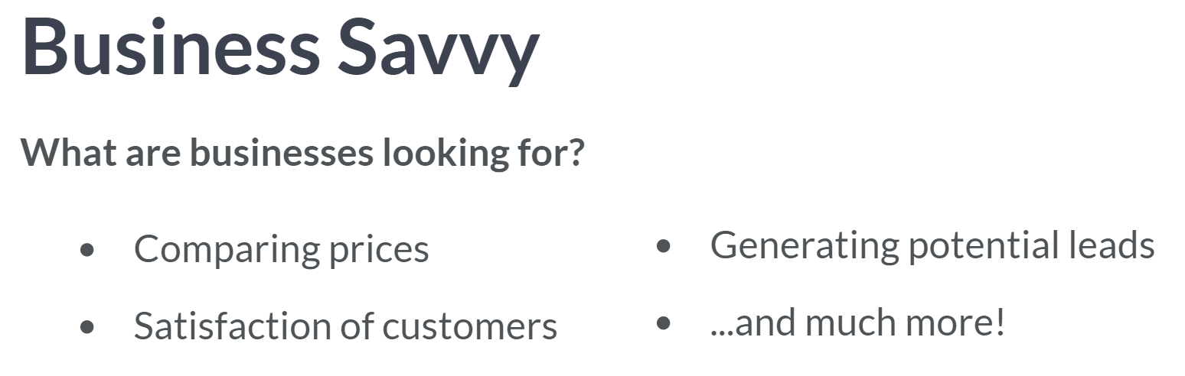  
You might ask yourself why business might employ those with experience web-scraping? Here are following advantages.

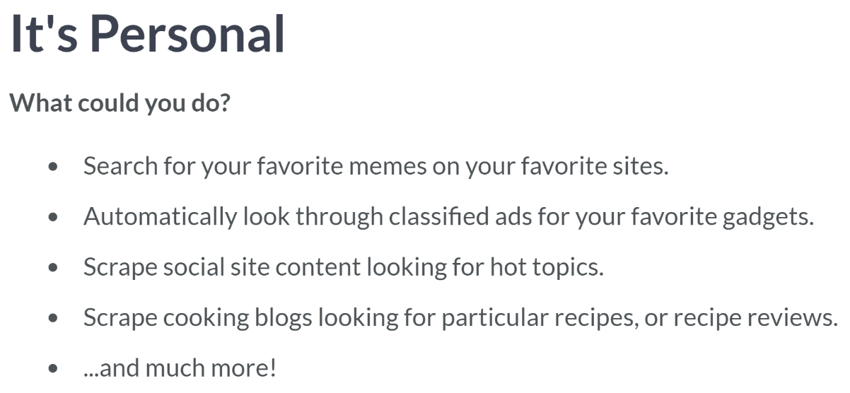

Here are some of things you can do to experiment yourself in web scraping.

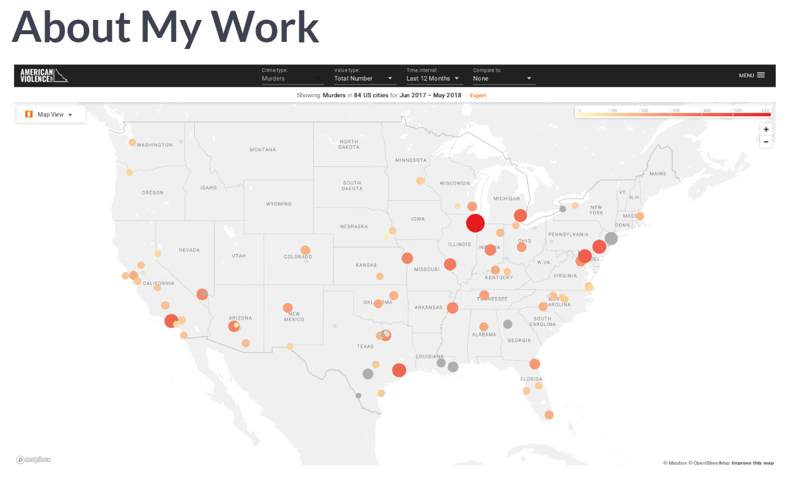  
Now let me give you an example that I've worked on. Here at the Center for Data Science, the instructor of this course has been heavily involved in collecting the data for the website: AmericanViolence.Org. It turns out though, that many such agencies publish this data online.

The work he's been done is to collect, process, and format these data into a single repository, starting with murder data for some of the largest cities in the US. So, realize this: many of the techniques you will learn in this course are same that he used to collect data for AmericanViolence.

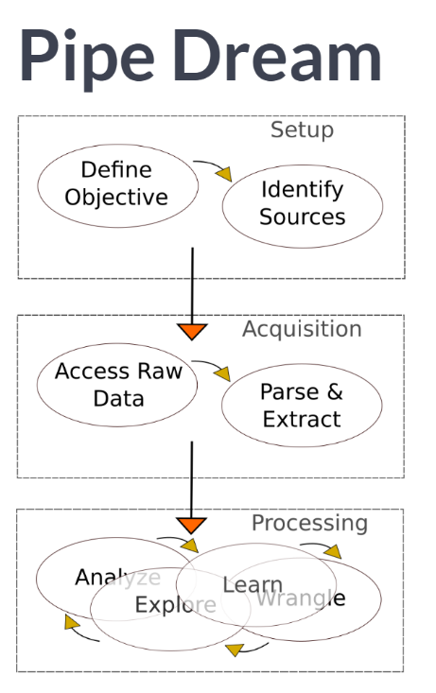   
To better visualize the focus of what you will learn in these lectures and exercises, let's roughly breakdown the web-scaping pipeline into three pieces.

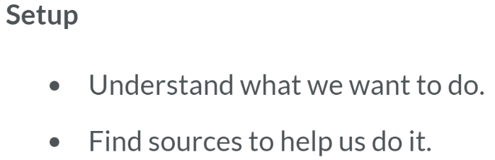  
The first piece is the setup, that is, defining the goal or task and identifying the online sources, which you believe will help you achieve the desired end result.

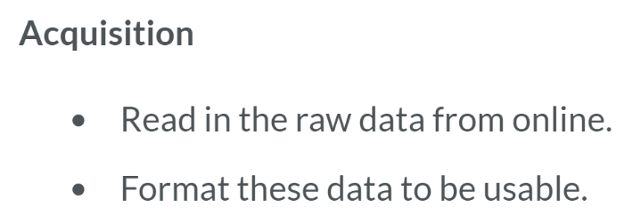

The second is the acquisition of these online data. This includes accessing the data, parsing this information, and extracting these data into meaningful and useful data structures.

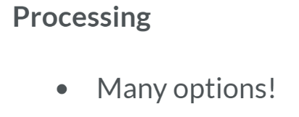

The third is the processing phase, where you run these downloaded data through whatever analyses or processes needed to achieve the desired goal.

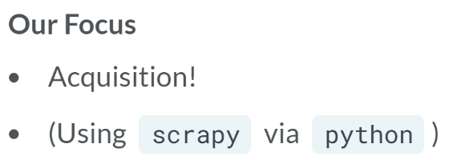

This course focuses on the acquisition phase. To accomplish this, we will be using Python and the web-crawling framework scrapy. We chose scrapy, since we can jump in quickly, and easily scale to large scraping projects.

However, even if you aren't sold on using scrapy or Python, you will still build techniques and intuition that will be valuable in any computational web-scraping environment you enjoy.

# Web-scraping is not nonsense!

Select which of the following is not correct.

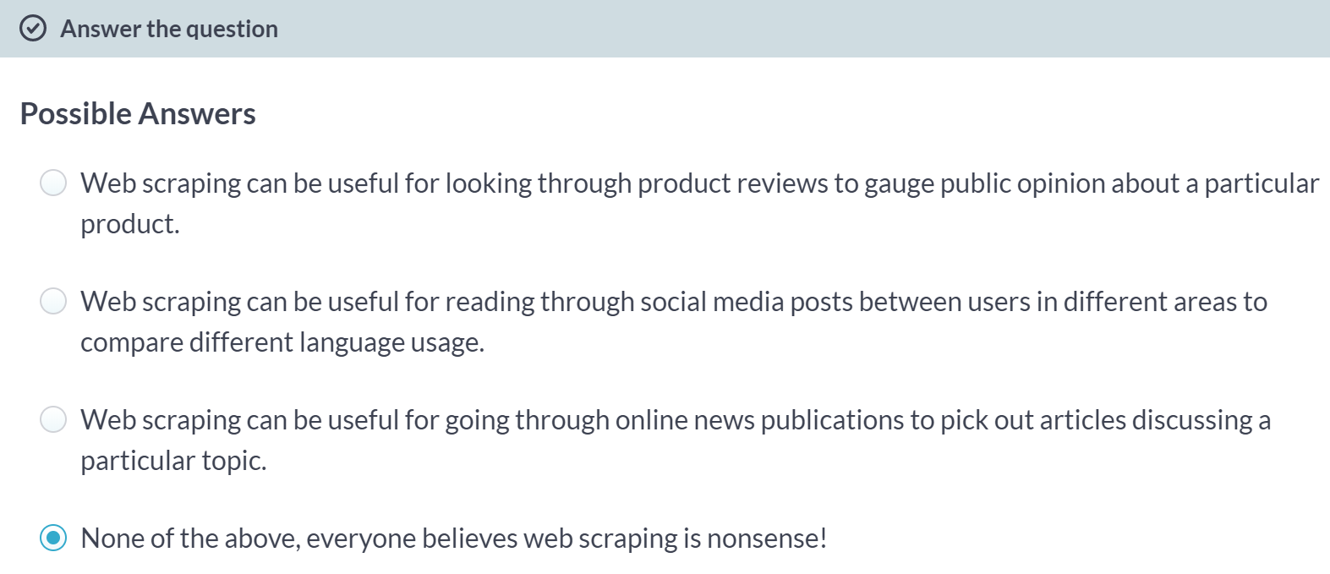

A: Looking through product reviews is a common use of web scraping employed by businesses!

B: Reading through social media posts between users in different areas to compare different language usage is a use of web scraping employed by researchers and others!

C: Going through online news publications to pick out articles discussing a particular topic is a using of web scraping employed by researchers and others!

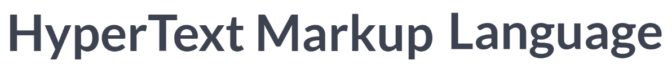

When we want to scrape the contents from a particular website, we are often given the HTML code, and therefore, the focus of this lesson will be learning to navigate HTML to arrive at the content we may be interested in retrieving.

In doing so, we will use a simple toy model of HTML as we become comfortable with how the code looks behind the scenes and see that we can picture a tree-like structure of HTML to easily interpret the task of HTML navigation.

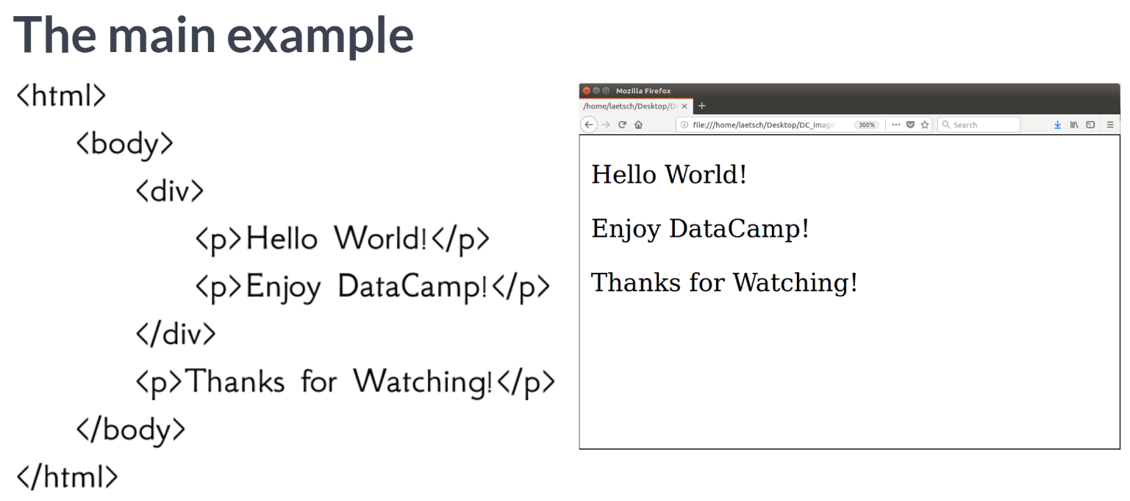  
Here we are given a first look at a very simple example of HTML. Throughout this lesson, we will be using this same bit of HTML while we gain intuition towards HTML navigation, before playing with much longer and more involved examples. To give you an idea of what a web browser would show, on the right side is how Firefox displays this HTML on my computer.

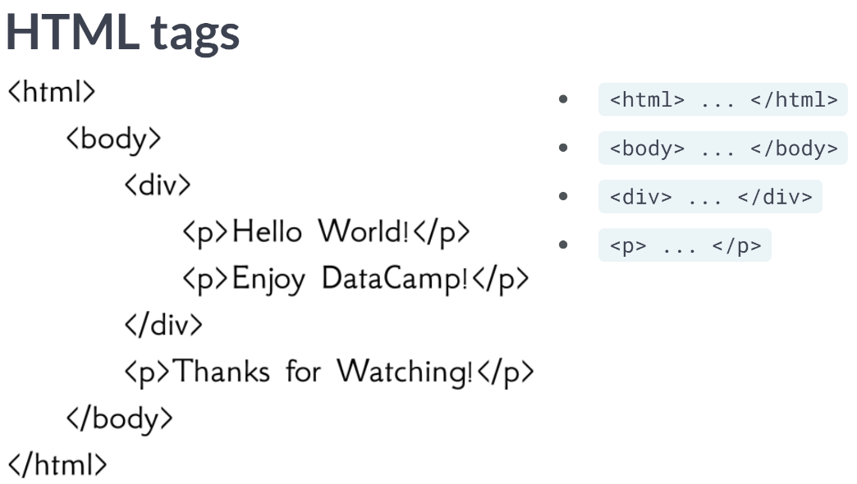  
The elements contained within the angle brackets are called "HTML tags", which, in well-formatted HTML, usually come in pairs. The pair contains a starting tag without a forward slash and stopping tag with a forward slash.

* The root tag containing the main HTML contents are those with the text "html" within the brackets.
* We also have a body tag, defining the body of the html
* A div tag defining a section of the body, and
* Several p tags defining paragraphs within the body.

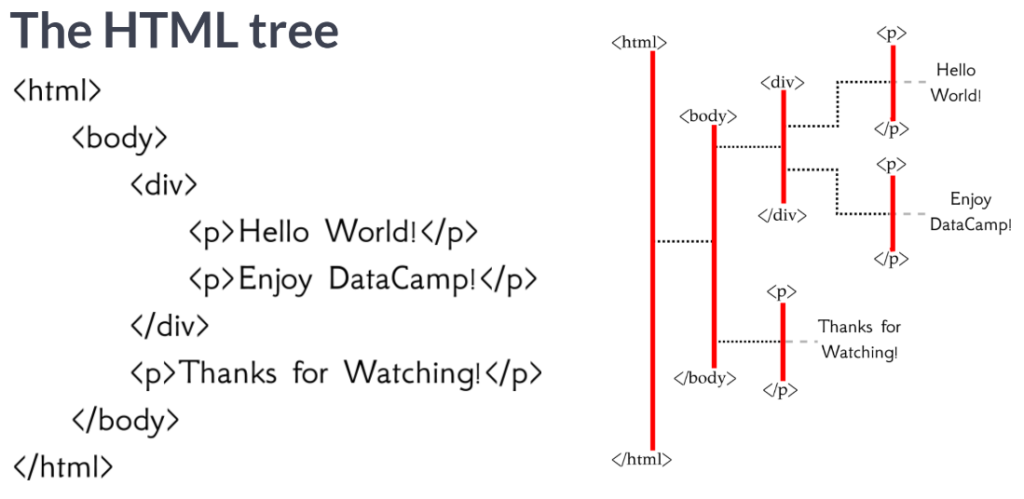  
We notice that the HTML tags are nested within others, such as the body tag nested within the html root tag; a div tag nested within the body tag; two paragraph tags nested within the div tag, etc. This nesting gives rise to a hierarchy in the HTML, which can be visualized as a tree structure as displayed here.

The vocabulary we use to describe moving around the tree comes from looking at ta family tree: As we move from left to right, we are moving forward generations; as we move top to bottom, we are moving between the same generation, and moving between siblings if the elements come from the same parent element.

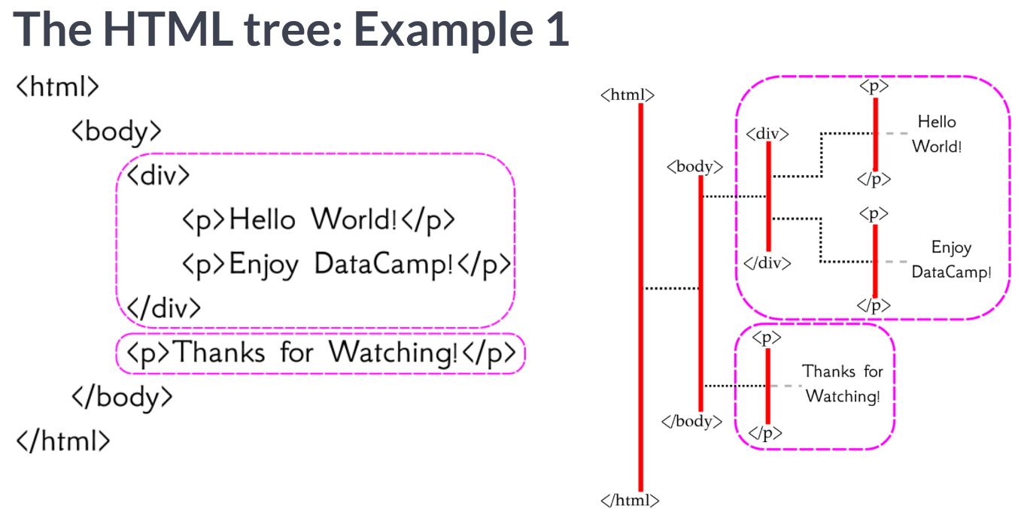  
For example, the children of the body element are the same as the second-generation descendants of the root html element; in order from top to bottom, div is the first child, p is the second.

These two elements (the div and p elements) are siblings as they are both children of the same parent, the parent being the body element.

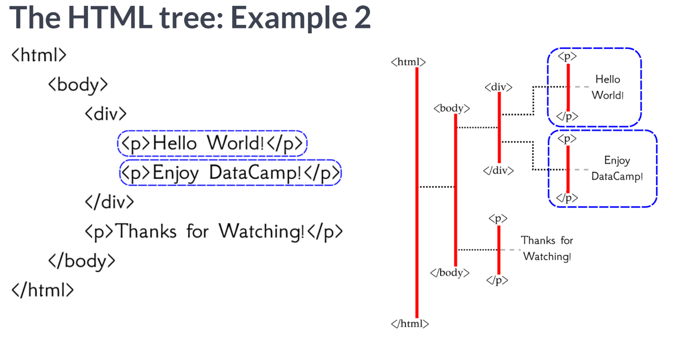  
The two third generation descendants of the html element are circled here. Both of these elements are paragraph p elements, and both are children of the same div element parent, and hence siblings.

Note that these two circled paragraph elements are not descendants of the third, uncircled paragraph element.

This is graphically represented by the fact that, although the two circled paragraph elements are further to the right on the tree, we cannot follow a path from the uncircled paragraph element to the two circled ones. This is analogous to saying that, even though your niece is a future generation, she is not your descendant.

To sum up, we just got our first glimpse at HTML, introduced ourselves to html tags, visualized the HTML code as a tree, and learned how to describe navigating that tree's structure.

# HTML tree wordy navigation

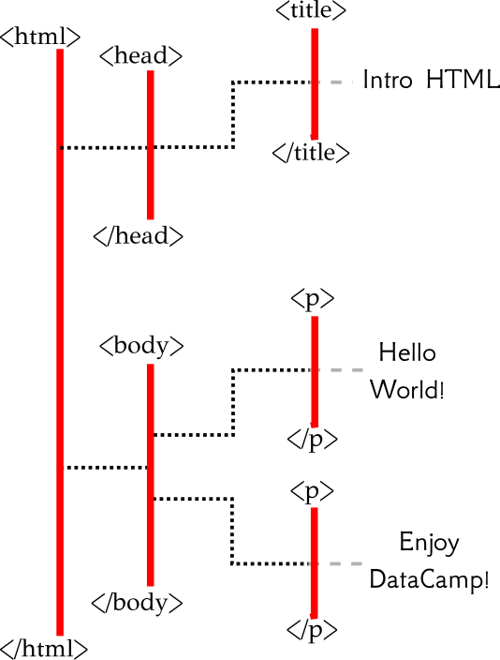

Given the html tree above, which of the following does not correctly navigate to the paragraph element containing "Hello World!"?

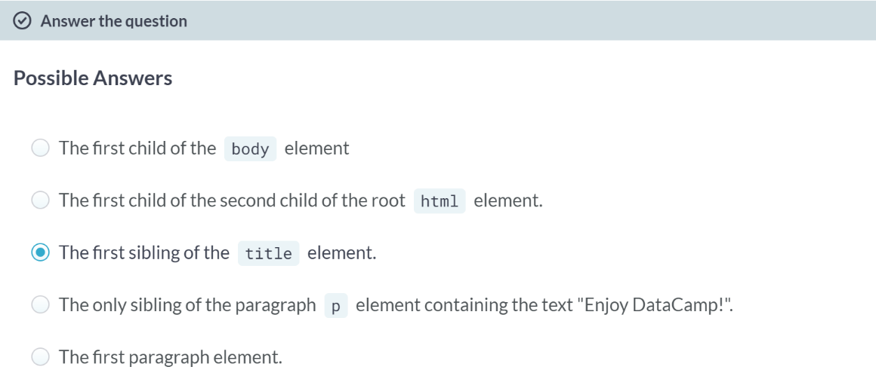  
C: Correct! The title element is the only child of the head element and thus has no siblings. So, this does not direct us to the p element containing "Hello World!".  
  
A: Moving from top to bottom, the first child of the body element is the p element containing "Hello World!".

B: Moving from top to bottom, the body element is the second child of the html root element; from the body element, moving from top to bottom, the first child is the p element containing "Hello World!".

D: The p element containing "Enjoy DataCamp!" has only one sibling, the only other child of the body element, which is the p element containing "Hello World!".

E: While moving from top to bottom and following the paths left to right, the first p element is the one containing "Hello World!".

# From Tree to HTML

Here you are given the chance to create your own bit of HTML code (as a python string). More specifically, below is an HTML tree image and you will finish the missing code within the string html which produces this HTML tree.

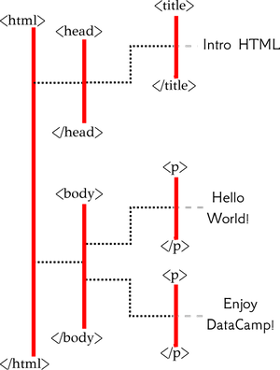

To note:

* We have started the string html for you, to help nudge you in the correct direction.
* The spacing we use in the portion of the string we provide (e.g., indenting <head> two spaces more than <html>) isn't necessary, but we did so just to make it easier to read.

(Exercise begins on the next page)

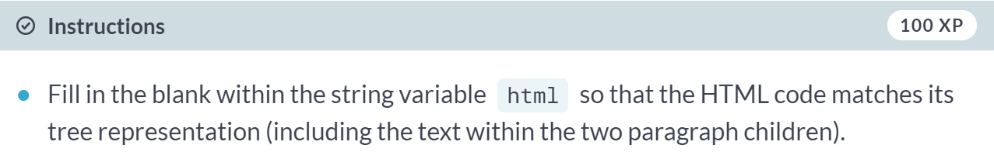

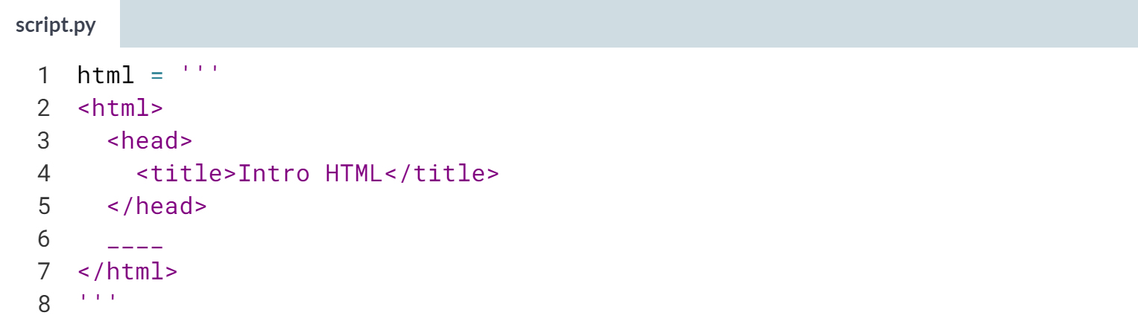

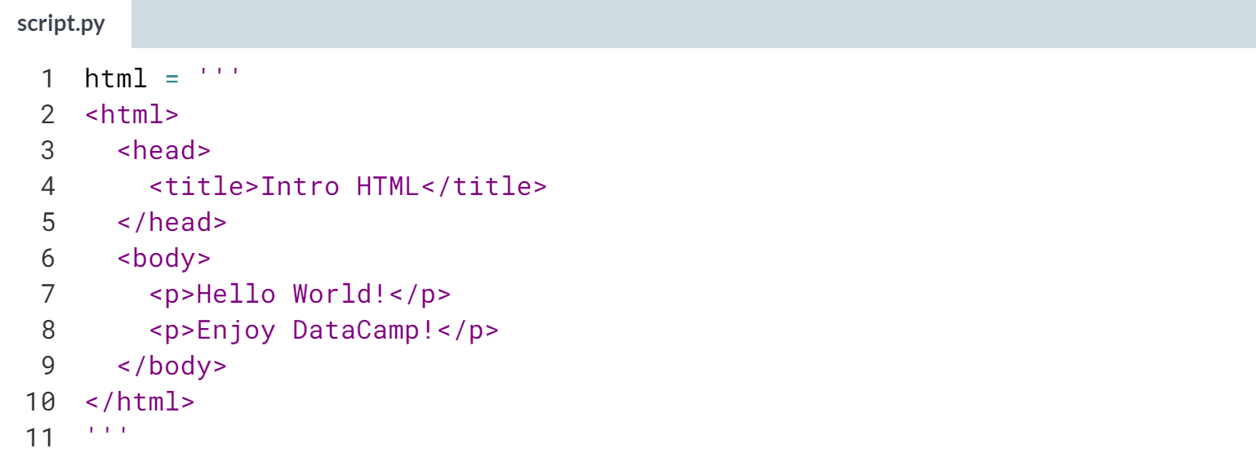

Great job writing your first bit of HTML code!

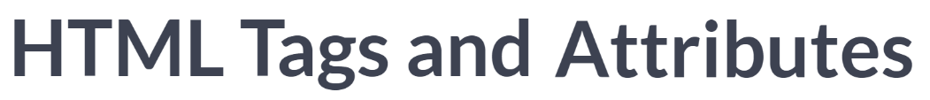

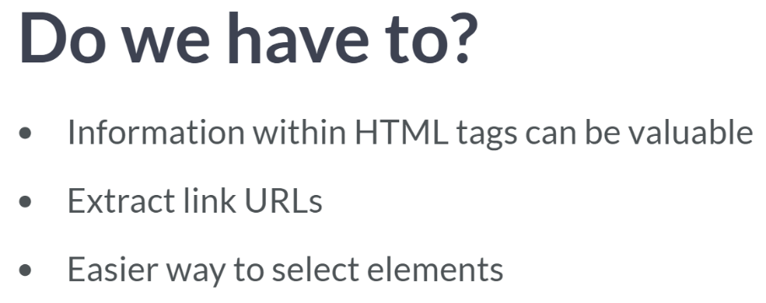  
Why do we have to get more specific in delving into the specifics of the HTML tags? Here are the reason why.

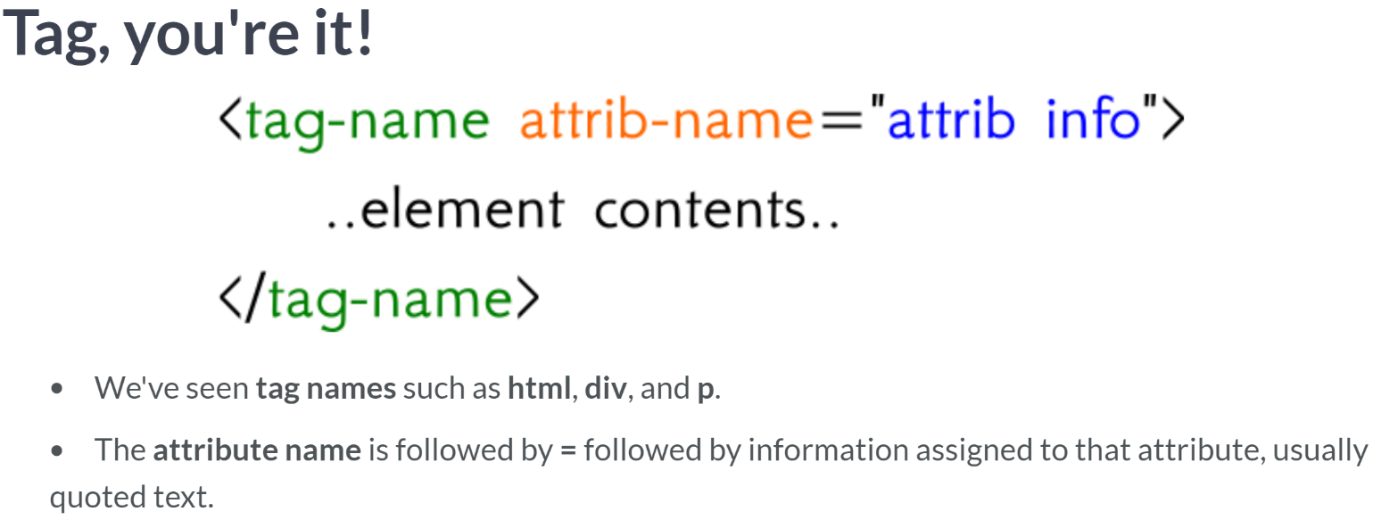

* To start, let's look at an abstract tag formatting. There are many HTML tag types that follow the same formatting; we have already seen three tag names: the html, div, and p tags.
* These tags can also contain **attributes**, which provides special instructions for the contents contained within that tag.
* Specific html attribute names are followed by an equals sign, followed by information, which is being passed to that attribute within the tag; in well-formatted HTML, the information is in quotes.

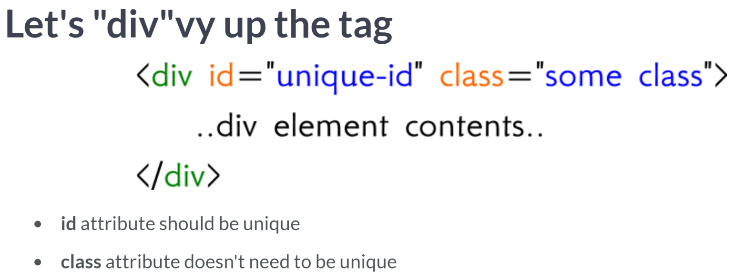  
To look at a specific example, let's consider a div tag with two attributes: id and class. We chose these two attributes here because they arise frequently in practice. In well-formatted HTML, the id attribute can be used as a unique identifier for the tag element.

In this example, the id "unique-id" should only belong to this specific div element, giving us a quick way to identify it. The class attribute "some class" can also help us identify this div element, but even in well-formatted HTML, it doesn't need to be unique.

No tag needs to have an id nor a class attribute, but all tags can be given an id and a class. A point that will find its way to a future lesson is that a tag can belong to multiple classes, and this is done when the class attribute (that is, the quoted text assigned for that class) has multiple class names separated by spaces. In fact, this div tag would belong to both classes: "some" and "class".

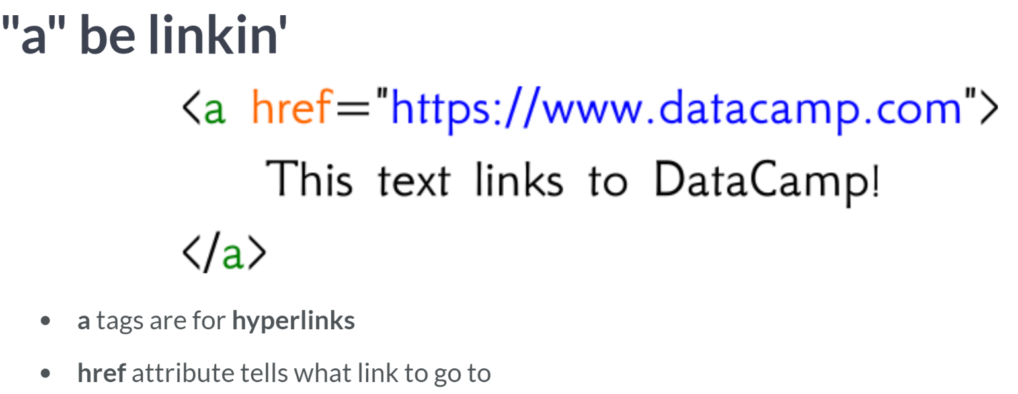

Let's look at another example. The "a" tag-name here is the specific tag for hyperlinks, the links we click on within a website to redirect somewhere. The most important attribute within these hyperlink tags is the "href" attribute, which is used to identify the URL where the hyperlink redirects to.

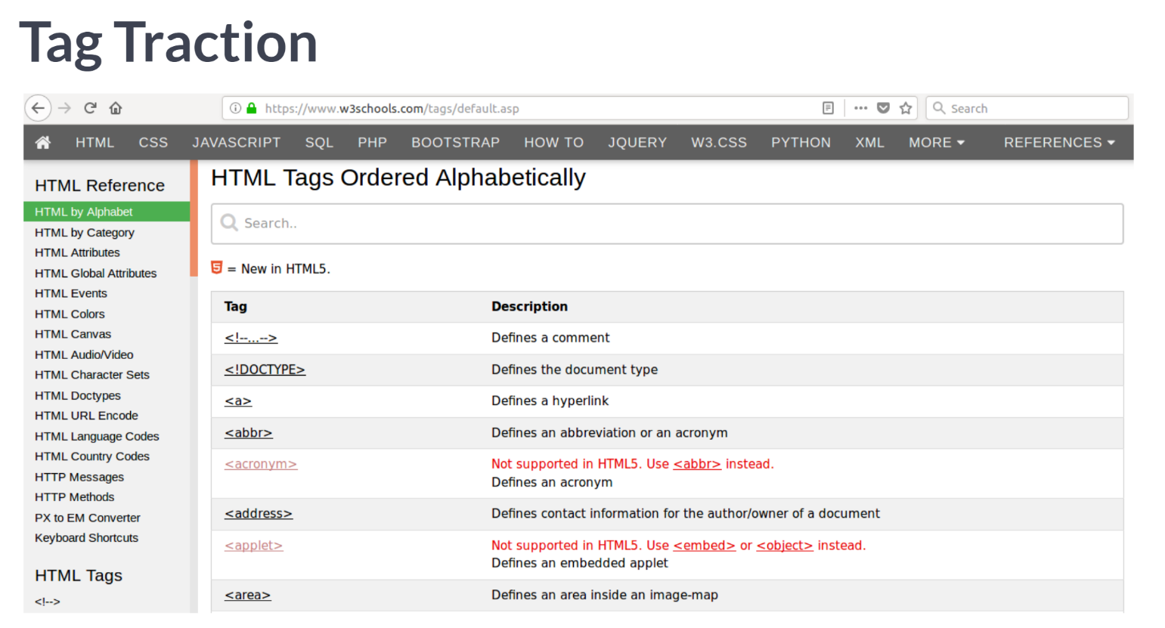  
It turns out that there are many allowable tag types in HTML, and many allowable attributes sometimes depend on those tag types. We are going to learn techniques that will be applicable regardless of the tag, with a special focus on *id*, *class*, and *href* attributes we saw in this lesson, building up methods that can easily apply to other attributes as you encounter them. Even with only those three attributes, we will get a lot of traction.

# Keep it Classy

In this two-part exercise, you will have a chance to show off what you've learned about attributes; in this case, we focus on the class attribute.

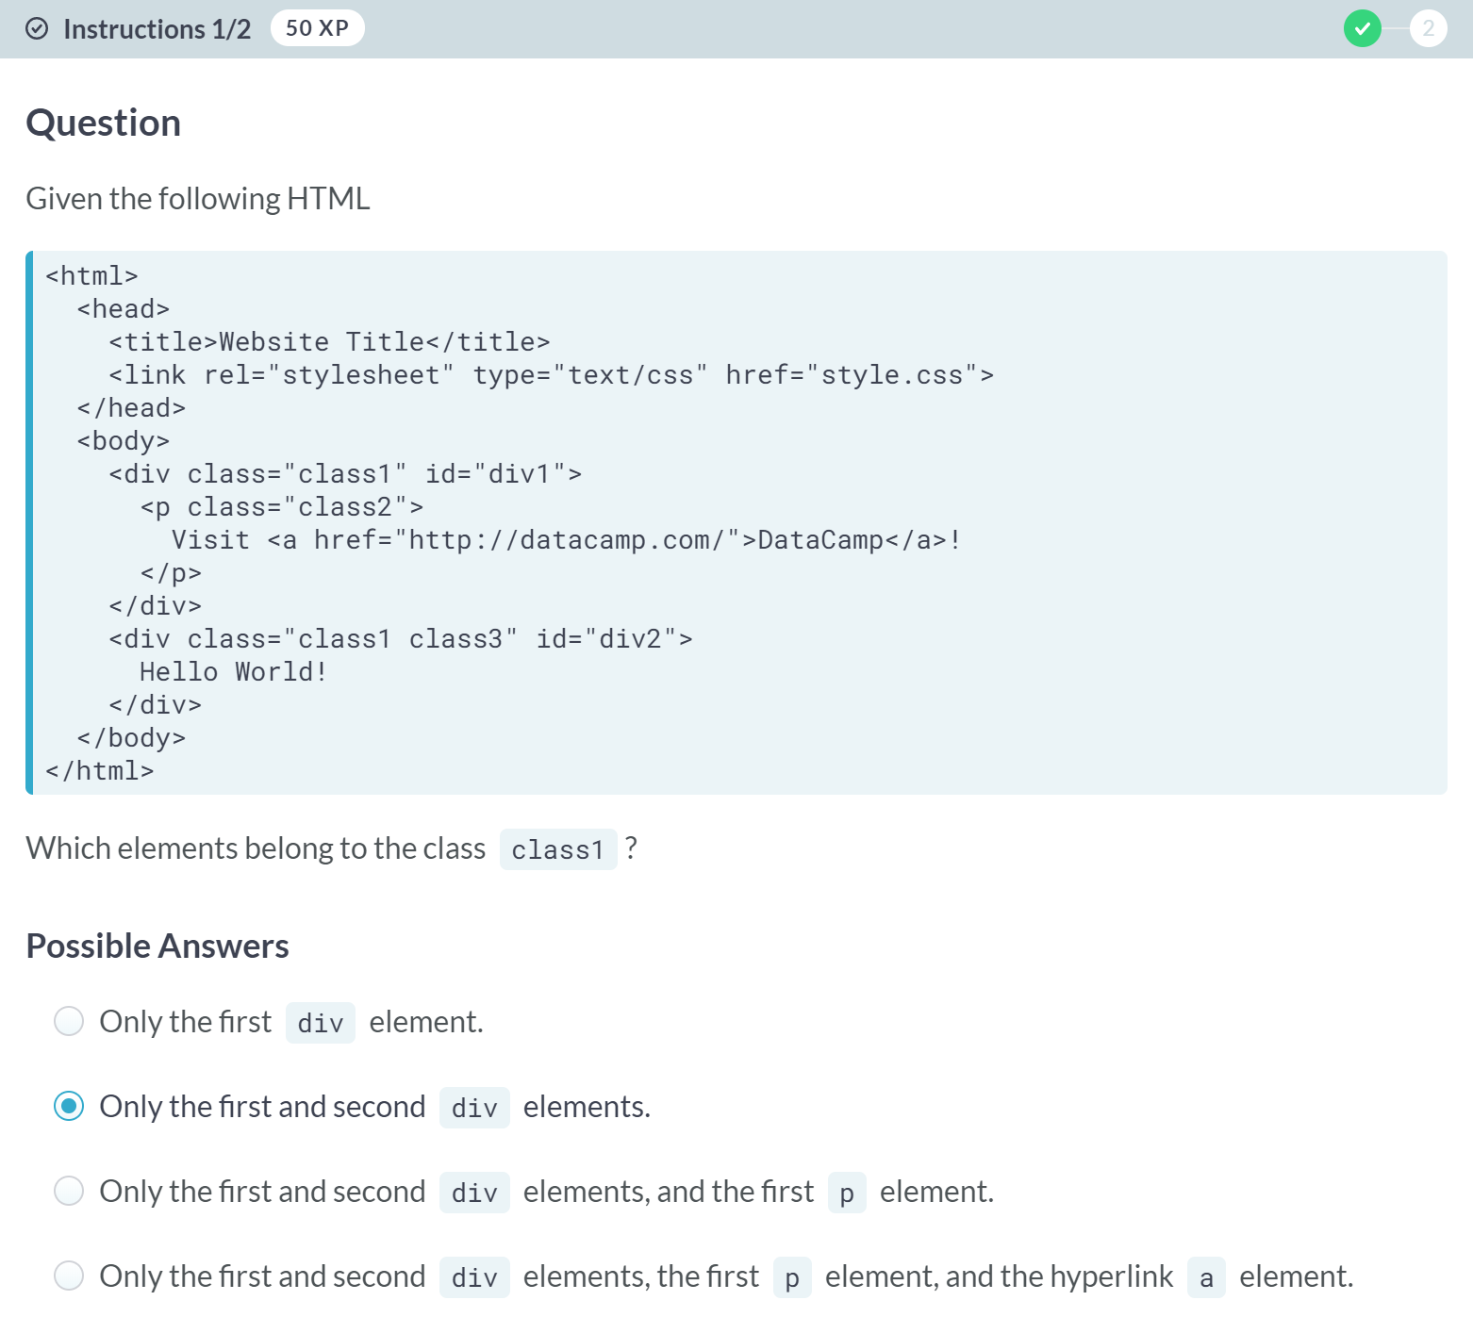

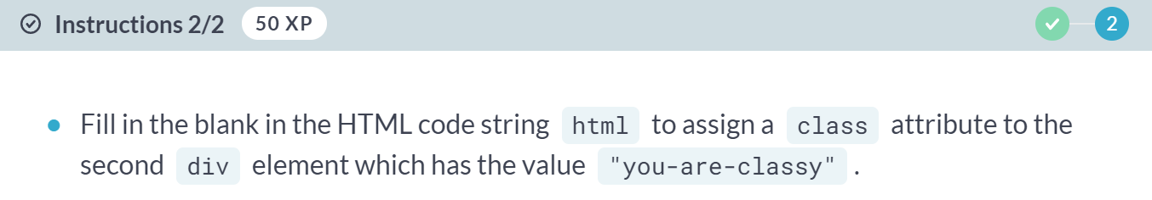

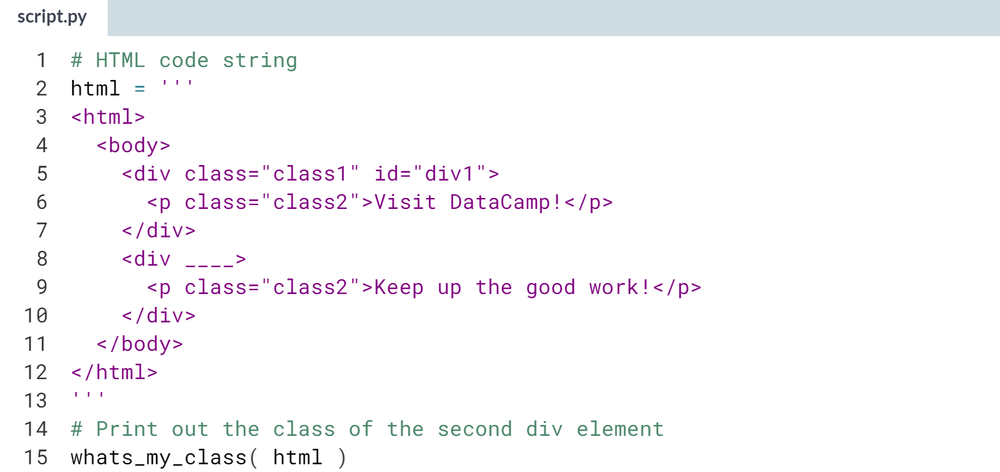

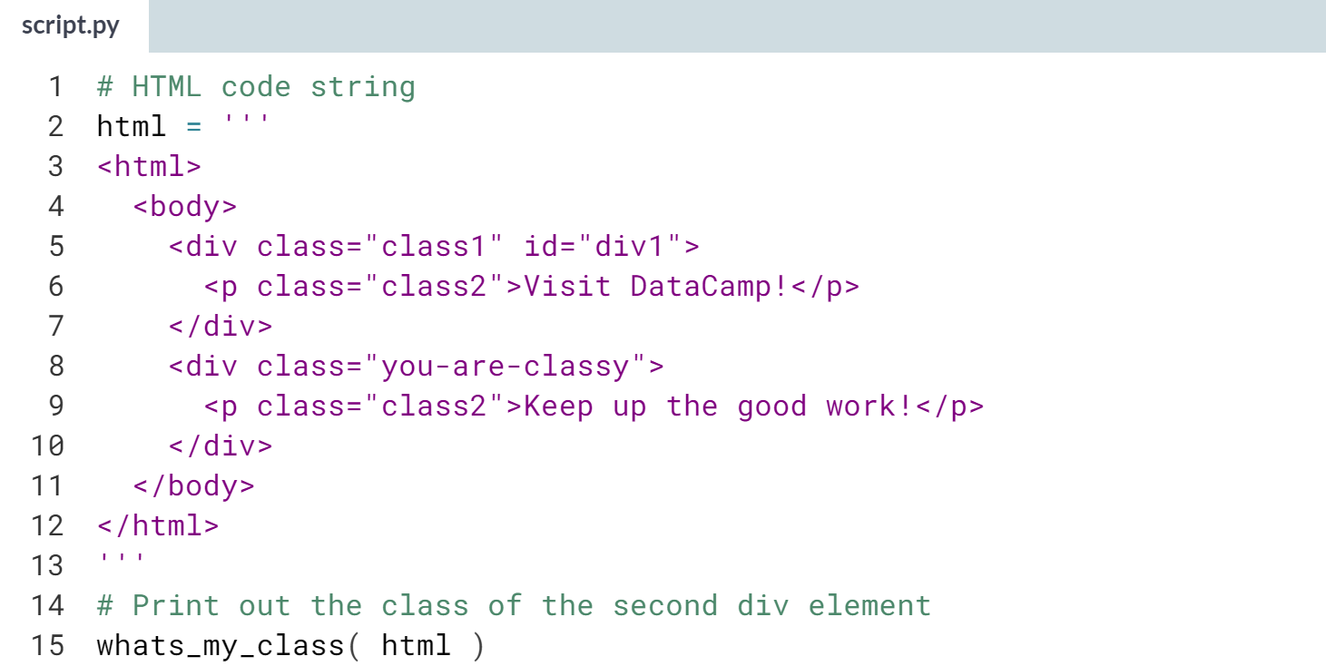  
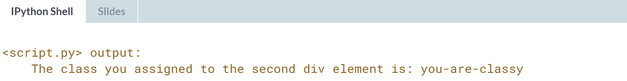  
Great! Adding in attributes isn't supposed to be hard, but helps give character to HTML code and at times how it's rendered online.

# Finding href

Considering the following HTML:

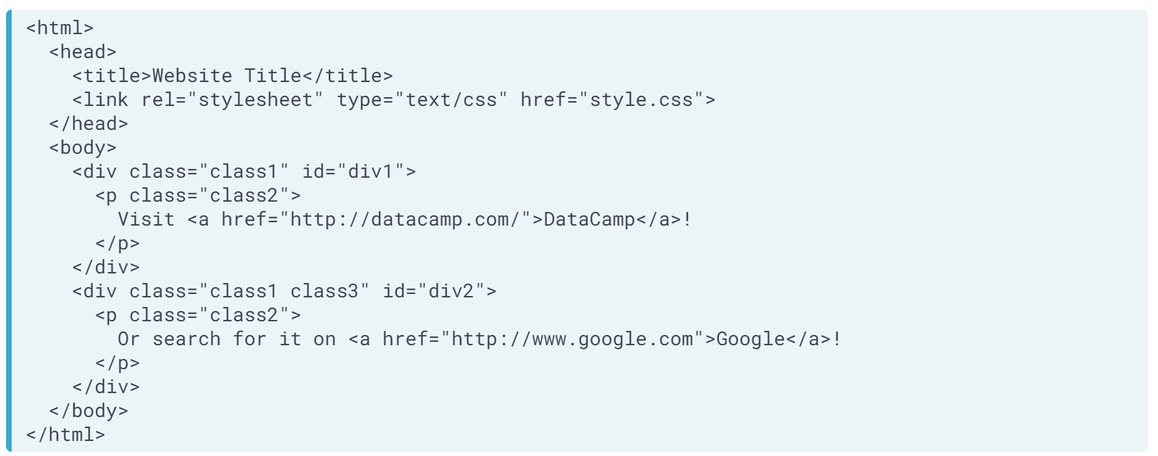  
Which of the following does **not** correctly describe how to get to the URL, http://datacamp.com?

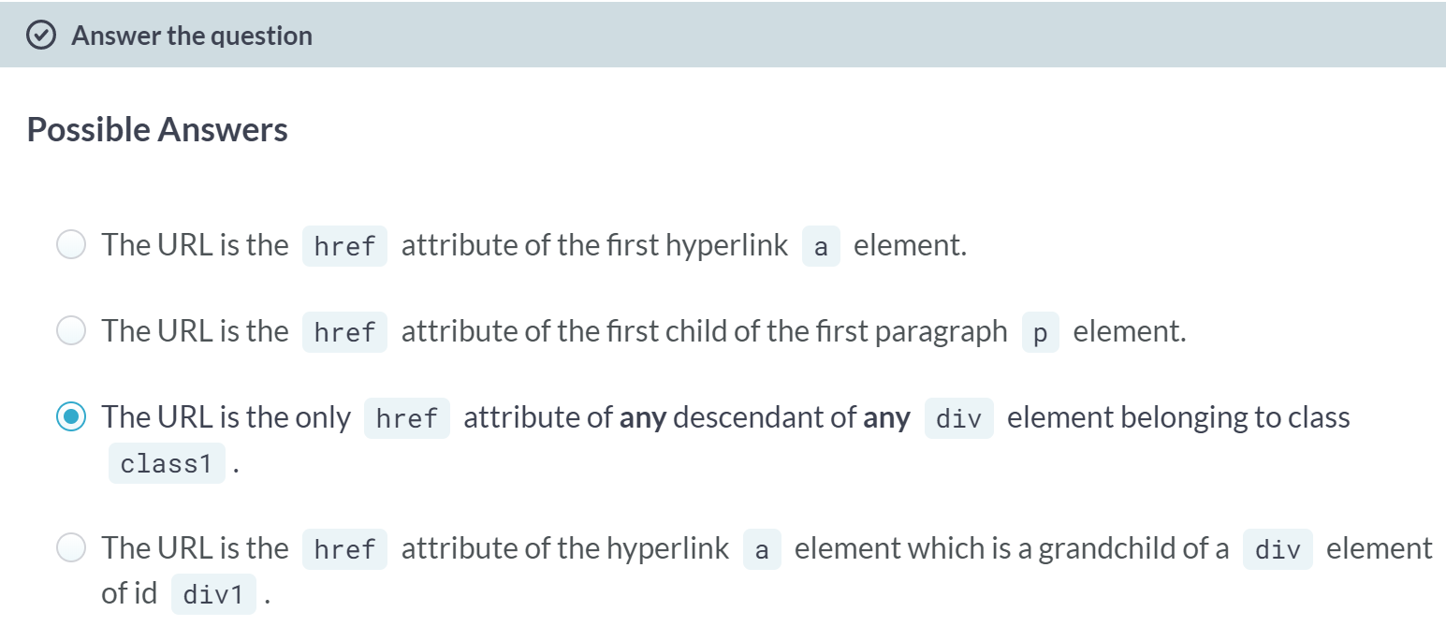  
C: Correct, both div elements belong to the class class1 (even though the second div element also belongs to class3), and both have an element as a descendant (in this case, a grandchild). So, this direction points to two href attributes, the first is the desired URL, the second is http://www.google.com.

A: Moving from top to bottom, we see that the first *a* element has an href attribute with the desired URL.

B: Moving from top to bottom, we see that the first *p* element has, as its first (and only!) child, the a element whose href attribute is the desired URL.

D: The id of div1 is unique to the first div element, which is the grandparent of the *a* element whose href attribute is the desired URL.



If we want to describe where the specific elements of HTML are within our programs, then we need to build up a standard, program-friendly language or syntax to do so. You have noticed that all your exercises at this point have been multiple choice, and this is because we didn't have the necessary understanding of how to turn out wordy navigation of HTML into a variable for the computer to ingest.

This lesson will give a crash course in some basics of what's called XPath location, one of two common choices for this purpose. And in the next chapters, we will go deeper into both syntaxes with many more examples.

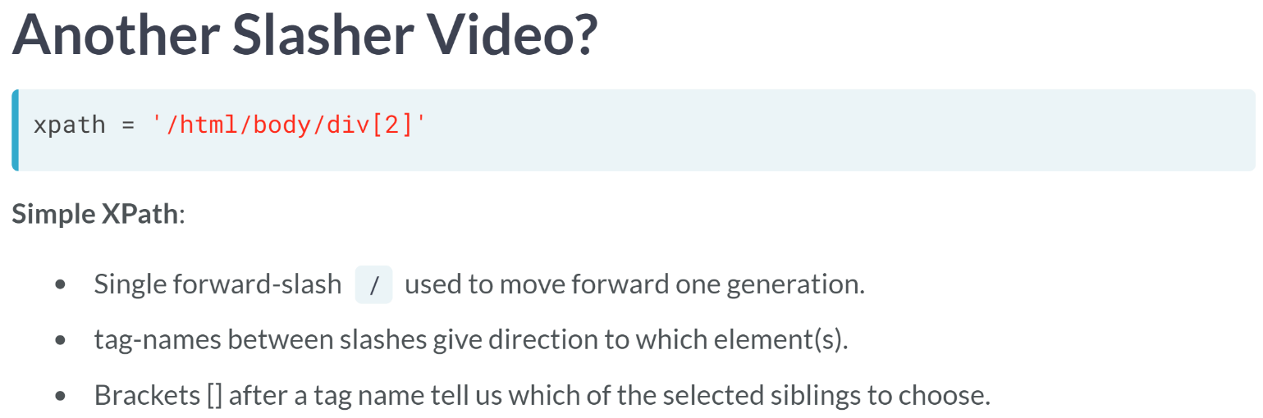

A simple XPath string we could write in Python is given here. One nice property of XPath notation is that you might already have some familiarity with similar syntaxes, because it uses a single forward slash in an analogous way as you do if you are navigating directories, or typing a URL into your browser.

The single forward-slash moves us forward one generation. In fact, if we think of the tag-names as the "directory" names, then these simple XPaths will look very much like navigating between directories.

What might seem unfamiliar are the brackets. These brackets are used to help specify which element or elements we want to direct to. For example, there could be several div elements which are children of the body element, that is, several div siblings, so we can use the brackets to narrow in on the div element we want.

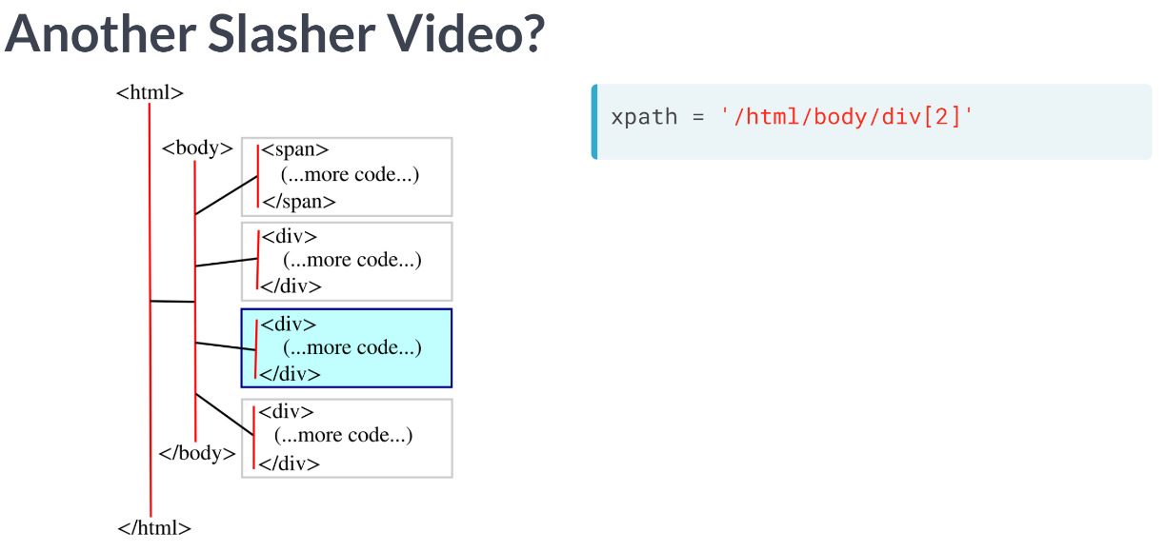  
To illustrate the sample XPath string we wrote in the last slide, here we have highlighted the div element, which would be selected within a tree representation of some HTML.

Notice that the number 2 in the brackets of our XPath expression refers to the second div element of the three div elements (ordered from top to bottom as usual), paying attention to the fact that the first child of the body is a span element, so is not counted when looking at the div elements.

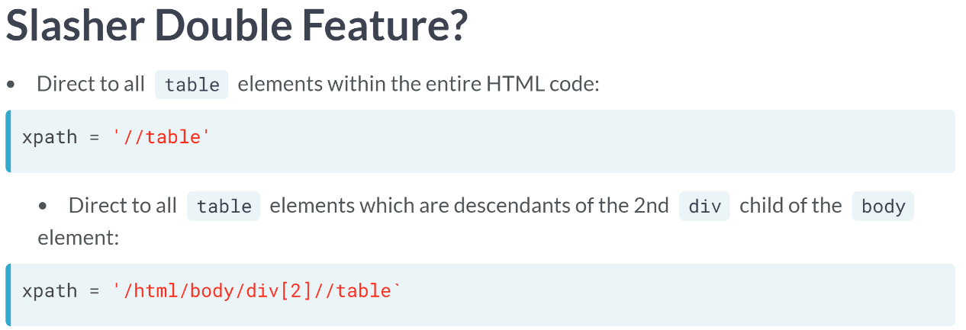  
Another important feature of XPath notation is the double forward-slash. Using the double-forward slash tells us to "look forward to all future generations" (instead of just one generation like the single forward-slash).

So, for example, we could navigate to all table elements within an HTML document by simply typing double forward-slash table.

Or, we could want to restrict to a specific div element (say, the one we learned how to navigate to in the last couple slides), and navigate to all table elements, which are descendants of that div element.

So far, we have only just scratched top of the surface of XPath notation, but we've gone deep enough that you can begin to write some code and get your feet wet navigating HTML computationally.

Let me emphasize here that XPath is general, meaning that it is not Python-specific. So, if you decide to start scraping the web in R, say, most libraries there will also be able to read and interpret your XPath strings.

# Where am I?

In this exercise, you will navigate to a specific element using your new knowledge of XPath notation.

Consider the HTML code:

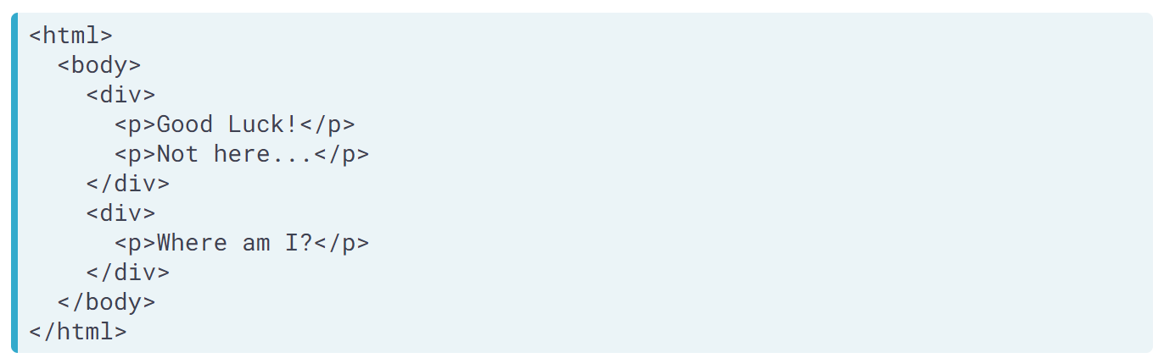

Your job will be to create an XPath string using **single forward-slashes** and **brackets** which navigates to the paragraph p element which contains the text "Where am I?".

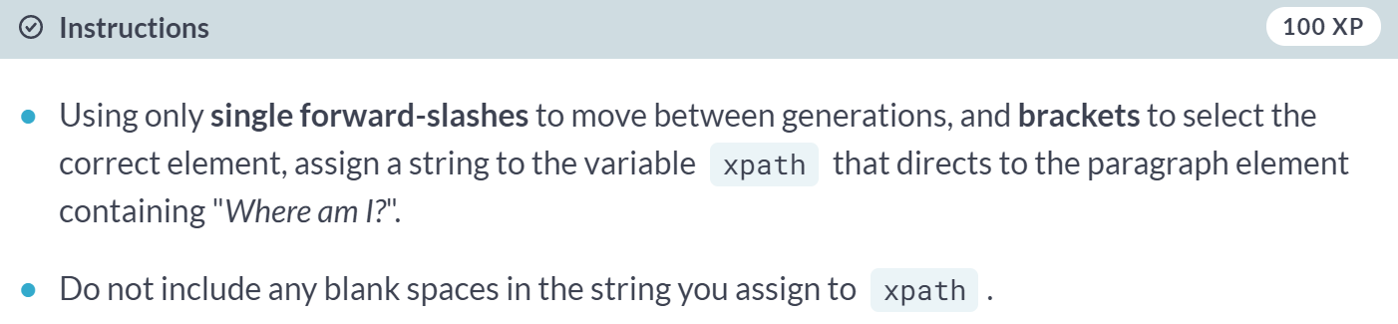

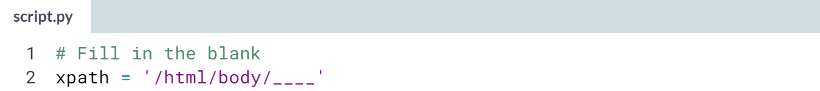

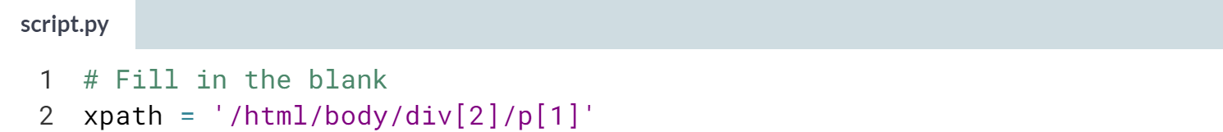

You've written your first XPath string and did great!

# It's Time to P

In the lecture, we learned how to use double forward-slashes to navigate to all future generations. In this exercise, you will select all paragraph p elements within the HTML.

Because we want you to navigate to **all** paragraph elements, it is not important that you know what the HTML code is, since the task can be accomplished with a simple XPath string using the **double forward-slash** notation you have learned.

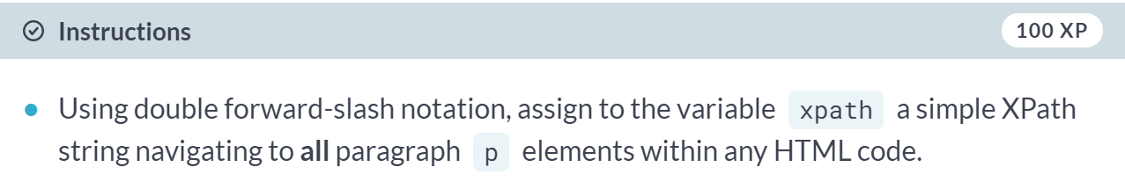

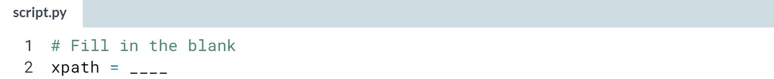  
Hint: In the lesson, we learned that *//table* directed to all table elements with the HTML.

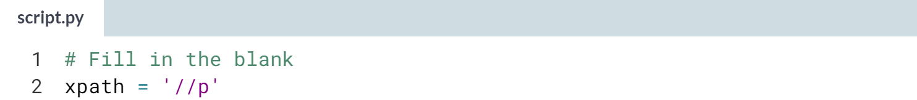

Great! You are getting the hang of single vs double forward-slashes in XPath notation!

# A classy span

Although we haven't yet gone deep into XPath, one thing we can do is select elements by their attributes using an XPath.

For example, if we want to direct to the div element within the HTML document whose id attribute is "uid", then we could write the XPath string '//div[@id="uid"]'.

The first part of this string, //div, first looks at all div elements in the HTML document. Then, using the brackets, we specify that we want only the div element with a specific id attribute (in this case uid).

To note, the phrase @id="uid" in the brackets would be read as "attribute id equals uid".

In this exercise, you will select all span elements whose class attribute equals "span-class". (Note: span is just another possible tag-name).

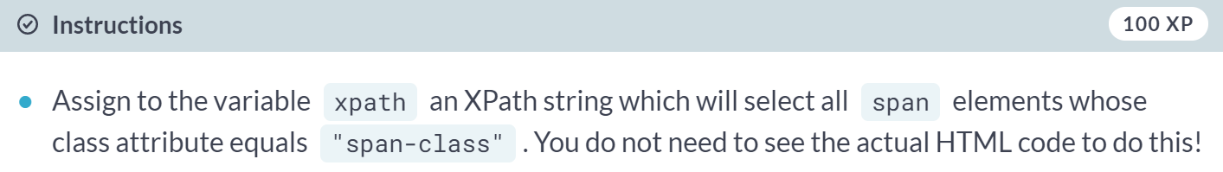

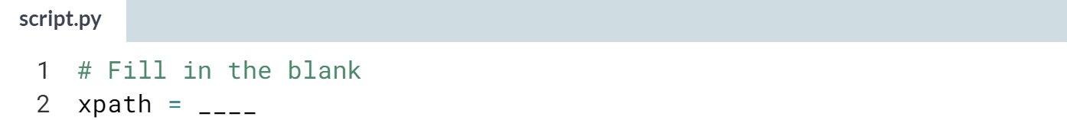

Hint: Work by analogy! Remember that *//div[@id="uid"]* selects all div elements whose id attribute equals uid.

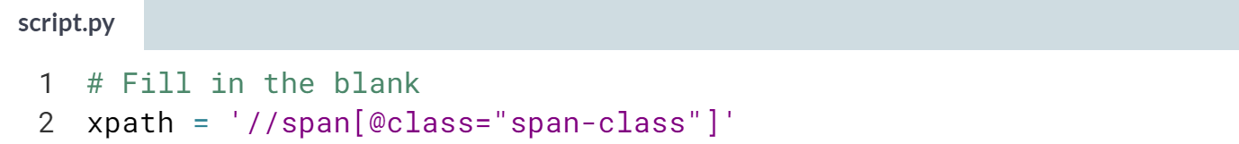

You were able to use the class attribute and XPath notation to direct to the correct element(s)!! AMAZING!!

**2. XPaths and Selectors**

Leverage XPath syntax to explore scrapy selectors. Both of these concepts will move you towards being able to scrape an HTML document.



Welcome to this chapter. We will start delving deeper into XPath notation to navigate HTML.

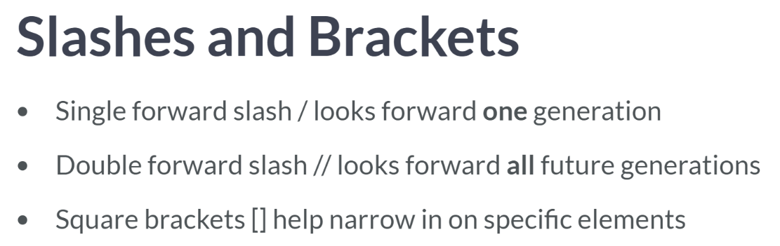  
As we briefly saw before, XPath directs us down one generation with a single forward slash, and down all future generations with a double forward slash.

We also saw that using square brackets in the XPath expression helps narrow in on which element or elements we want, but it turns out these brackets aren't always necessary nor desired.

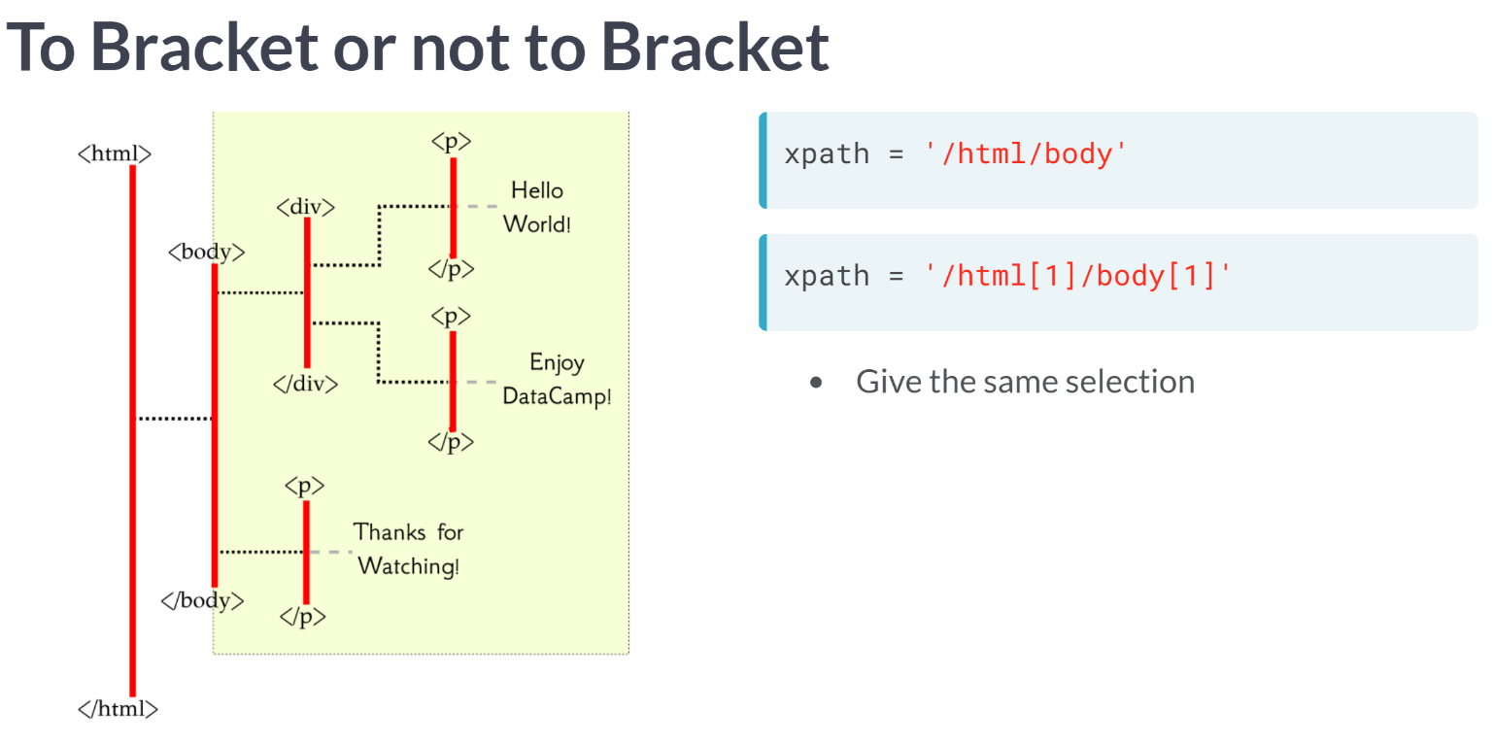  
For example, the first XPath expression without brackets and the second with brackets lead us to the same element the body element since there is only one HTML element at the root level, and one body element, which is a child of that HTML element.

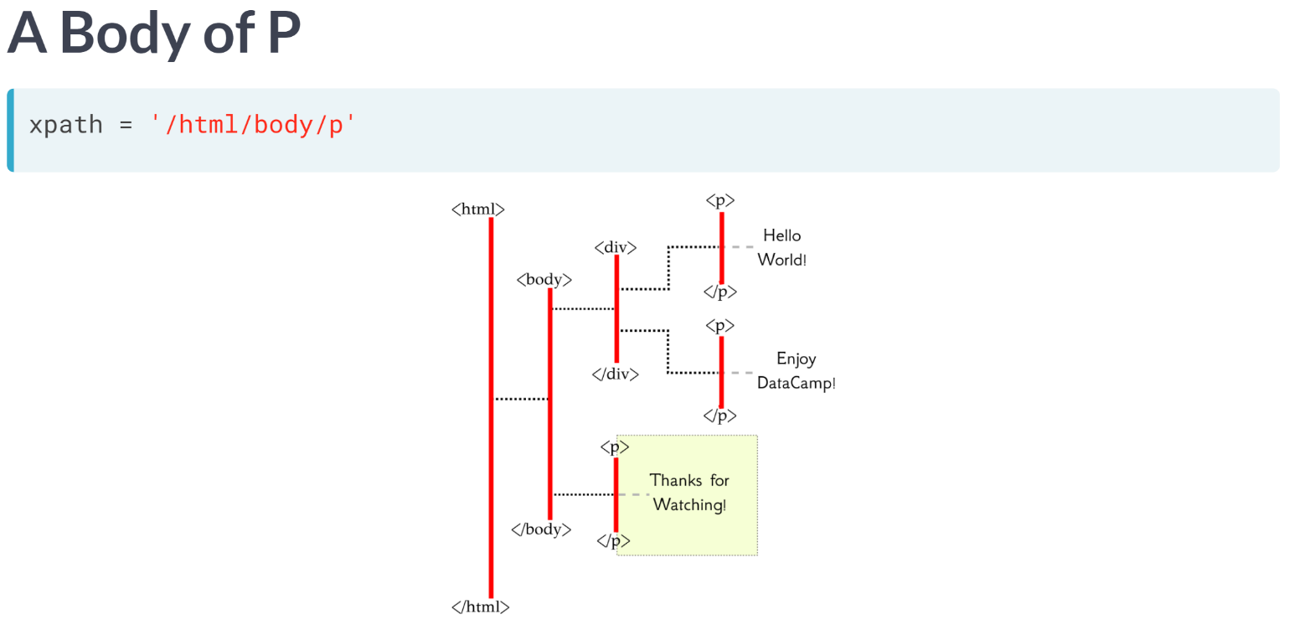  
As another example, the XPath string here leads us to the single paragraph element which is one generation below the body element.

Do you understand why there is only this one element selected? It is because there is only one paragraph element, which is a child of the body element.

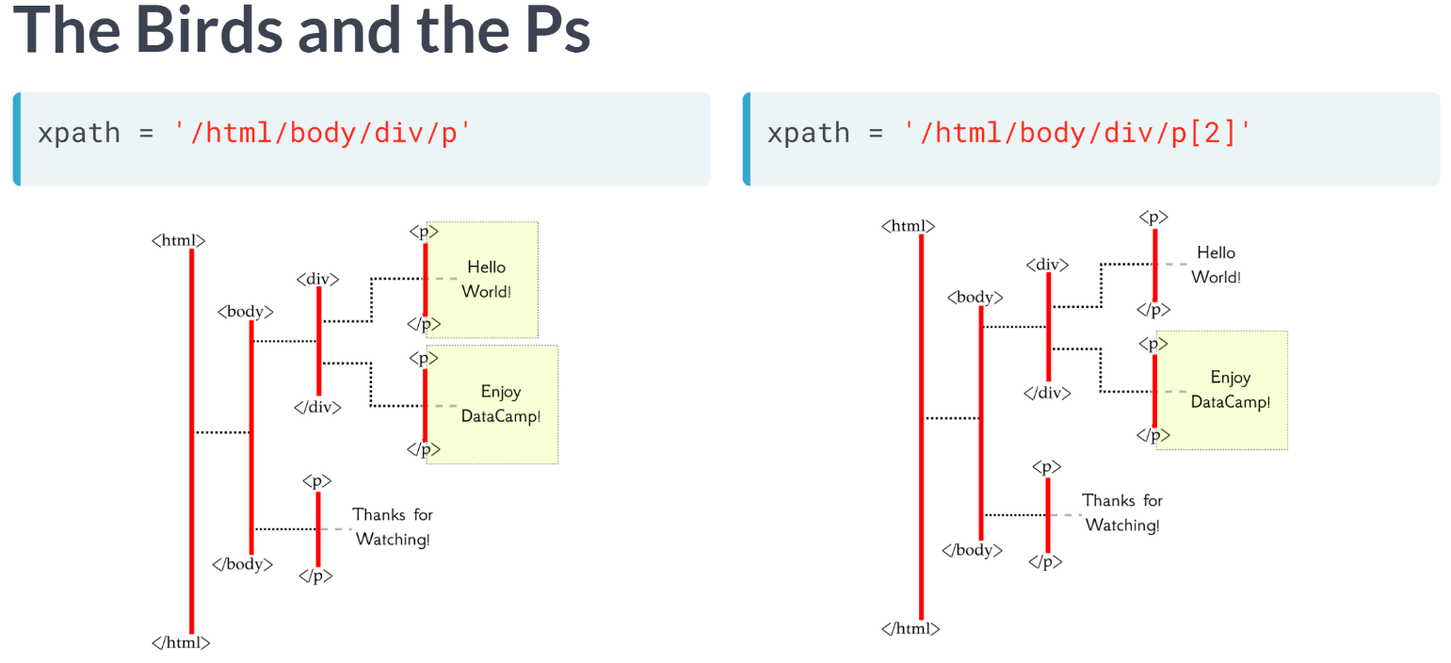  
On the other hand, if we consider the XPath string here, this directs us to both paragraph children of the div element. We haven't clarified a specific one.

We could, of course, add in brackets to help narrow in on which element we want; in this case, we will be selecting the second paragraph child of the div element.

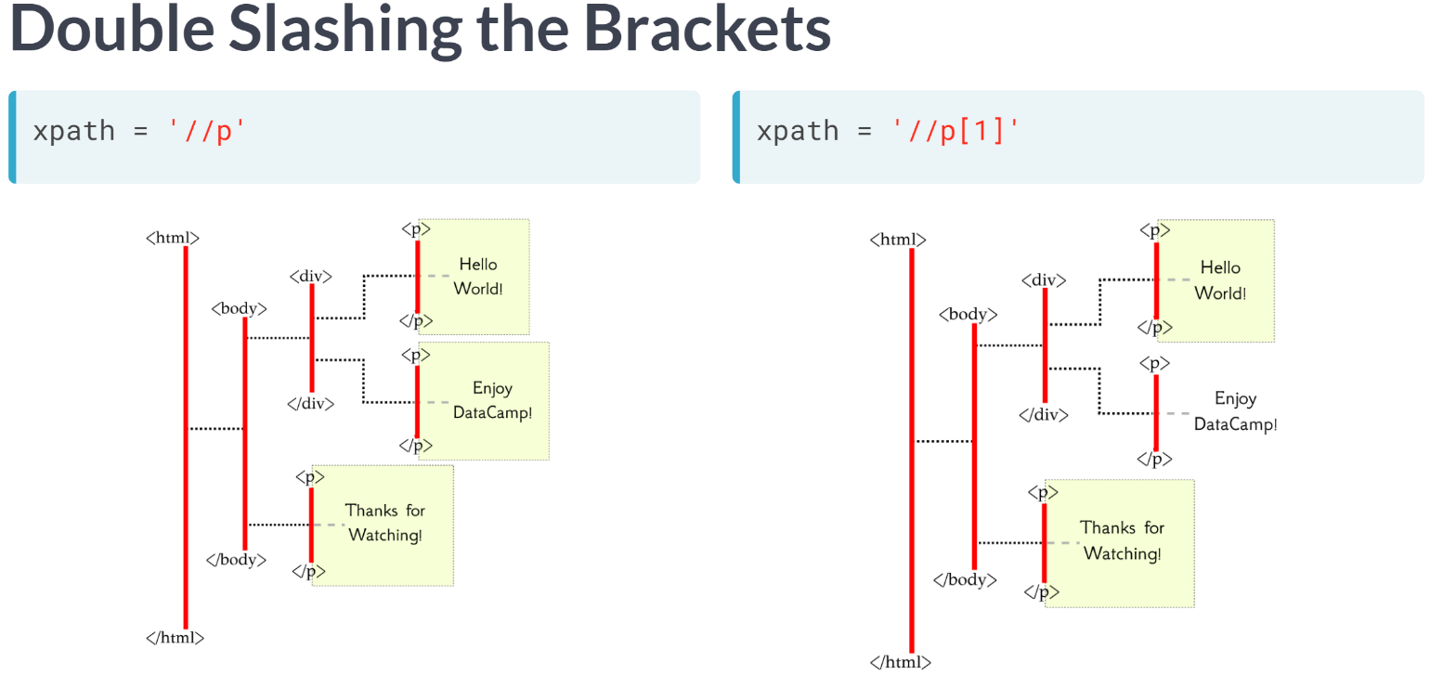  
Using a double forward-slash, we could have selected all paragraph elements, which are within the HTML document. Adding the bracketed number 1, it turns out we select two elements.

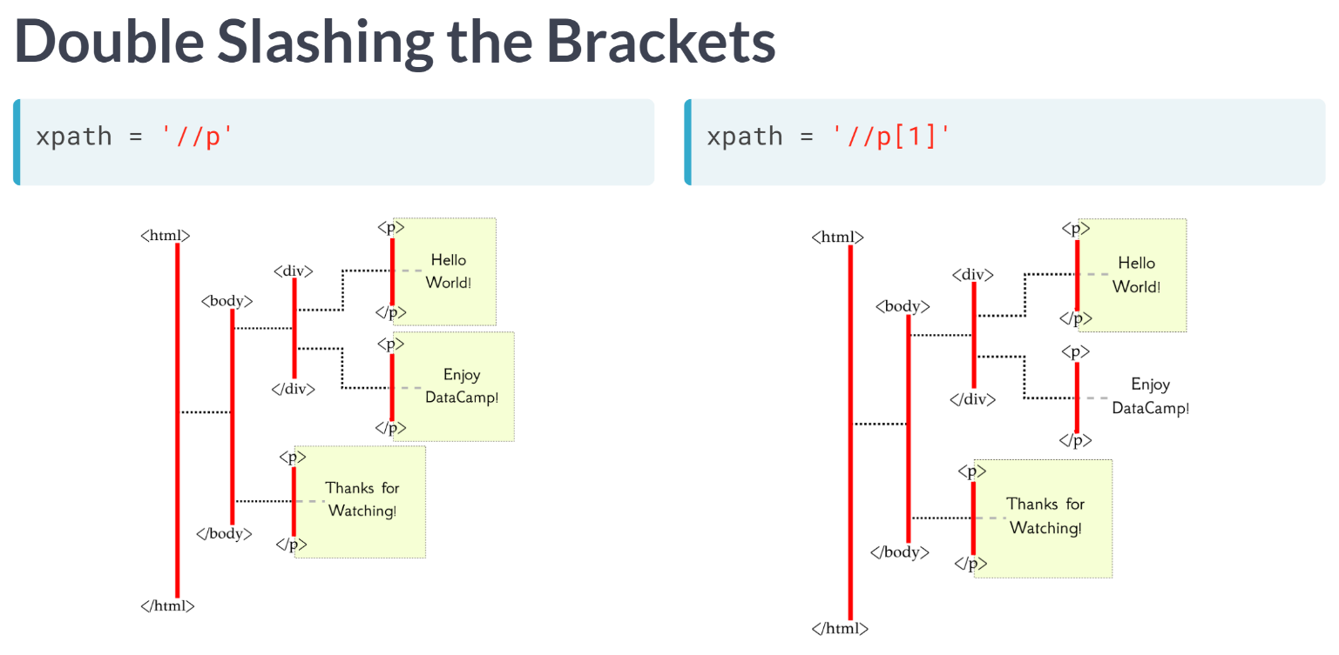  
Let's take this opportunity to be very careful in describing exactly what adding the brackets filled with a number does. When we add the brackets filled with the number N, say, to the end of an X path expression, each of the elements that are selected before adding the brackets ask: "Am I the Nth of my selected siblings?"; if the answer is "Yes", then that element is selected.

Here, with the brackets filled with the number 1, the top paragraph element is selected because it asks, "Am I the first element of my selected siblings?", and an answer is "Yes". The bottom paragraph element is also selected since its sibling is the div element, which was not originally selected, and so when the bottom paragraph element asks "Am I the first element of my selected siblings?", the answer is again "Yes!". Instructor says he doesn't often mix double forward slashes and brackets filled with numbers.

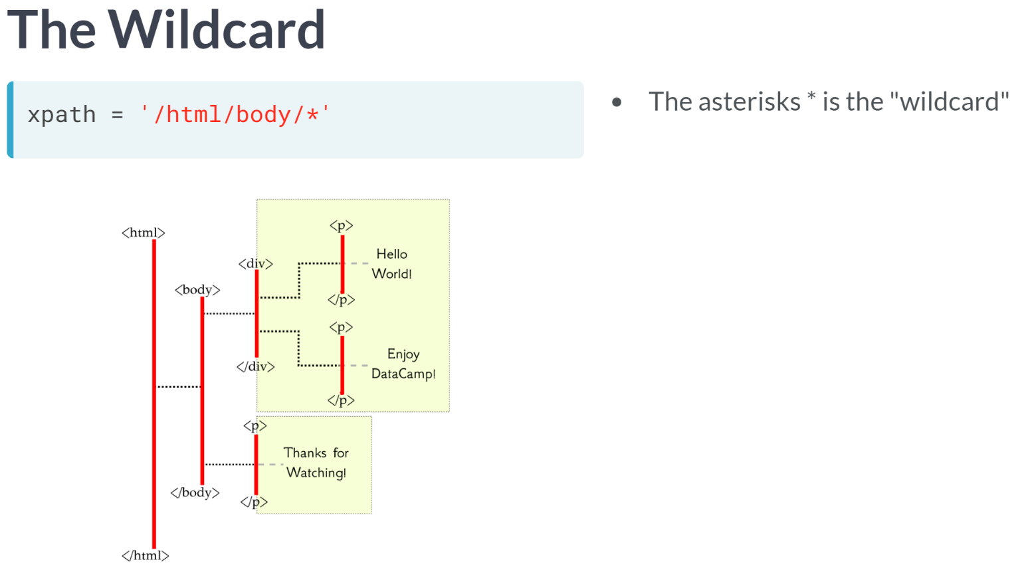  
One final piece of notation we will cover in this lesson is the "wildcard" character, the asterisks. The asterisks indicate we want to ignore tag type. For example, in this expression, we are directed to both children of the body element, regardless that one is a div element and one is a paragraph element.

To summarize, we have learned the basics of XPath notation, including the meaning of single and double forward slashes, as well as some uses for the square brackets; and finally, you saw the asterisks as the "wildcard" character.

# Counting Elements in the Wild

Below, you are given a few options to consider regarding counting the number of elements which are selected. Choose the one which is **incorrect**!

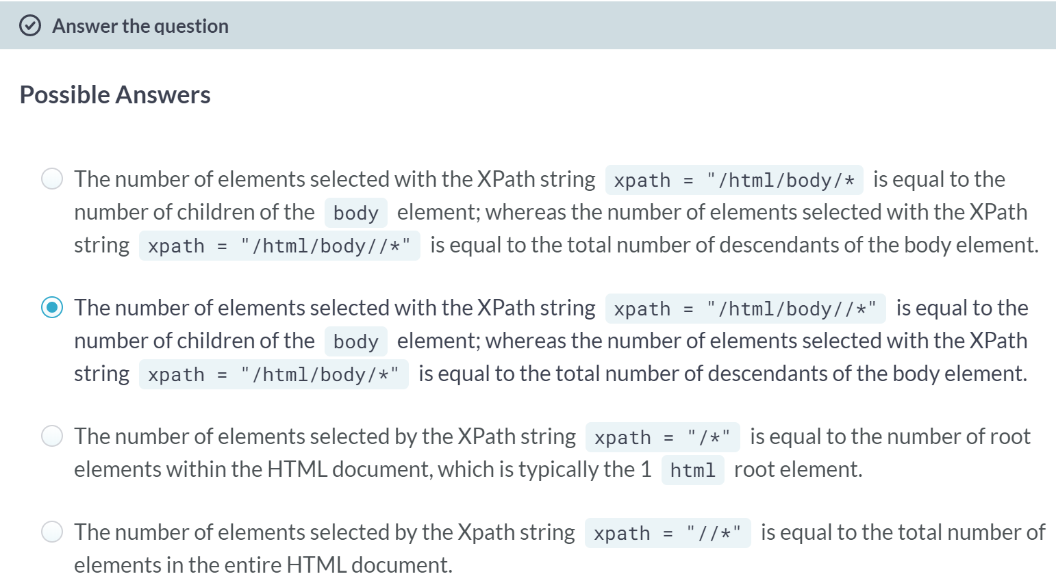  
B: You correctly chose the incorrect statement! Since *"/html/body/*"* selects all elements one generation below the body element without concern of the tag type, it selects all children of the body element. On the other hand, *"/html/body//*"* selects all elements from all future generations of the body element (that is, all descendants of the body) regardless of tag type.

Incorrect Choice Analysis

A: You incorrectly chose the correct statement. Since "/html/body/*" selects all elements one generation below the body element without concern of the tag type, it selects all children of the body element. On the other hand, "/html/body//*" selects all elements from all future generations of the body element (that is, all descendants of the body) regardless of tag type.

C: You incorrectly chose the correct statement. Since "*/*"* selects all elements in the HTML document of the first generation (without concern of tag type), it will select any root element, which is typically the 1 html root element.

D: You incorrectly chose the correct statement. Since *"//*"* starts at the root level and selects all elements of all future generations without regards to tag type, it selects all elements within the HTML document.

# Body Appendages

We have loaded the HTML from a secret website and have used it to create a function how_many_elements(). The way this function works is that you pass it an XPath string and it will print out the number of elements the XPath you wrote has selected. For example, by running the code how_many_elements('//*') in the console will print out the total number of elements the HTML document has (try it!).

Your job in this exercise is to create an XPath string which can be used to direct to all child elements the body (regardless of tag type). To note, you can first test your solution with how_many_elements() to find the total number of children in the body element if you wish.

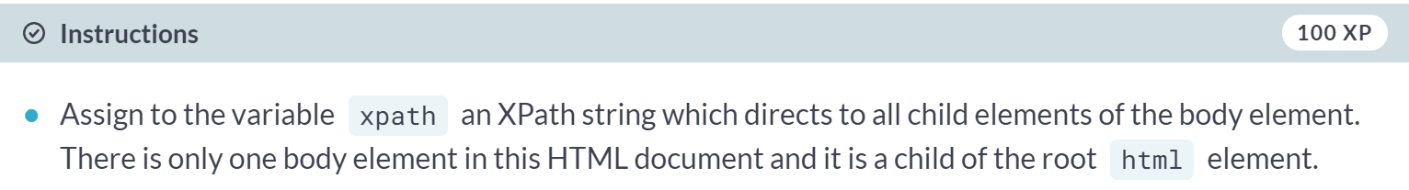

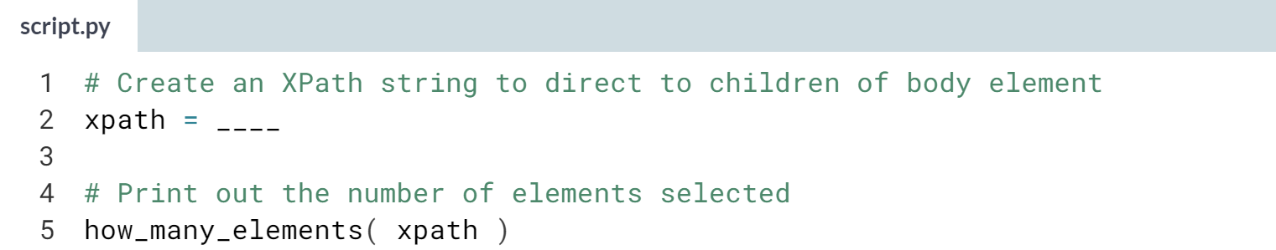

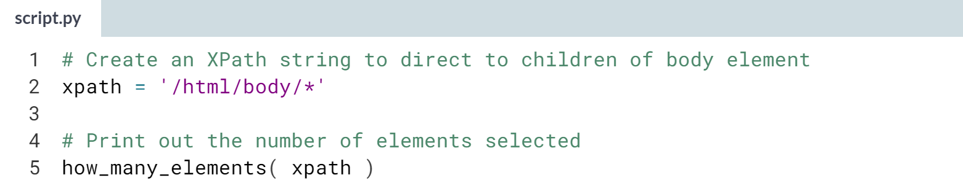

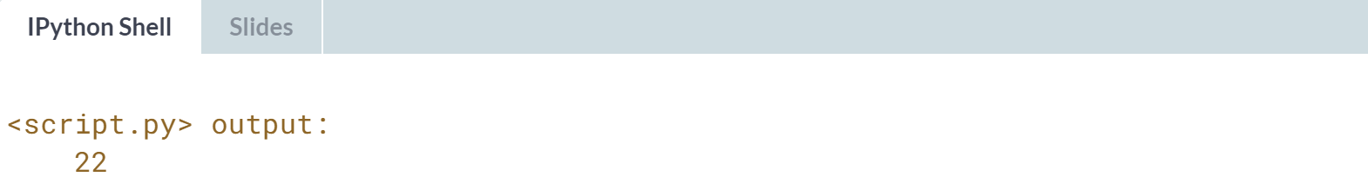

You were able to direct to all children of the body element! You must be becoming comfortable with the wildcard character!

# Choose DataCamp!

In this exercise, we want to give you the opportunity to create your own XPath string to achieve a certain task; the task is to select the paragraph element containing the text "Choose DataCamp!".

Consider the following HTML:

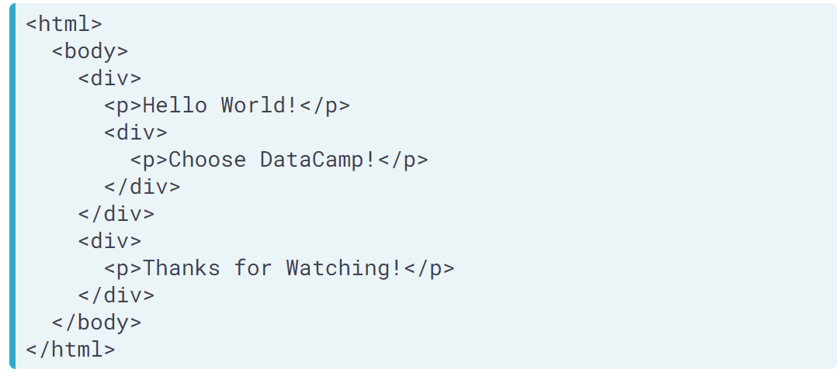

We have created the function print_element_text() for you, which will print the text contained in your element (if it contains any). Feel free to use this function to check if your solution is correct!

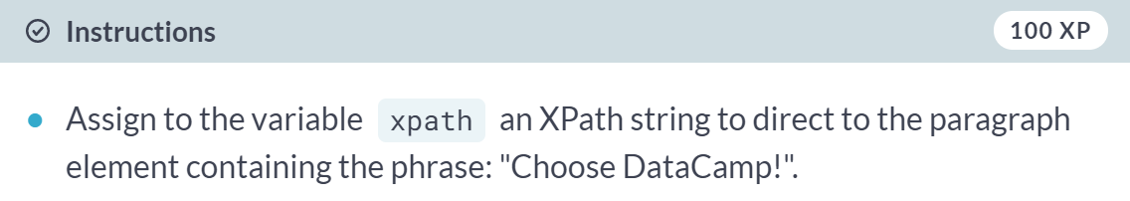  
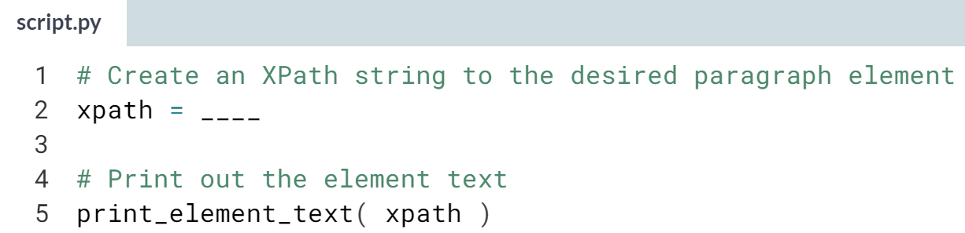  
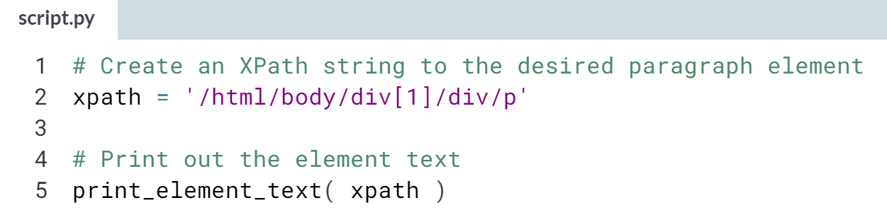  
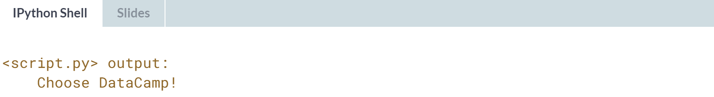  
You did it! You were able to create an XPath string to direct to the correct paragraph element.

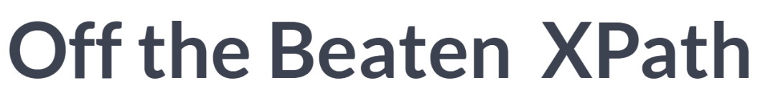

In this lesson, we are going to continue build on our XPath syntax, learning to navigate to elements based on their attributes as well as direct to the attribute information within elements. It might seem that we are getting unnecessarily technical here, but we are so close to getting to the point to start using what we've learned to scrape real websites.

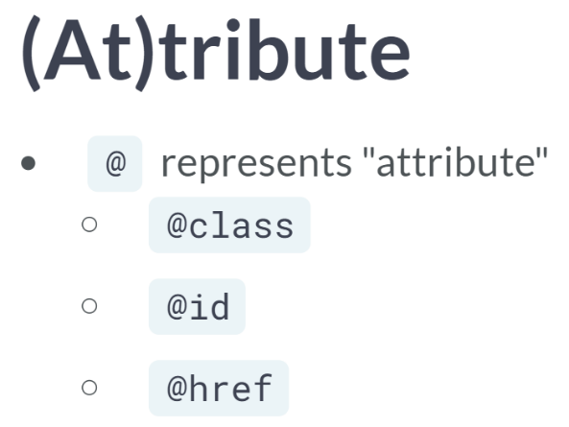  
In XPath notation, the @ symbol is used to distinguish attributes. If we see @class, @id, or @href, it is referring to a class attribute, id attribute, or href attribute, respectively.

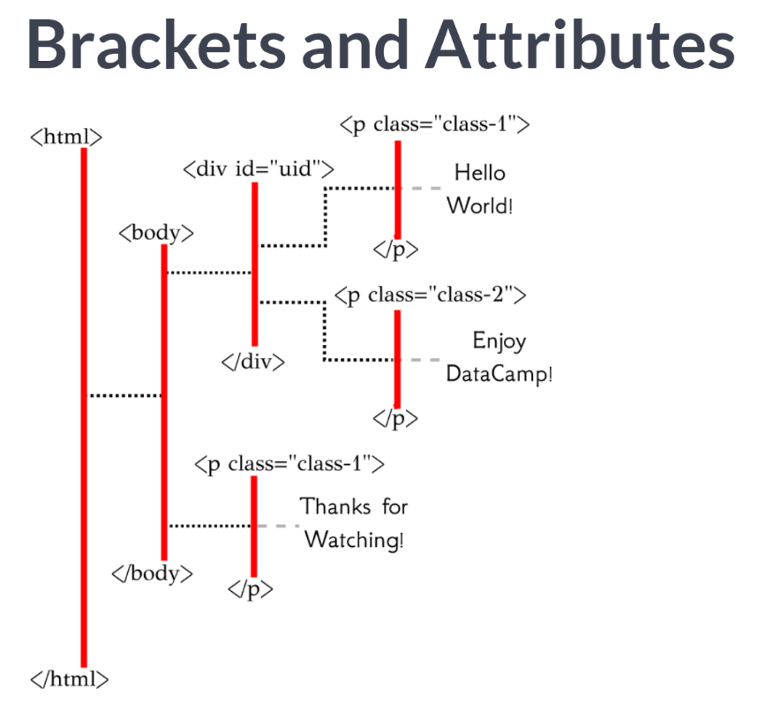  
We saw that square brackets can be used in XPath syntax to hone in on a specific or elements based on their order within a given generation.

We can also include other information within square brackets to select specific elements.

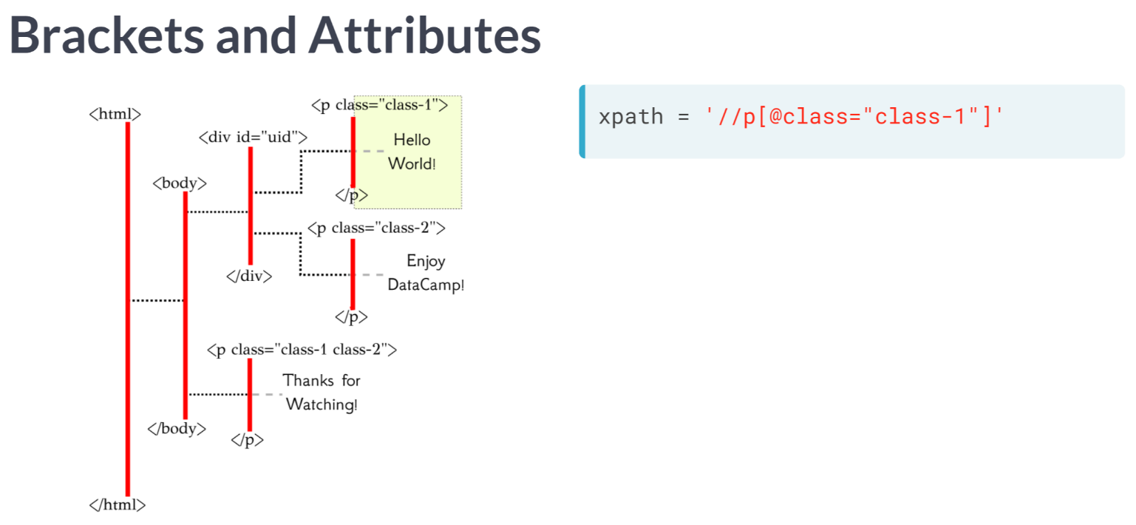

For example, the XPath string here will direct to all paragraph elements from //p, and then reduce down to all those whose class attribute is equal to "class-1".

Note that we have the class attribute in quotations. Now, my convention is to use single quotes to define the XPath string and double quotes as needed within the XPath expression itself.

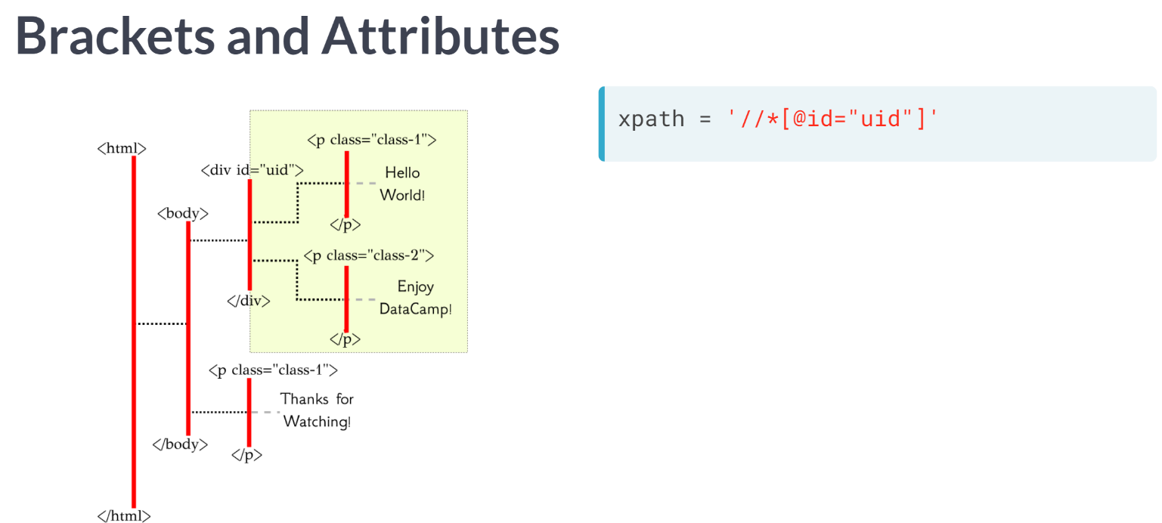  
As another example, we could use the expression here with the wildcard character to first direct to all elements within the HTML document and reduce down to whichever element has "uid" as its id attribute.

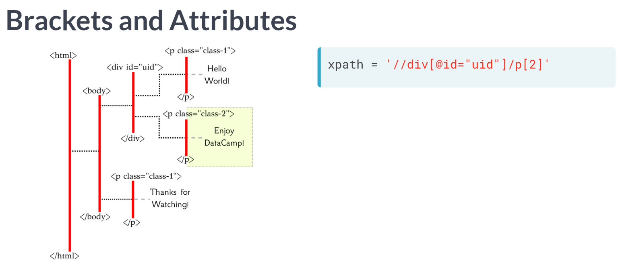  
Or, we could combine what we know to first navigate to the div element with id attribute equal to "uid", and then collect the second paragraph child of that div element.

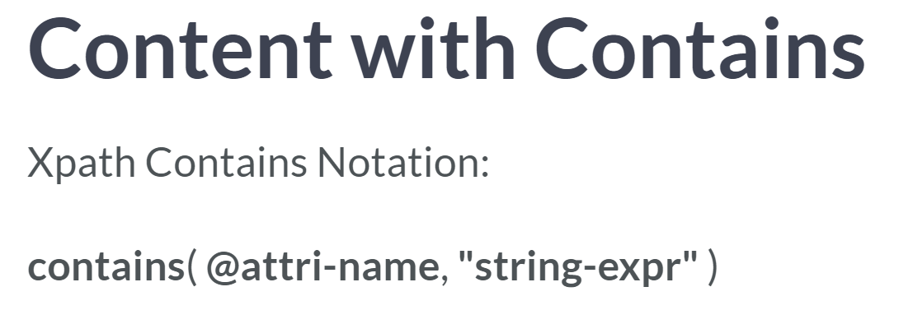  
A useful tool we can include within our square-bracketed expression is the "contains" function. The format of the "contains" function is given abstractly here, with the left argument containing the attribute name (including the @ symbol), and the right argument is the string expression we want to search for within the given attribute.

What it does is searches the attributes of that specific attribute name and matches with those where the string expression is a sub-string of that full attribute.

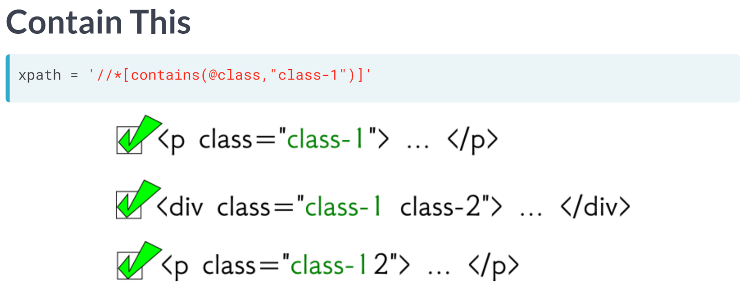  
To make this clear, let's look at an example. The expression here will choose elements in which the string "class-1" is contained as a substring within the full class attribute; this even includes the third paragraph belonging to class-12, because class-1 is a substring of class-12.

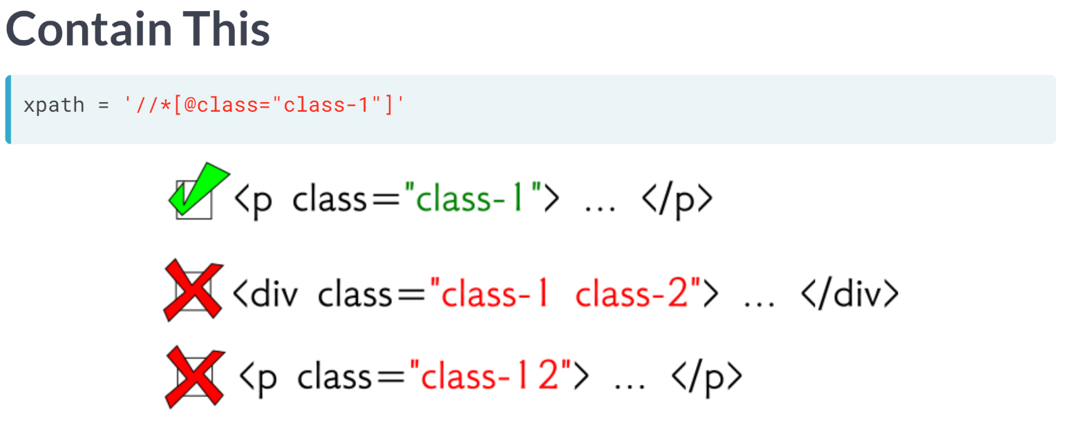  
The last example differs from what we've seen so far since the expression here without the ***contains()*** function only matches elements whose entire class attributes is equal to "class-1"

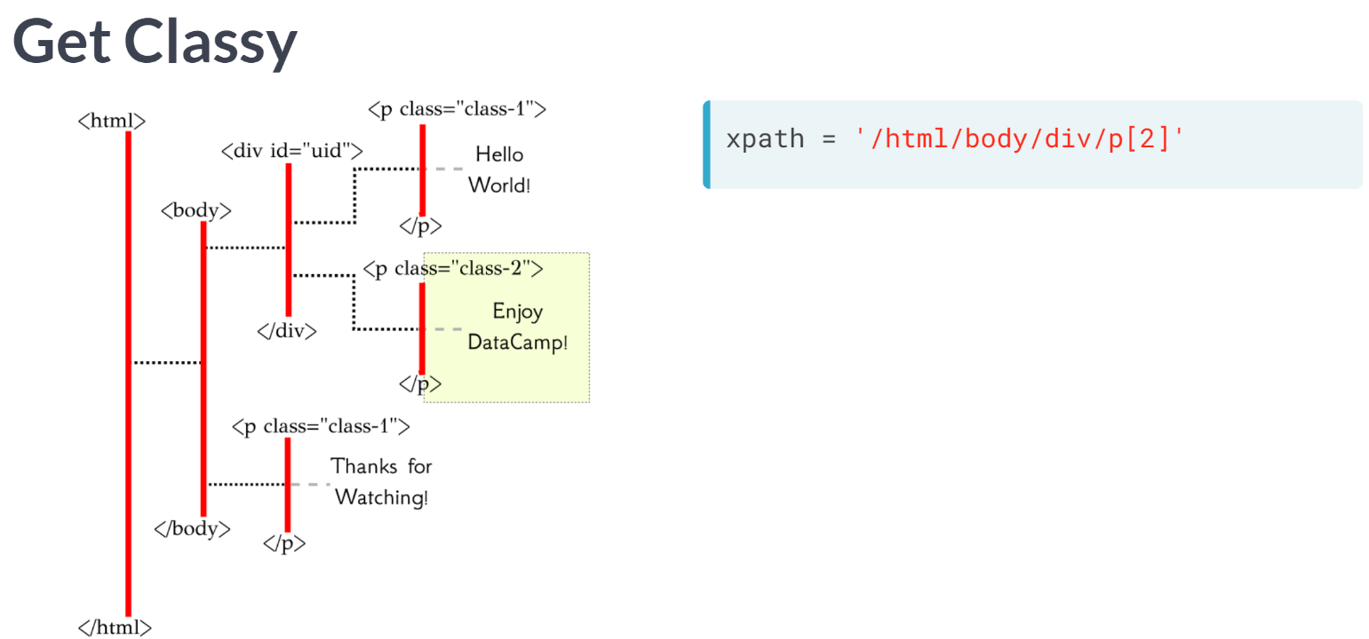  
Now, let's consider how to direct to the attribute information itself. To do so, we first create an XPath expression to the element or elements we want to pull out some attribute information from. Say, we would like to direct to the class attribute of this highlighted paragraph element. We already know how to direct to the highlighted area.

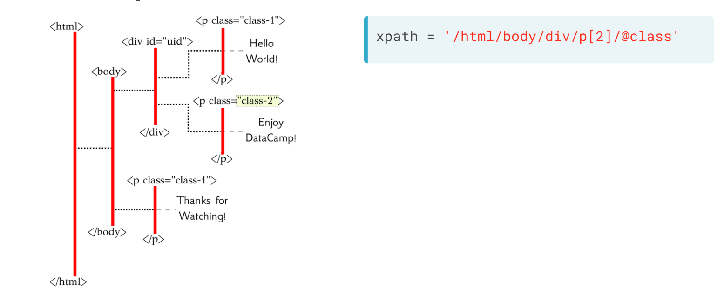  
To direct to the attribute itself, we take the XPath, follow it by a forward slash, and follow that by the @ symbol connected to the attribute name of interest, in this case, class. As a quick note, if we were instead to use a double forward slash before the @ symbol with the attribute name, we would not only direct to the attribute of the elements selected in the XPath, but also all of those attributes in their future generations, too.

# Where it's @

In this exercise, you'll begin to write an XPath string using attributes to achieve a certain task; that task is to select the paragraph element containing the text "Thanks for Watching!". We've already created most of the XPath string for you.

Consider the following HTML:

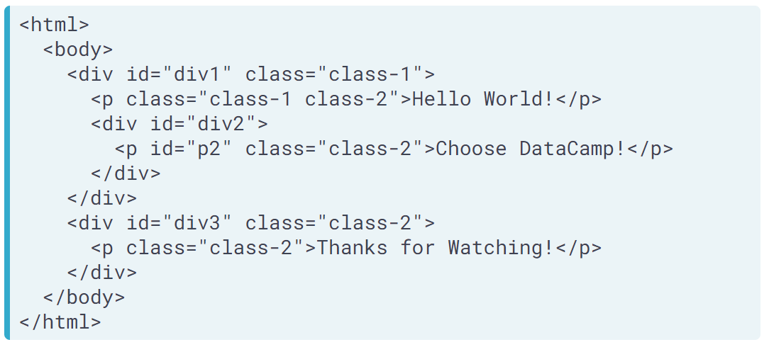

We have created the function print_element_text() for you, which will print any text contained in your element.

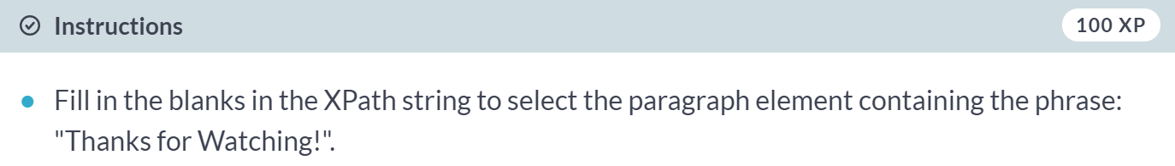

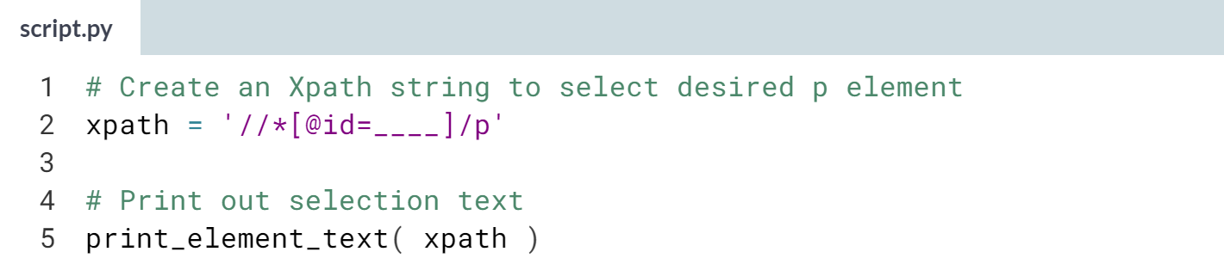  
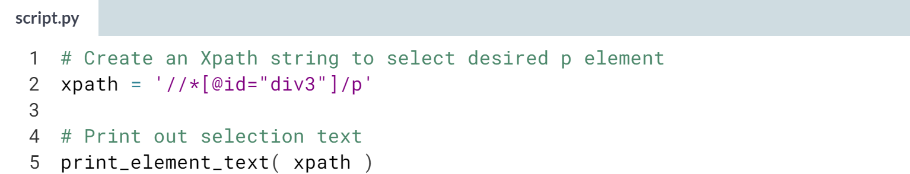  
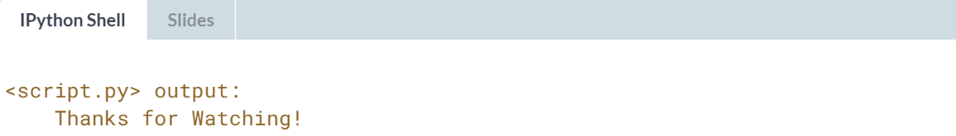  
Awesome! You found the correct element!

# Check your Class

This exercise is to emphasize that when you use an XPath to select an element by its class attribute without using the contains() function, you match the class exactly. Your job is to fill in the blank below and finish the variable xpath directing to the specified element.

Consider the following HTML:

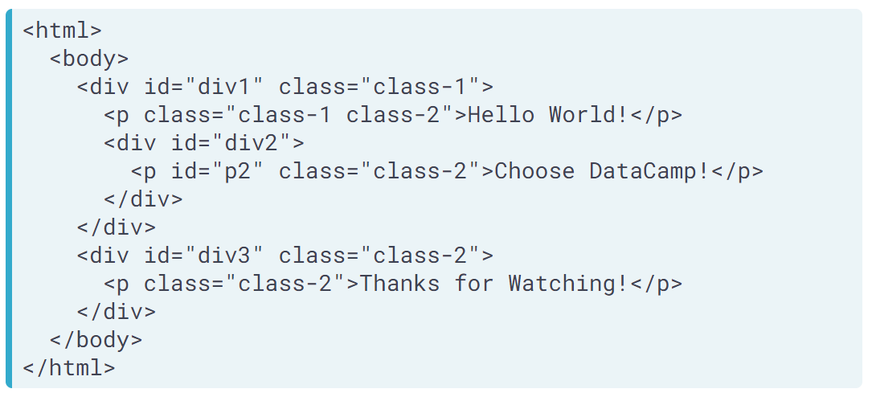

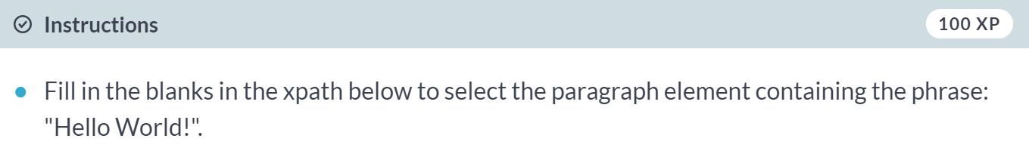   
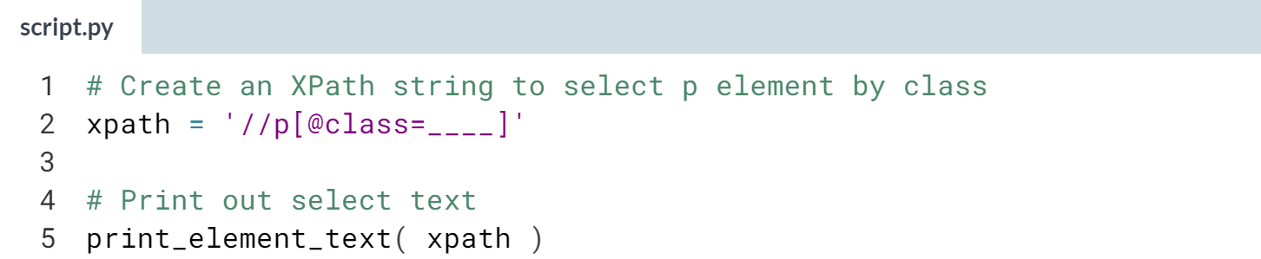  
Hint: Be careful to use the double-quotation marks within the XPath (i.e., it has the form *xpath = '//p[@class="____"]'*. Make sure to match the class attribute value exactly, including any spaces.

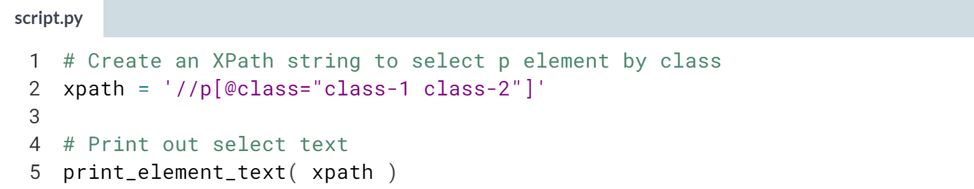  
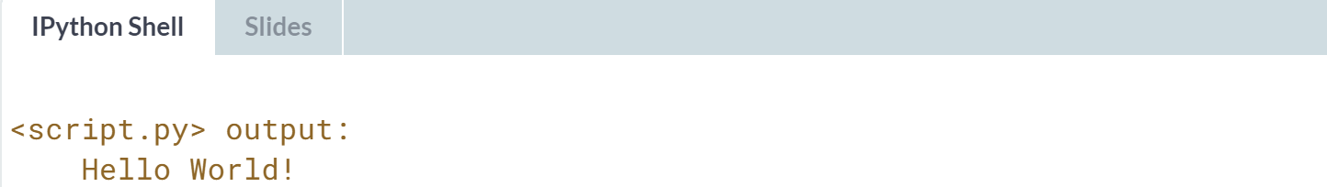  
Great job selecting the correct paragraph element by class! Notice how sensitive it is to use an XPath string to select by class -- you even need to get the spacing correct!

# Hyper(link) Active

One of the most important attributes to extract for "web-crawling" is the hyperlink url (href attribute) within a tag. Here, you will extract such a hyperlink! We have created the function print_attribute to print out the data extracted from your XPath, so you can test your XPath strings in the console, if you like.

The exercise refers to the following HTML source code:

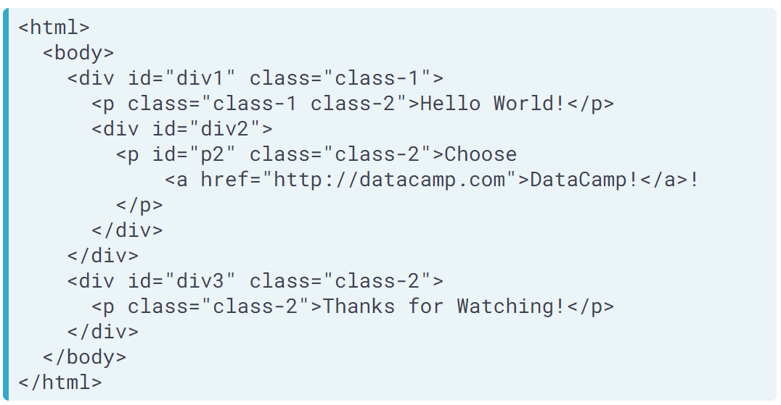

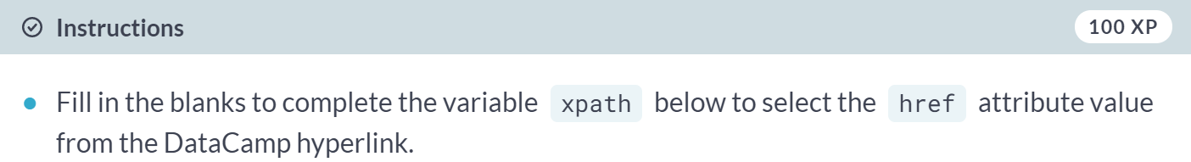  
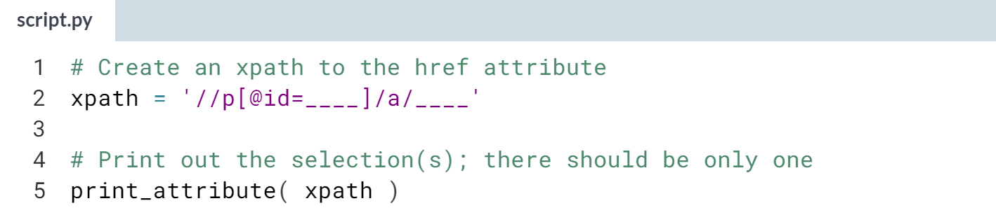  
Remember to use the double-quotation marks within the XPath attribute value and to use the @ symbol to refer to attributes.  
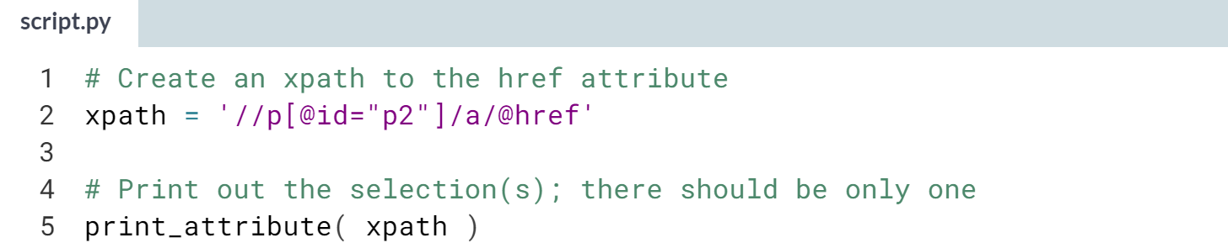  
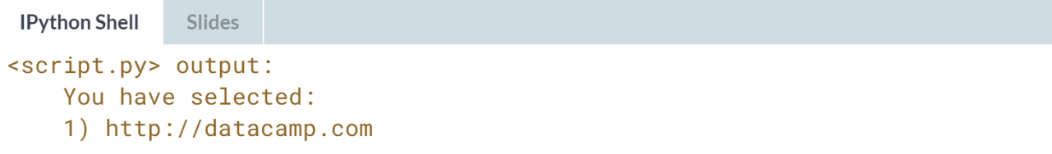  
You did it! You were able to select the correct paragraph element by id, narrow down to the hyperlink child, and finally direct to the href attribute!

# Secret Links

We have loaded the HTML from a secret website and have used it to create the functions how_many_elements() and preview(). The function how_many_elements() allows you to pass in an XPath string and it will print out the number of elements the XPath you wrote has selected. The function preview() allows you to pass in an XPath string and it will print out the first few elements you've selected.

Your job in this exercise is to create an XPath which directs to all href attribute values of the hyperlink a elements whose class attributes contain the string "course-block". If you do it correctly, you should find that you have selected 40 elements with your XPath string and that it previews links (with some repetition).

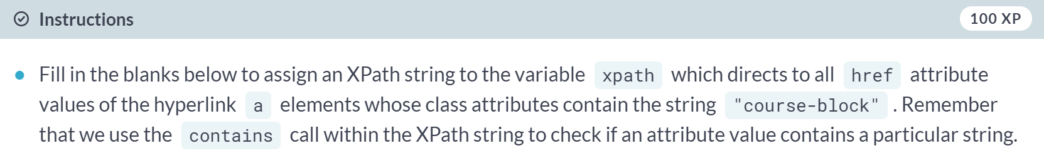

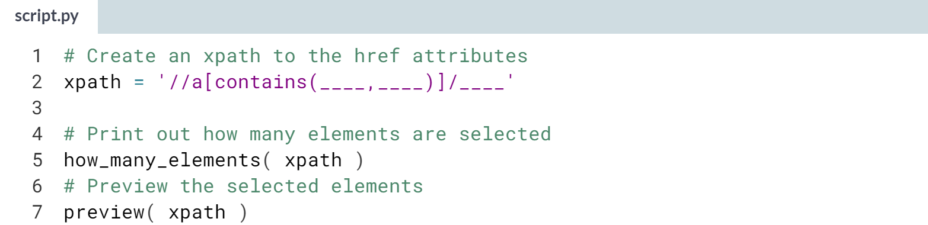

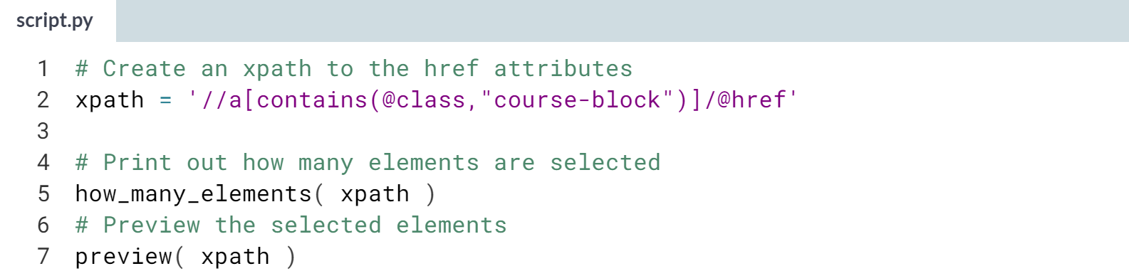  
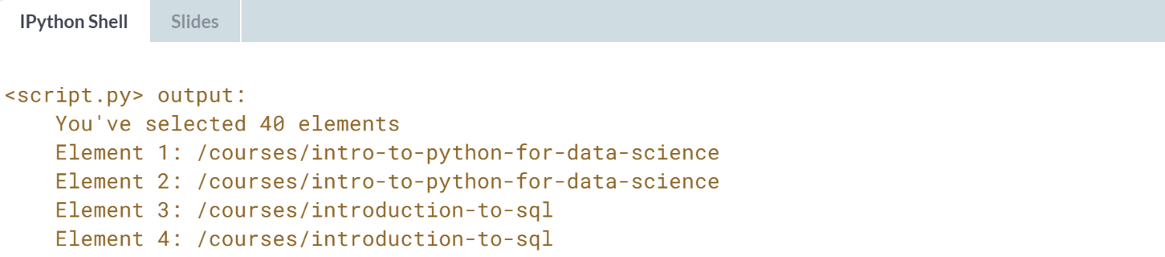  
Congratulations! You have selected all 40 href attributes.



In this lesson, we will begin to familiarize ourselves with scrapy's Selector object, so named because it is he scrapy object used to select portions of the HTML using XPath (or a so-called CSS locator - something we will learn about later).

Once we master this step, we will have already learned how to use the main parsing tool scrapy offers, letting us actually read in an HTML document and access the inner elements we want.

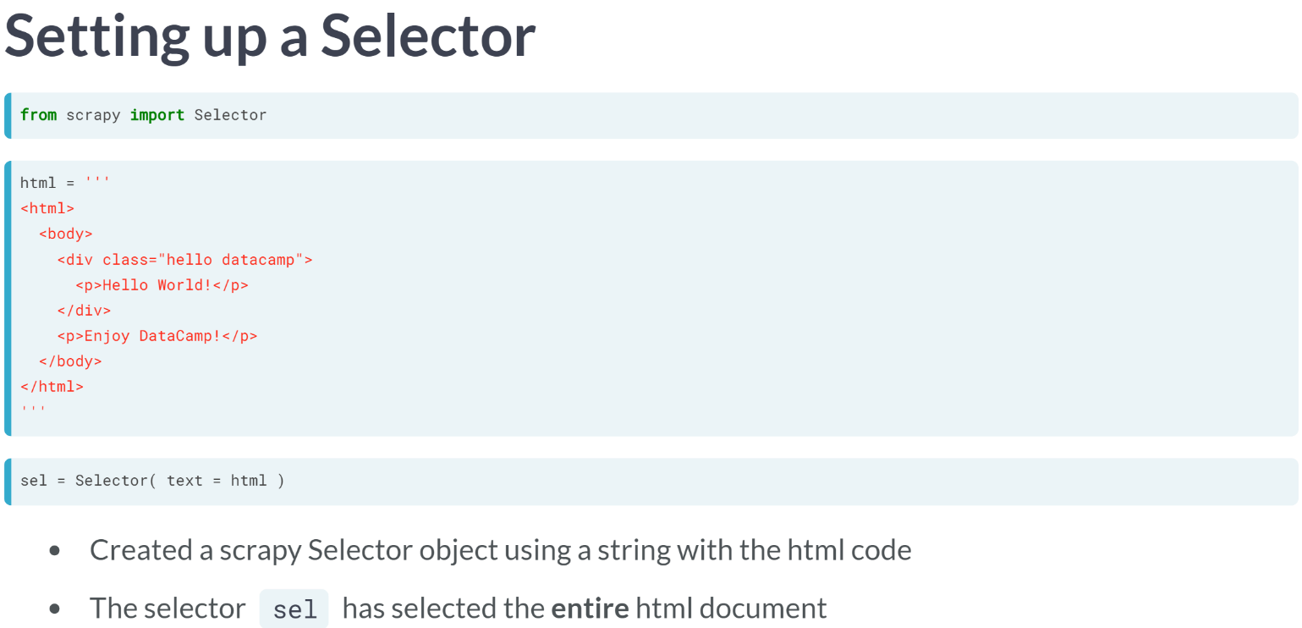

Through this lesson, we will be using the Selector we set up in the slide as our running example. We will import Selector from scrapy. We have made a string of HTML, which we pass to the Selector as text, creating a selector object *"sel"*, which is the object we will be learning to use.

We can think of the Selector *"sel"* as having "selected" the entire HTML document. Before moving on, let's note that the html has two paragraph elements, the first saying "Hello World!"; the second saying "Enjoy DataCamp!"

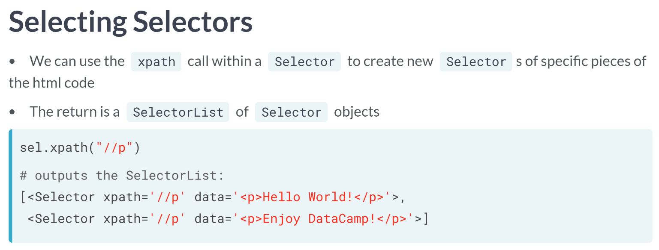  
For example, if we use an XPath to select all paragraph objects from our running example, we will have a SelectorList of two Selector objects, one for each of the paragraphs.

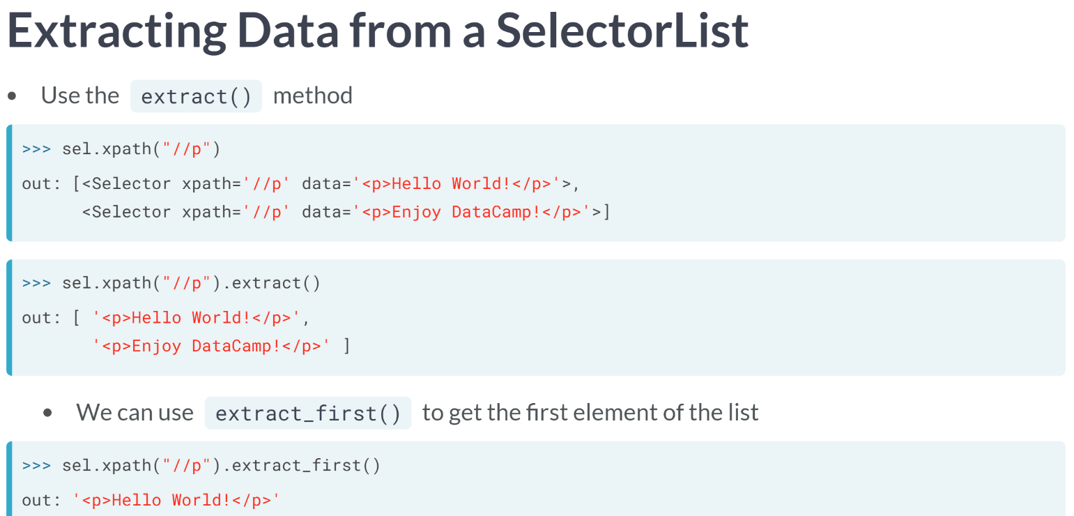  
Selectors and SelectorLists are nice, but at the end of the day, we really want to access the data inside the Selector or SelectorList. We can do this easily by using the ***extract()*** method.

For a SelectorList, by calling the extract method, we are left with a list of strings, where each of the strings is the data from the Selectors, which were originally in the SelectorList.

If we only want the data as a string from the first element of a SelectorList, we can also call the quick ***extract_first()*** method.

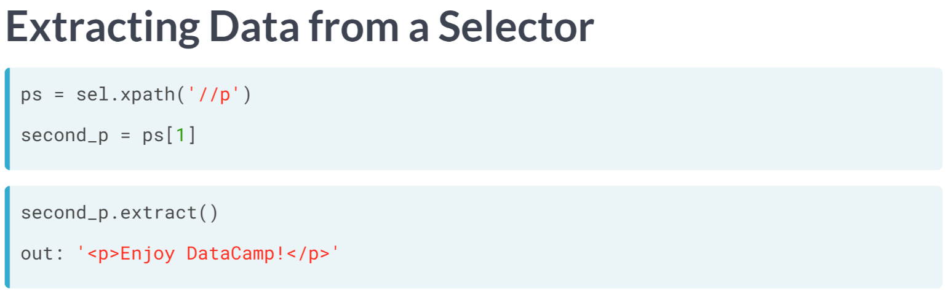  
Although ***extract_first()*** is convenient if you want the first piece of data in a SelectorList, we could grab the data from any other Selector within our SelectorList.  
  
To give an example of this, let's say we create a SelectorList named ps, then the second Selector in the list (remembering that Python indexes lists starting at 0, so we use the index 1 rather than 2).

Then, we apply the ***extract()*** function to this Selector. Note that a Selector only has one piece of data, so extract leaves us with the string of this data (rather than a list of strings as was the case with SelectorLists).

In this lesson, we learned briefly how to set up a scrapy Selector object, but more importantly, spent time learning how to use an XPath to select and extract pieces of the HTML code.

# XPath Chaining

Selector and SelectorList objects allow for chaining when using the xpath method. What this means is that you can apply the xpath method over once you've already applied it. For example, if sel is the name of our Selector, then



is the same as



or is the same as



The only catch is that you need to "glue together" the XPath pieces by using a period at the start of each subsequent XPath string (notice the periods we added to the XPath strings in our examples).

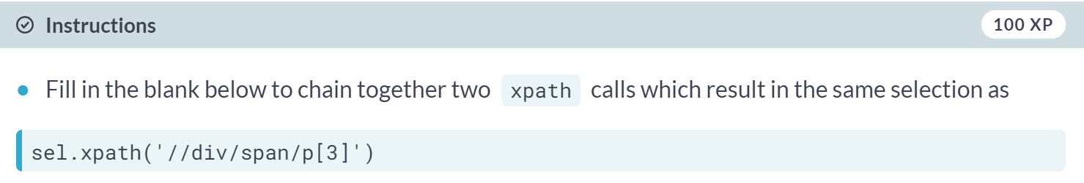  
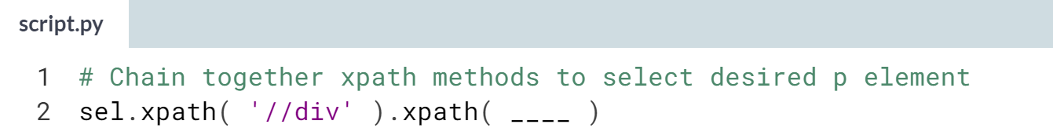  
Don't forget to use a period ***.*** as "glue" when chaining the *xpath* function!

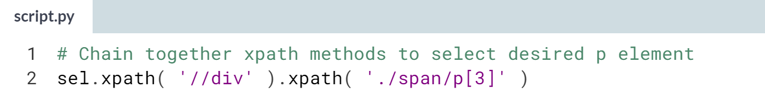

Great! Hopefully you found that it was straight forward to chain together xpath arguments, as long as you use glue!

# Divvy Up This Exercise

We have pre-loaded an HTML into the string variable html. In this two part problem you will use this html variable as the HTML document to set up a Selector object with, and create a SelectorList which selects all div elements; then, you will check your understanding of what happens within the SelectorList.

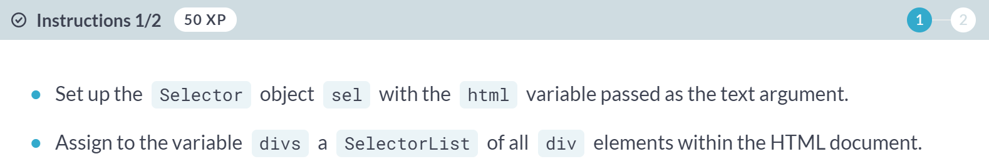

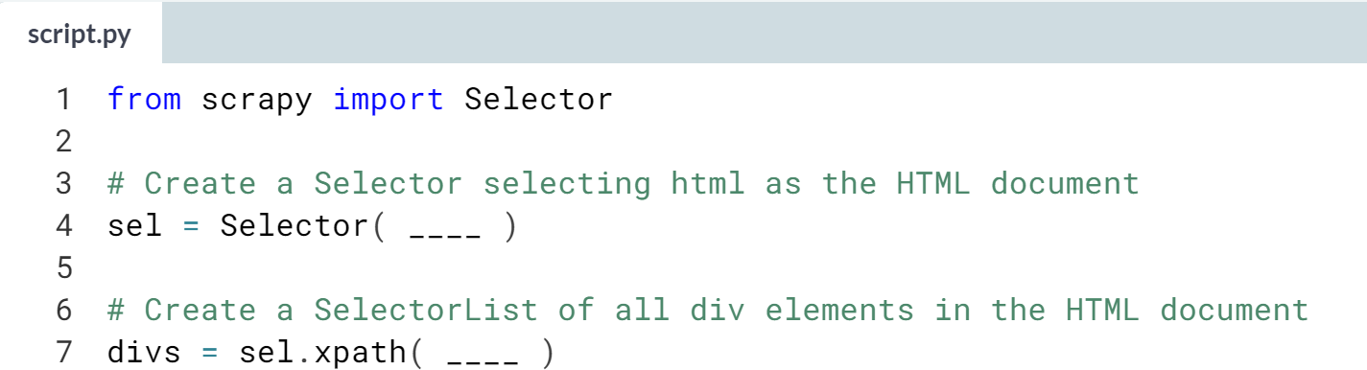

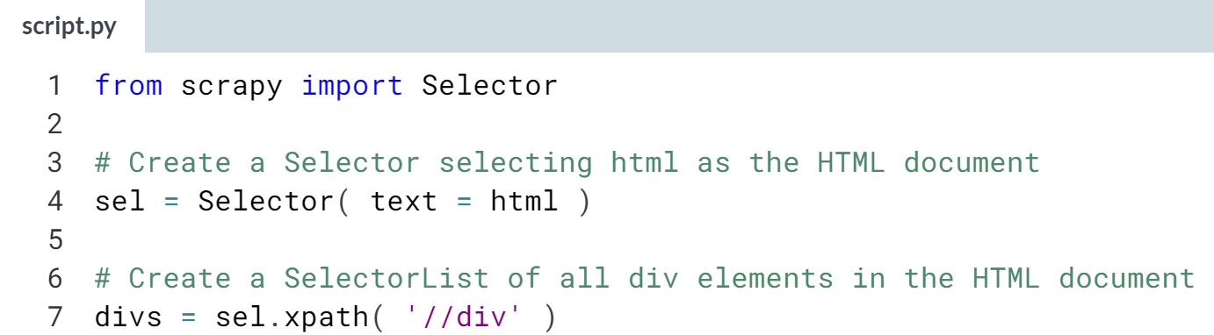

Great job!

(Exercise continues on the next page)

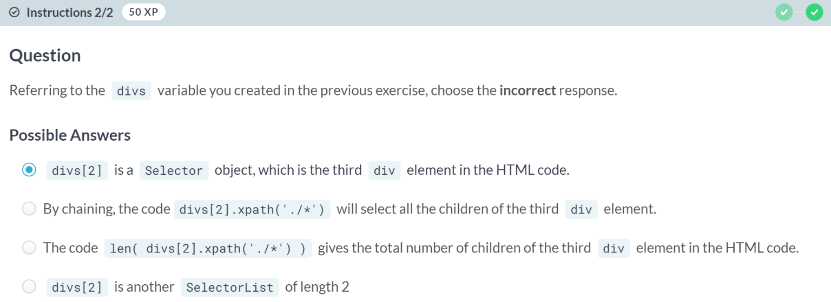  
A: You correctly chose the incorrect answer. The code divs[2] is one element from a SelectorList, and therefore is a Selector (not another SelectorList).

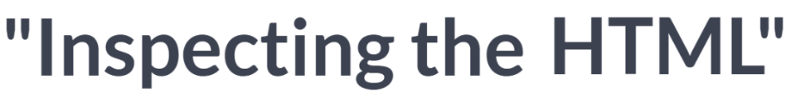

We will spend this lesson looking at how we go about exploring HTML and inputting the HTML as text into a Selector object. For this lesson, we will describe the exploration part using the Firefox browser, but even if that isn't your browser of choice, most major web browsers have similar functionality. So, we should be able to use this lesson and by analogy use another browser, which has similar capability.

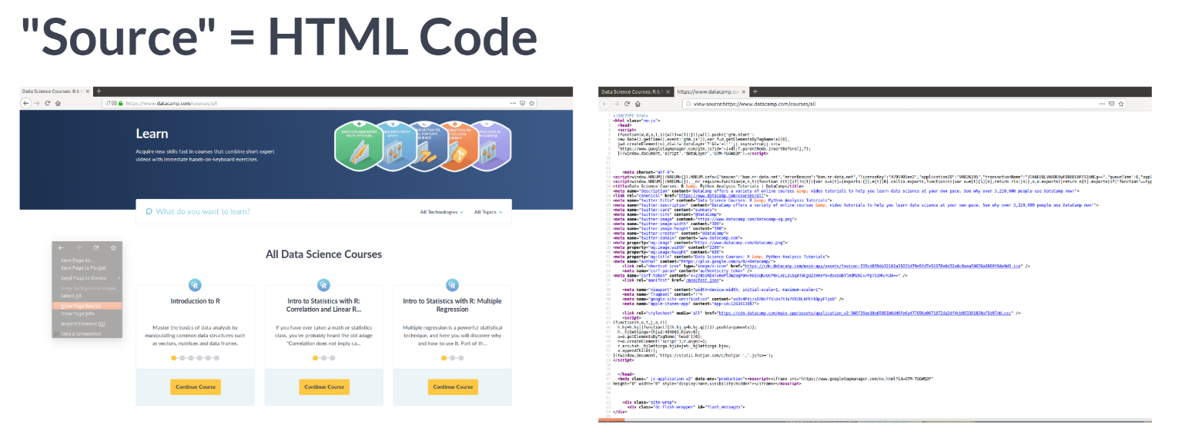  
If I navigate to a website which has content I want to scrape, I can view the HTML source doe of the website in Firefox by either right clicking within the page and selecting "View Page Source"; or another way to get there on my version of Firefox is by going to the Tools menu, selecting Web Developer and selecting "Page Source". This is the first step in "inspecting the HTML", looking at the actual HTML source code.

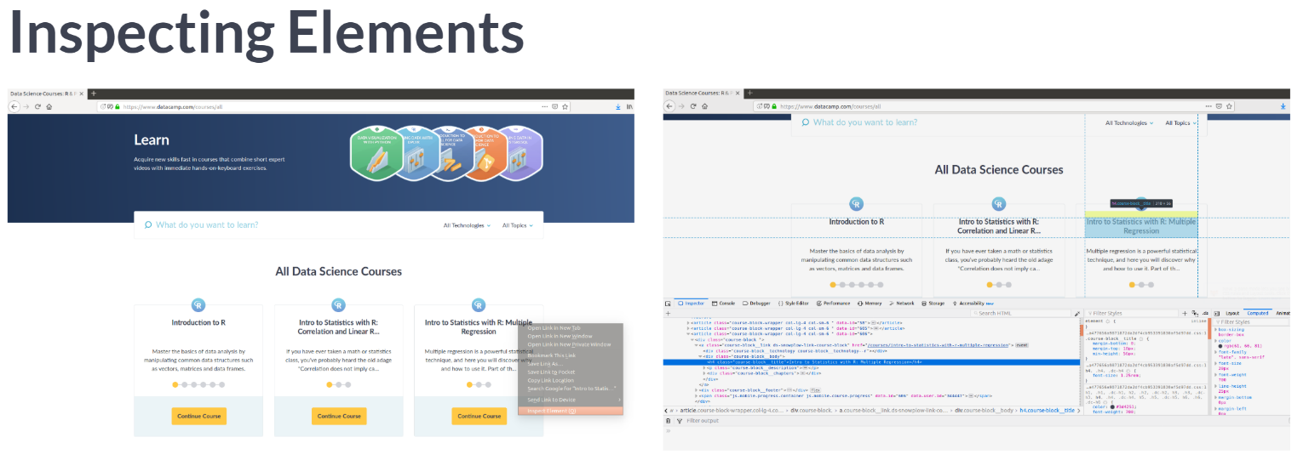  
Another useful tool which Firefox provides (as does Chrome and other browser) is the ability to "inspect an element". What this means is that you can select an element on the website and ask to be directed to the actual HTML code for that specific element. In Firefox, you let your mouse hover over the elements you are interested in, then right-click, and select "Inspect Element".

This opens a second pane in the browser and highlights the HTML for that specific element. This is extremely useful when trying to figure out characteristics of an element which you might want to use in your scraper.

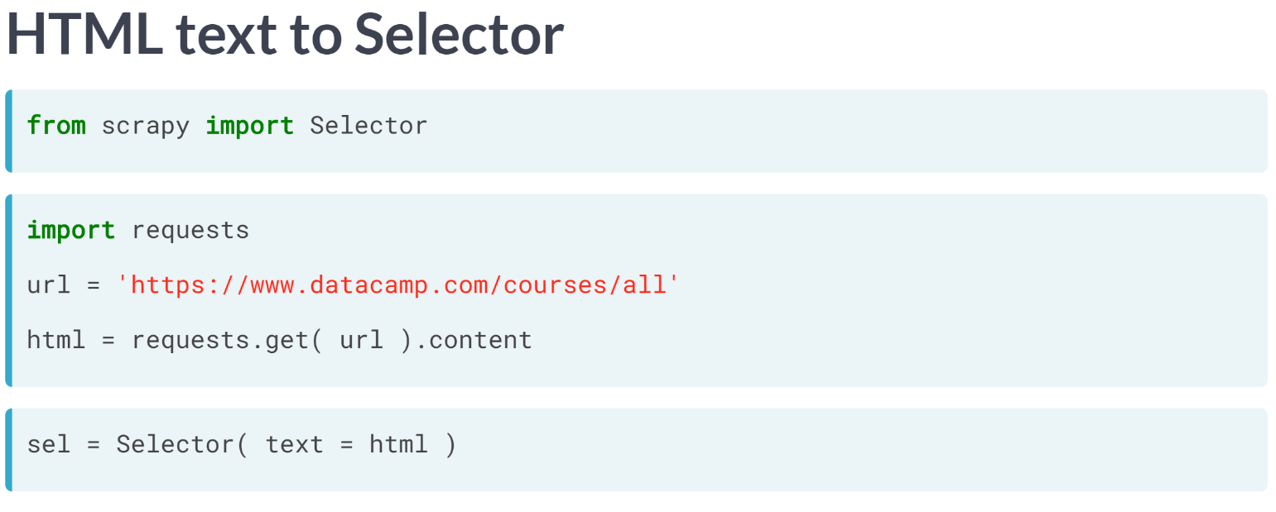  
The final piece of this lesson is to give you a quick understanding of how we get the HTML text into a Selector object. The way we do this is using the Python requests library.

Just a quick side note, we will learn how to do everything within scrapy itself, without using requests.

But this is still a nice piece of information to carry with you. In this example, we will get the HTML from the DataCamp course directory.

The requests library makes it easy to get the HTML as a string by first passing to requests, get the URL as a string of the site you want the HTML from, then looking at the content, as we have done before. You will notice that we assigned the content to the variable html to pass to the Selector.

# Course Class by Inspection

In the lesson, you had a brief glimpse of the following screenshot taken when "inspecting the element" of the DataCamp course title for the course Introduction to R:

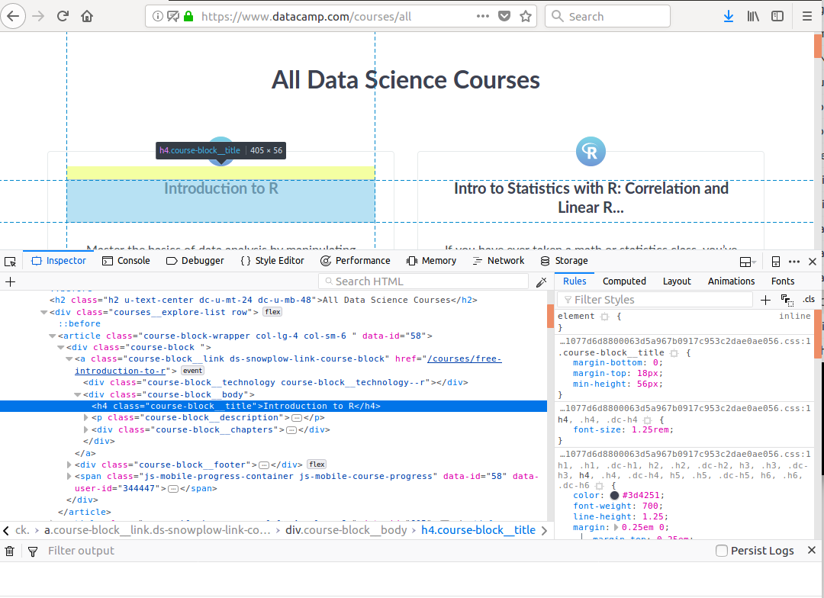  
By looking at the source (HTML) code provided in this image, choose which of the following matches the class attribute for the h4 element containing the text for the title of the selected course.

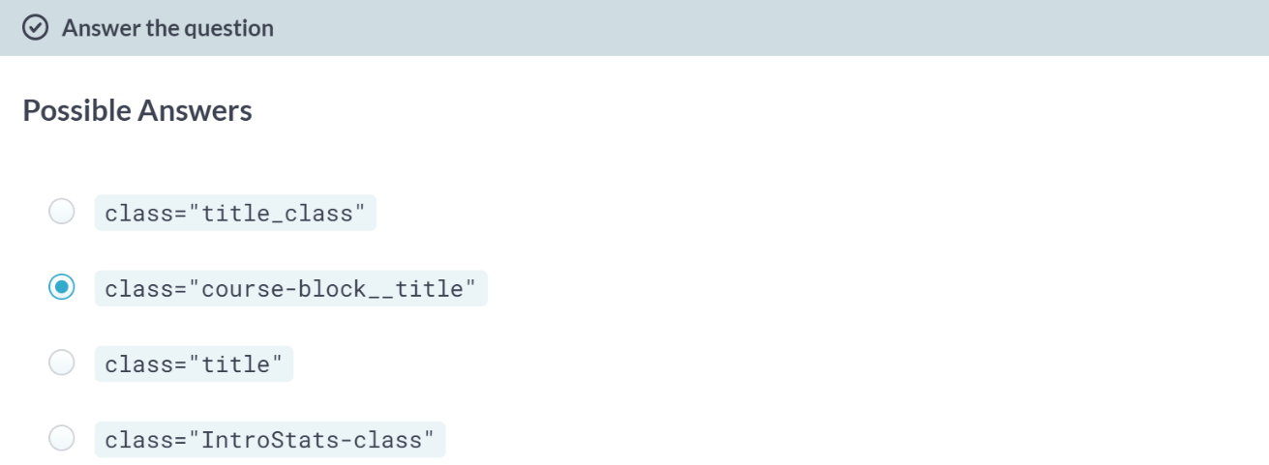  
Good job!

# Requesting a Selector

We have pre-loaded the URL for a particular website in the string variable url and use the requests library to put the content from the website into the string variable html.

Your task is to create a Selector object sel using the HTML source code stored in html.

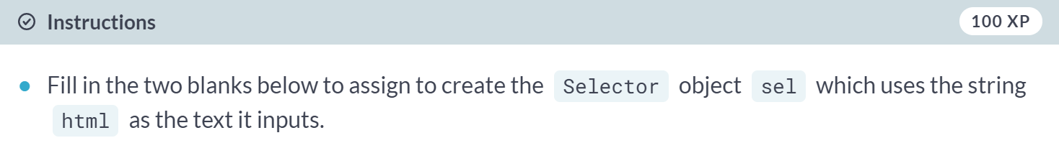  
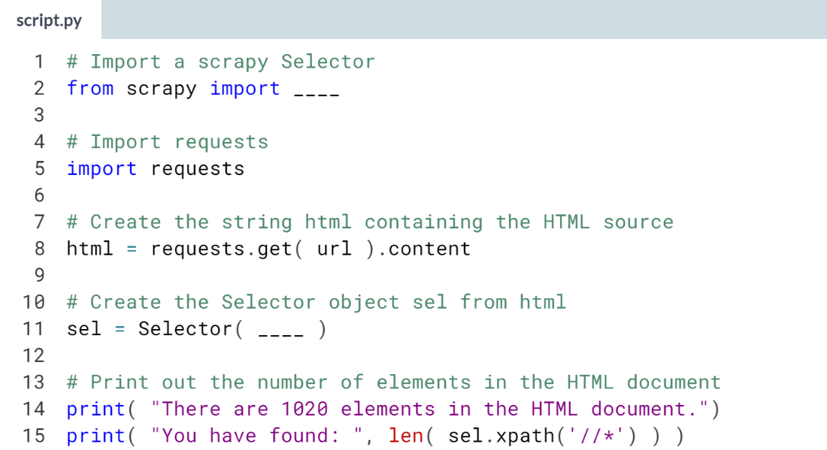  
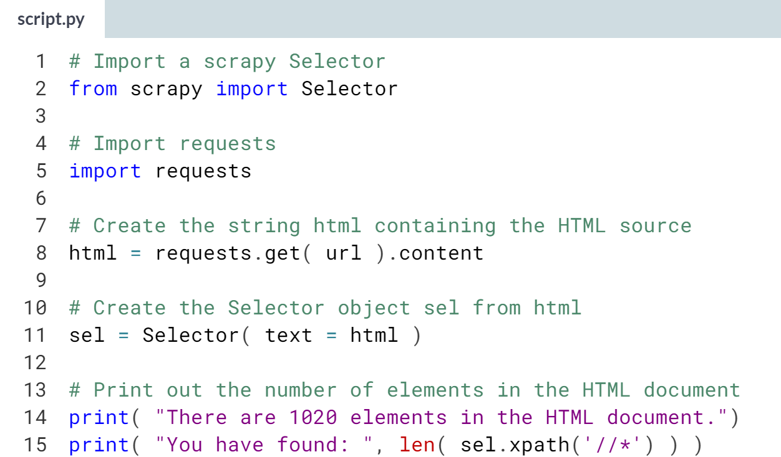  
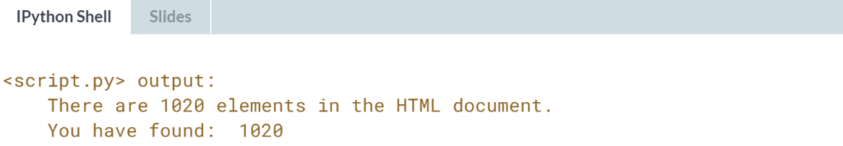

**3. CSS Locators, Chaining, and Responses**

Learn CSS Locator syntax and begin playing with the idea of chaining together CSS Locators with XPath. We also introduce Response objects, which behave like Selectors but give us extra tools to mobilize our scraping efforts across multiple websites.



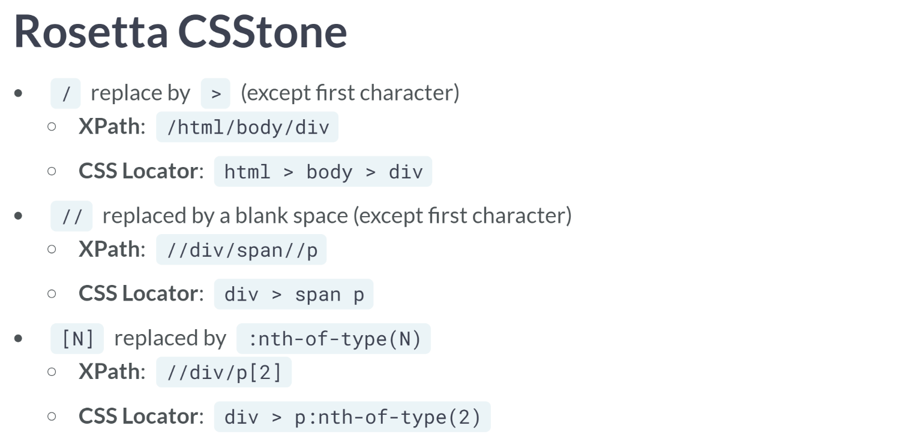  
At this point, we have become familiar using XPath to navigate HTML. In this lesson, we will learn about another commonly used notation for this purpose.

We will learn about CSS Locators. CSS stands for Cascading Style Sheets, which describes how the elements are displayed on the screen.

People are often divided on whether XPath or CSS Locators are the best way to go. The best way is to learn both, having power of utilizing different tools and becoming more capable.

Since we are so familiar with XPath at this point, let's quickly translate between what we know in XPath to what we use in CSS Locator notation.

A single forward-slash in XPath is replaced by a greater-symbol in CSS Locator notation; so, a greater-than symbol moves us forward one generation. There is an exception where if the first character of an XPath is a single forward-slash, we ignore it.

The double forward-slash in XPath is replaced by a blank space; so, a blank space looks forward all generations. And again, we ignore a double forward-slash if it is the first part of the XPath string.

Given an XPath with square brackets filled with a number, we replace it with the colon-nth-of-type call with that number as its argument.

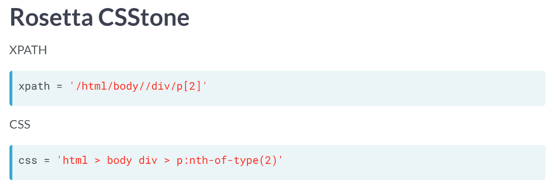  
As an example, suppose we have the XPath string given on top. The corresponding CSS Locator string is then given below.

Notice that the single forward-slash between html and body as well as between div and p are replaced with greater-than symbols, but that the very first forward slash is ignored.

We see that the double forward-slash between body and div is replaced by a blank space; and that the square bracket 2 is replaced by :nth-of-type(2).

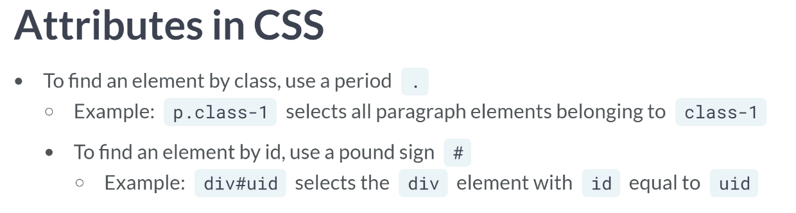  
One good reason to learn CSS Locator is that we can select elements by class or id attributes that uses a very simple notation.

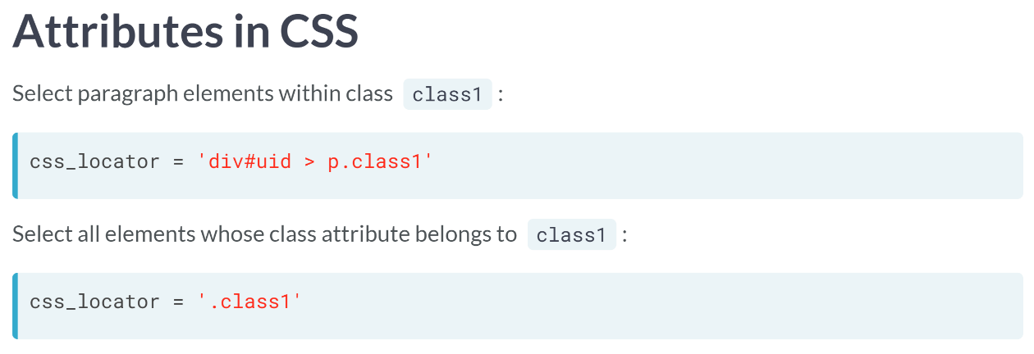  
To illustrate how this works, we could create a CSS Locator string, which first navigates to the div element whose id is "uid" (using pound sign), then down one generation (using the greater sign), and finally to whichever paragraph element within that generation has a class attribute which belongs to a class1 (using a period followed by the class name of interest).

Alternatively, we could write a CSS Locator string, which directs to all elements in the HTML document whose class attribute belongs to class1 by simply writing.

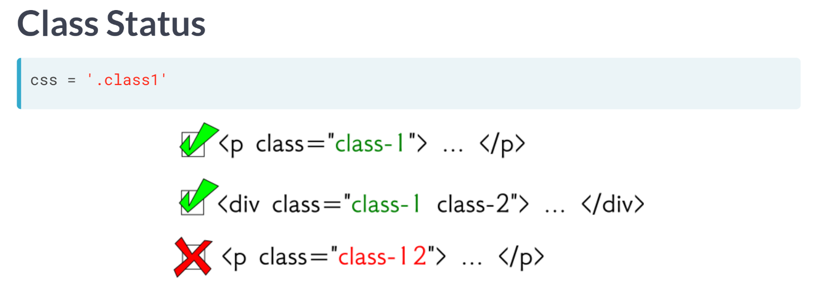  
Note that selecting a class like this in a CSS Locator direct us to all elements belonging to that class, even if they belong to other classes.

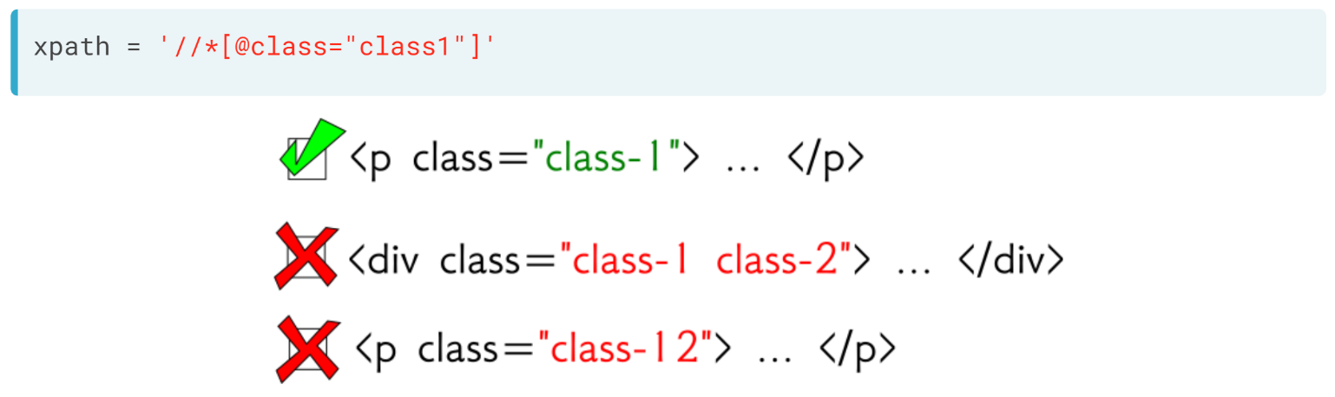  
Recall that this is different than the XPath that we've learned where either using equality in the brackets forces an exact match of the class attribute.

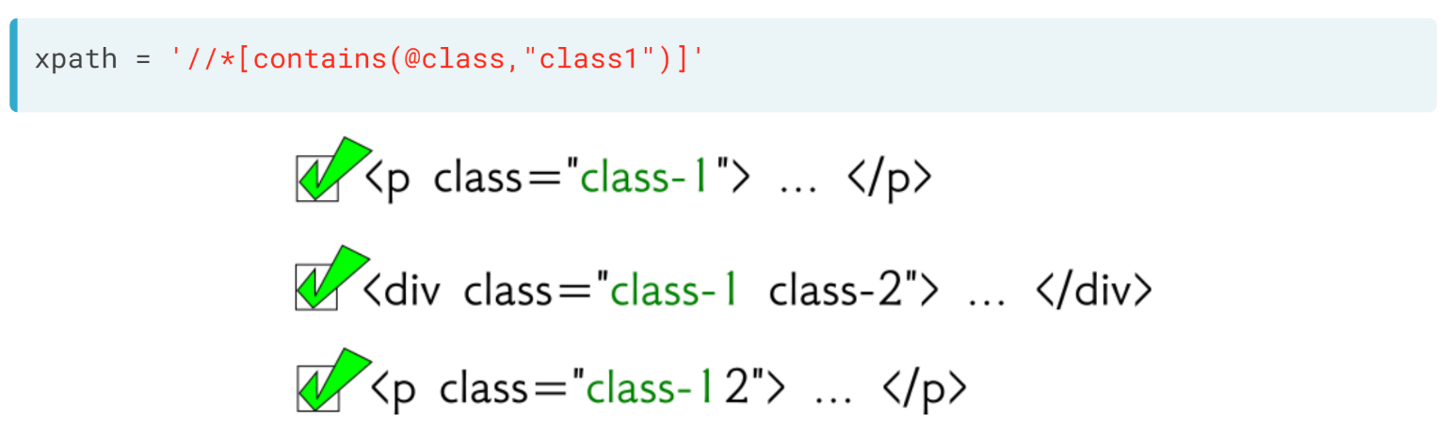  
Or using the ***contains()*** function, which searches for all matching substrings.

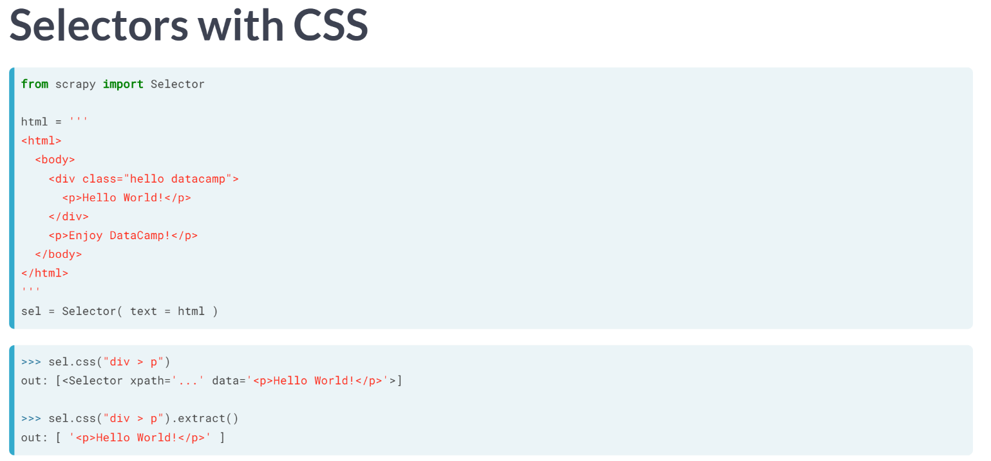  
In the last chapter, we learned how to use XPath within scrapy Selectors to select specific HTML elements and from there extract the data.

Well, we can do the same with CSS Locator by simply using the method CSS method rather than the XPath method within the selector.



We will learn how to use CSS Locators to select attributes and how to use both CSS Locator and XPath notation to select the displayed text on the website.

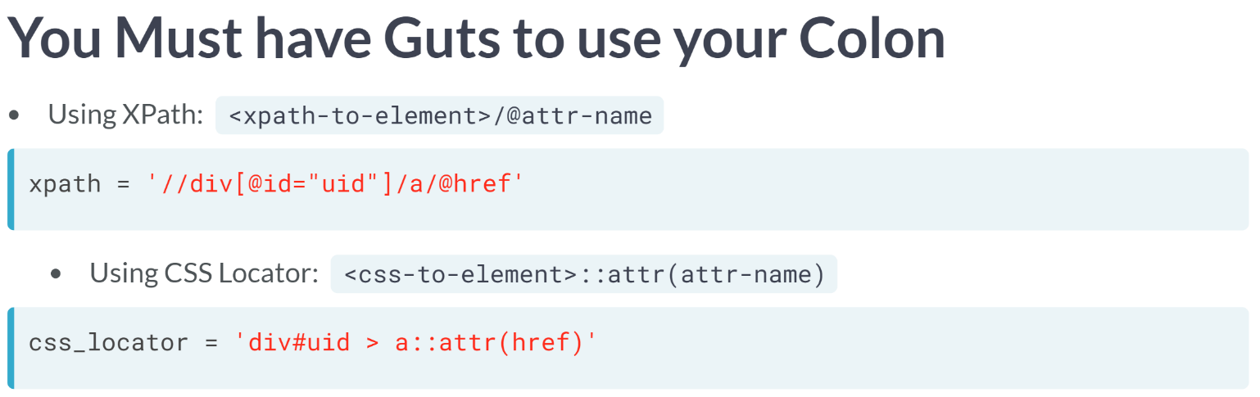  
Recall that to select an attribute in XPath, we use the @ symbol, so that the general form of the XPath would be to first select the element whose attribute we want to get to, followed by a forward-slash, followed by the @ symbol connected to the attribute type name we want to select.

For example, if we first select the div element with id equal to uid, and from there select the href attributes from all the hyperlink children, this XPath string would do the trick.

For a CSS Locator, we again direct to the element whose attribute we want to get to and follow this by a double-colon connected to the attr attribute function.

Then, the argument within the attr function is the attribute name. So, to select the name href attributes as we did in the XPath string above, we would write the following.

Remember that the pound sign tells us to select the div element by its id attribute, the greater than symbol move down one generation, and here we see our newly introduced double colon attr piece, this is to select the desired attribute (in this case href).

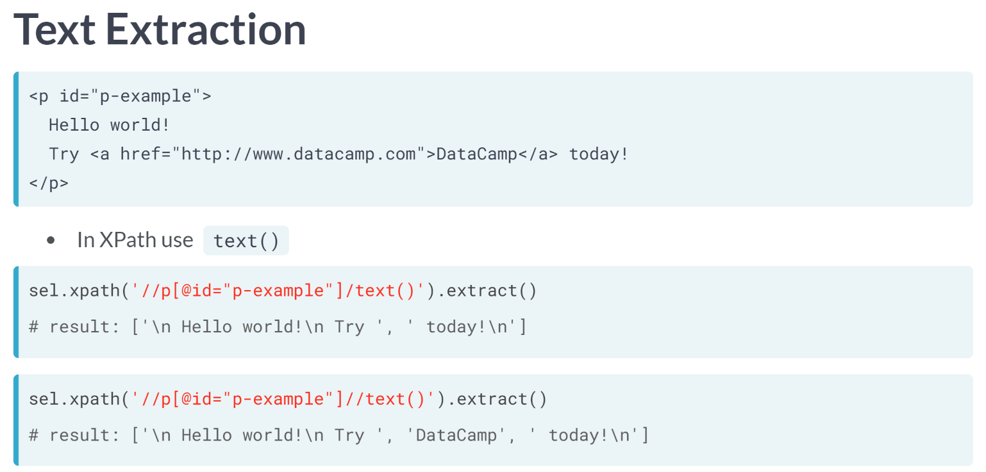  
We are going to switch gears a bit to hit on an extraction point we've neglected so far.

Suppose that we have navigated to a paragraph element with id "p-example", and we want to direct to the text within that paragraph element.

To do this, we can use the ***text()*** method within XPath. Here, we've gone ahead and put the XPath into a scrapy Selector to look at the output.

By using the single forward slash before the text method, we will direct to all chunks of text that are within that element, but not within future generations.

On the other hand, if we use a double forward slash, then we will point to all chunks of text that are within that element and within its descendants; in this case, we pick up the "DataCamp" text, since it belongs to the next generation hyperlink element.

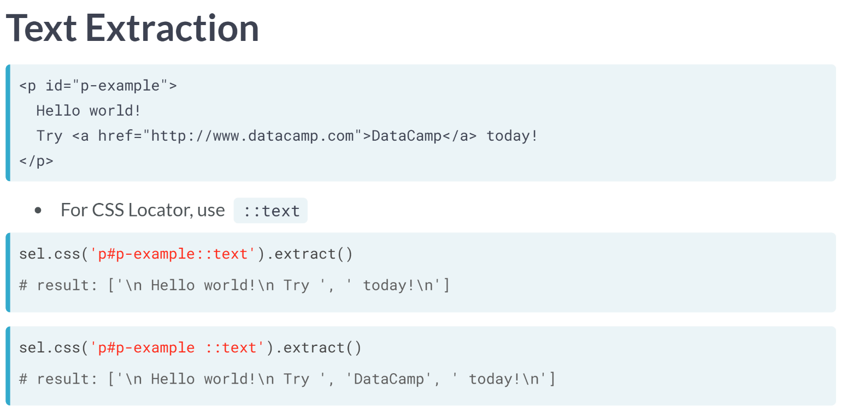  
Similar to attribute selection, to navigate to this text in CSS Locator notation, we again follow the element selection by the double-colon. But this time, we follow the double colon only by the word text.

As we did with XPath, we can indicate whether we want only the text in the current element (but not from future generation), or if we want to also include the text within future generations.

To grab only the text within the element, but not future generations, we use the double colon without preceding it by a space.

On the other hand, if we also want to include the text within future generations, we simply add a space before the double colon. As a note: In both XPath and CSS Locator notation, the extracted text is broken up by elements.

So, in this example, since there is a hyperlink child, the text is broken into the chunk before the hyperlink child, the text of the hyperlink child, and the text following the hyperlink child.

# The (X)Path to CSS Locators

Many people prefer using CSS Locator notation to XPath notation. As we will see later, it often makes attribute selection very easy. To help get you more comfortable going back and forth between XPath and CSS Locator strings, we give you a chance in this exercise to do some direct "translation" between the two.

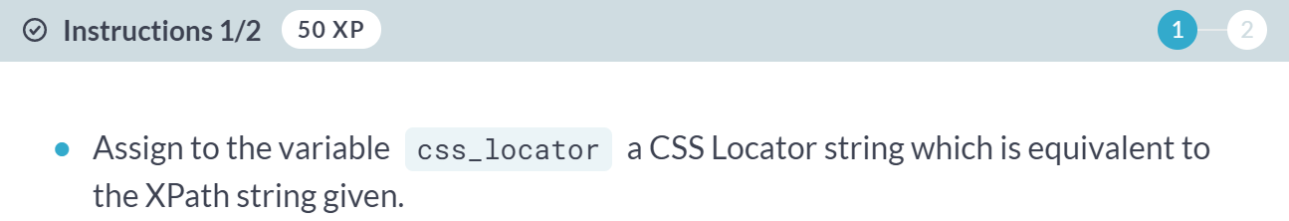  
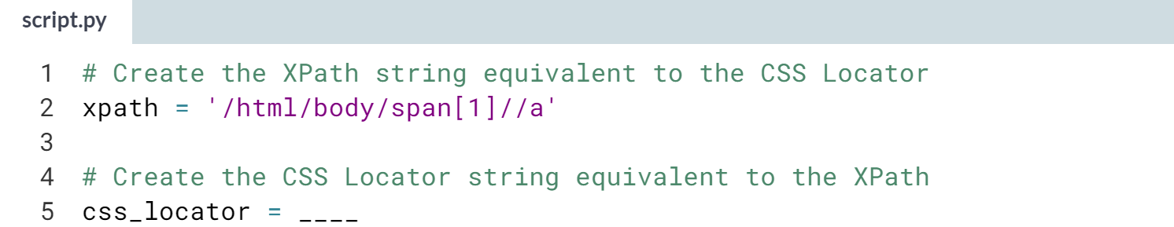  
  
Hint: Pay attention to the single vs double forward-slashes. You will likely need to use the :nth-of-type argument somewhere in your string.  
  
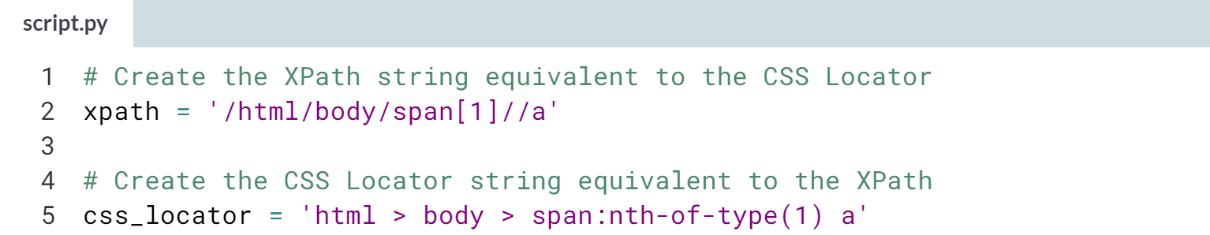

(Exercise continues on the next page)

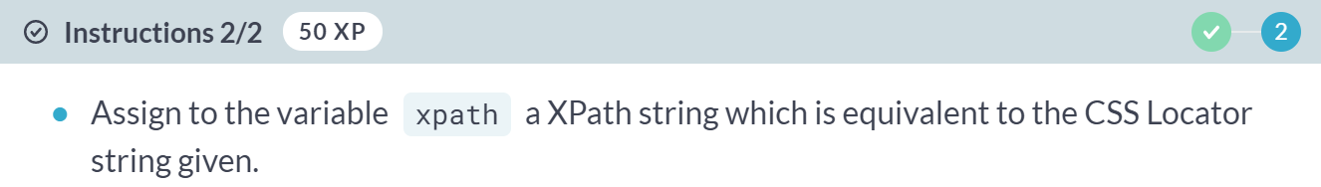  
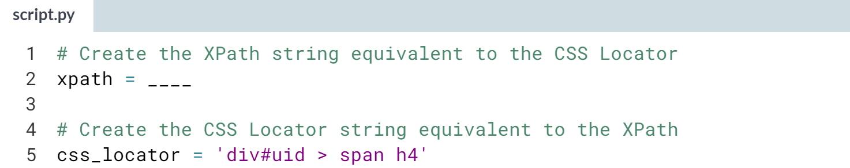  
  
Hint: The trickiest part of this is to decide whether to start your *XPath* string with a single forward-slash or a double forward-slash. So, think about whether you are selecting just root level div elements, or all div elements in the document. Also, don't forget that *#* indicates a selection by the *id* attribute.

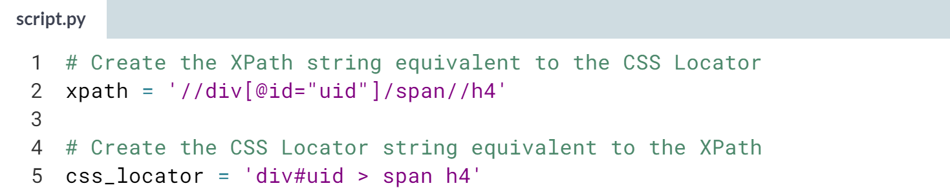  
  
Great translation! You have been able to go back and forth between XPath and CSS Locator strings!

# Get an "a" in this Course

We have loaded the HTML from a secret website which you will use to set up a Selector object and the function how_many_elements(). When passing this function a CSS Locator string, it will print out the number of elements that the CSS Locator you wrote has selected.

In the second part of this problem, we want you to create a CSS Locator string which will select a certain collection of elements as described here: Select the hyperlink (a element) children of all div elements belonging to the class "course-block" (that is, any div element with a class attribute such that "course-block" is one of the classes assigned). The number of such elements is 11, so you can check your solution with how_many_elements if you choose.

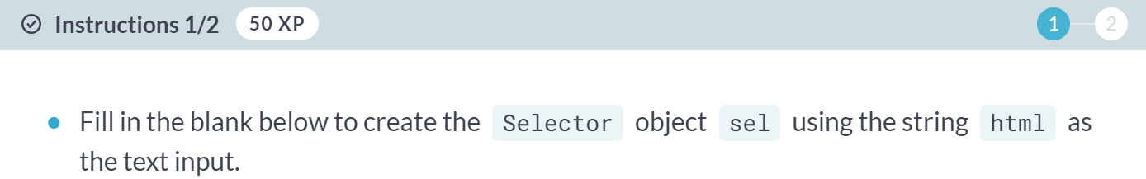

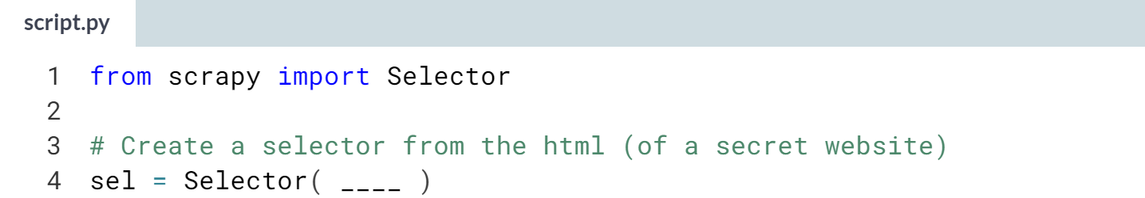

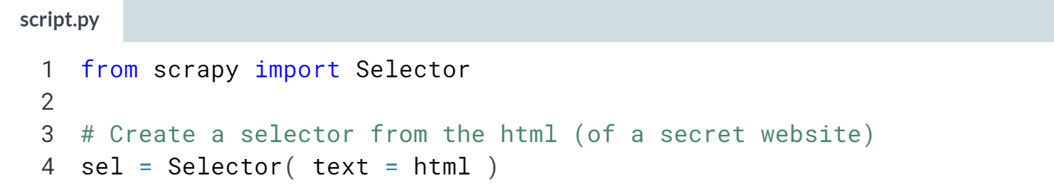

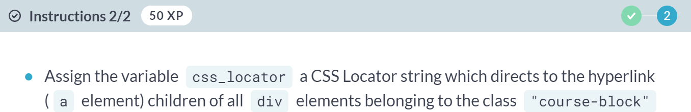

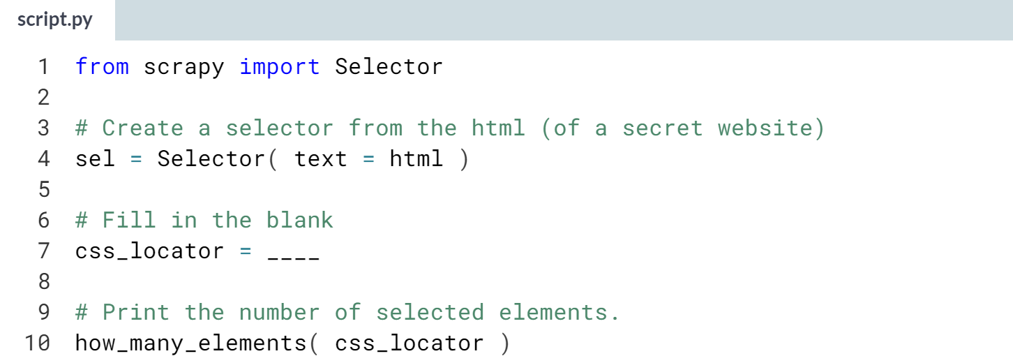

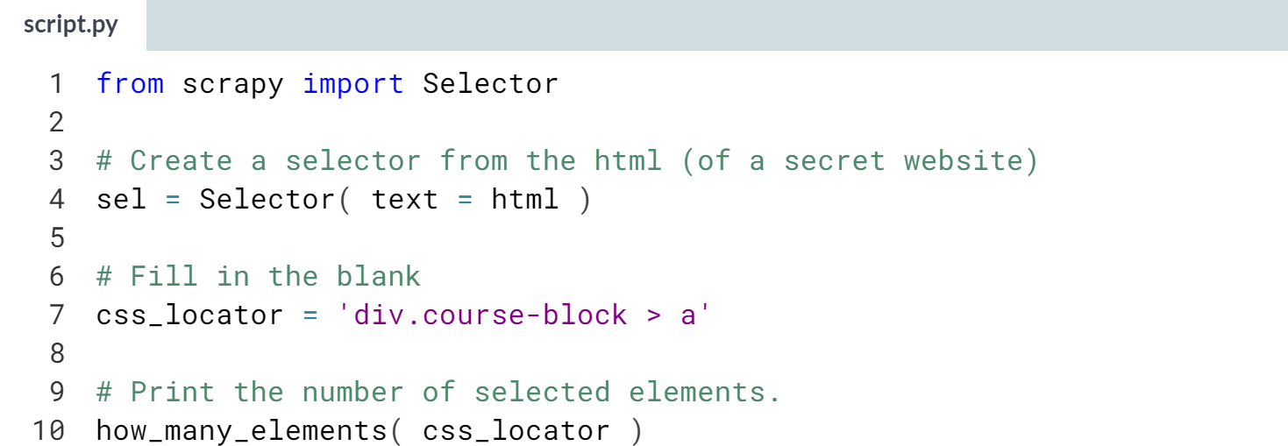

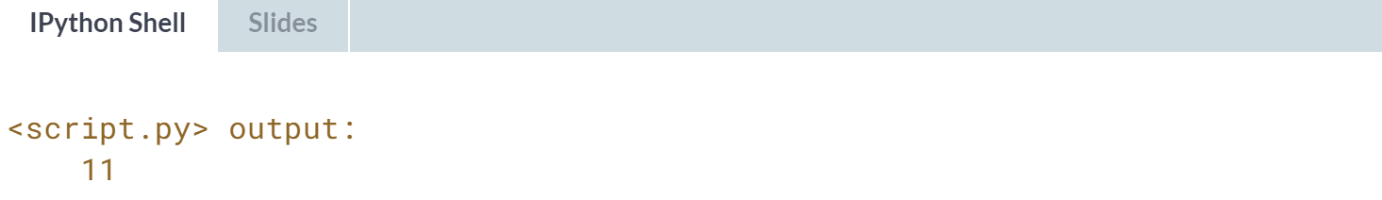

Amazing! You have found all the hyperlink children of the course-block div elements.

# The CSS Wildcard – **REVIEW**

You can use the wildcard * in CSS Locators too! In fact, we can use it in a similar way, when we want to ignore the tag type. For example:

* The CSS Locator string '*' selects all elements in the HTML document.
* The CSS Locator string '*.class-1' selects all elements which belong to class-1, but this is unnecessary since the string '.class-1' will also do the same job.
* The CSS Locator string '*#uid' selects the element with id attribute equal to uid, but this is unnecessary since the string '#uid' will also do the same job.

In this exercise, we want you to work by analogy with the wildcard character you know from XPath notation to discover how to select all the children of a certain element in CSS Locator notation.

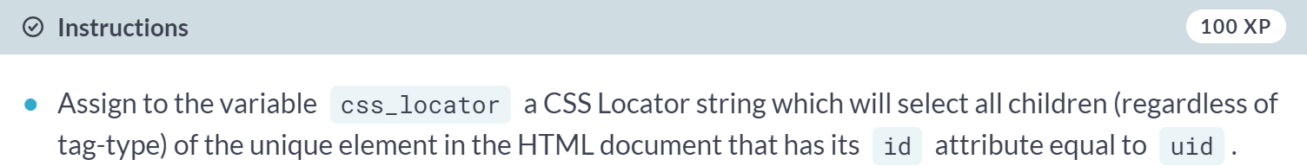

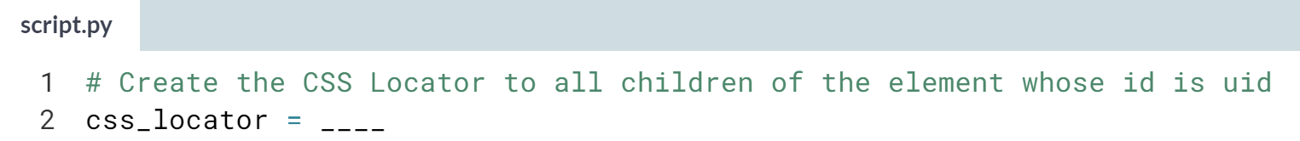

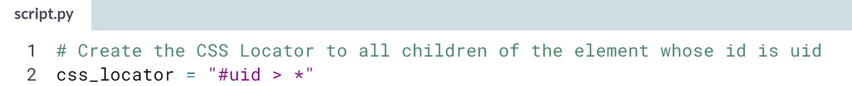

Wow! You were able to combine your knowledge of CSS Locators with your instincts for the wildcard character to do the job!!

# You've been `href`ed

In a previous exercise, you created a CSS Locator string to select the hyperlink (a element) children of all div elements belonging to the class "course-block".

Here we have created a SelectorList called course_as having selected those hyperlink children.

Now, we want you to fill in the blank below to extract the href attribute values from these elements. This is another example of chaining, as we've seen in a previous exercise.

The point here is that we can chain together calls to the methods css and xpath and combine them!

We help nudge you in the correct direction by giving you the solution if we chain with another call to the css method.

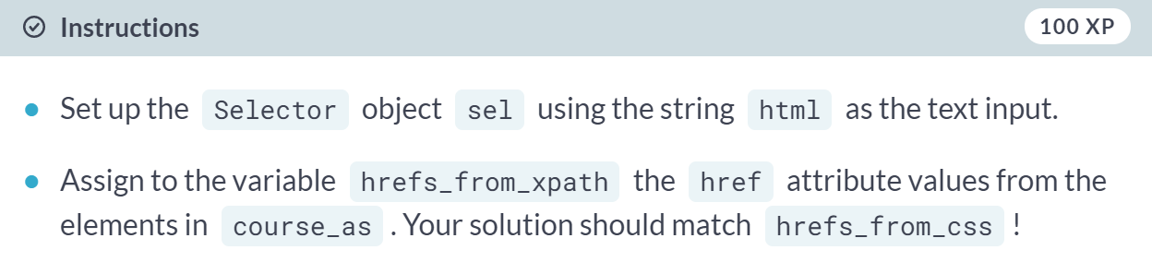

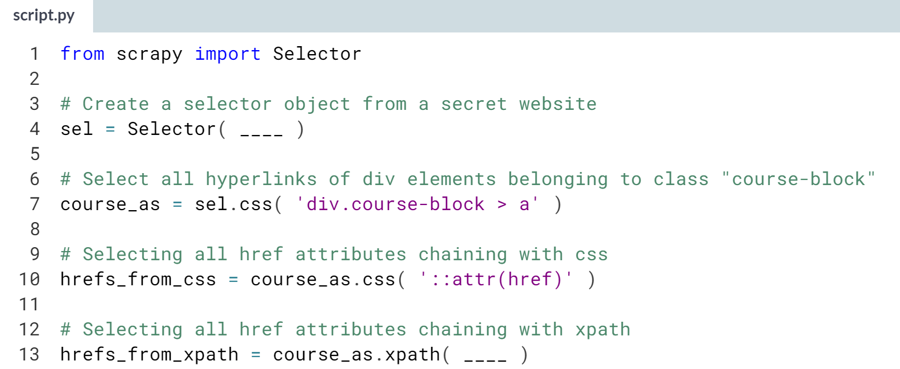

(Solution on the next page)

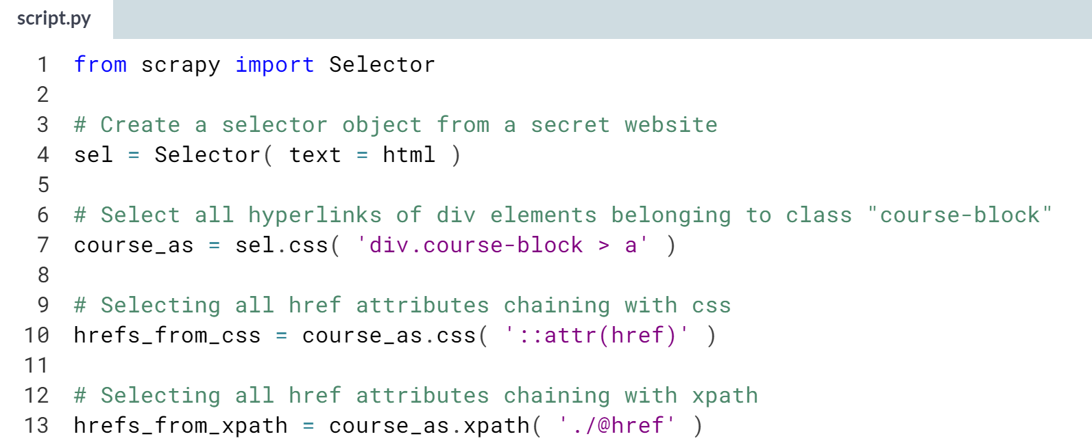  
  
You did it! You even remembered to use the period as glue when creating the XPath. Maybe you noticed, but if you chain with css (rather than xpath), you don't need any glue!

# Top Level Text

This exercise will have you write an XPath and CSS Locator string to direct to the text of a specific paragraph p element. The p element in the HTML is uniquely defined by its id attribute, which is "p3".

With this small piece of information, you should be able to create the desired strings; however, we have preloaded the variable html with a string containing the HTML in which this link belongs, if you want to peruse it.

In this exercise, you will only be selecting the text within the element, which **does not include** the text in future generations of the element. We have created a function print_results for you to compare which elements your strings direct to.

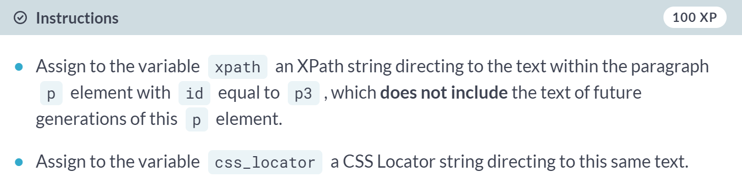

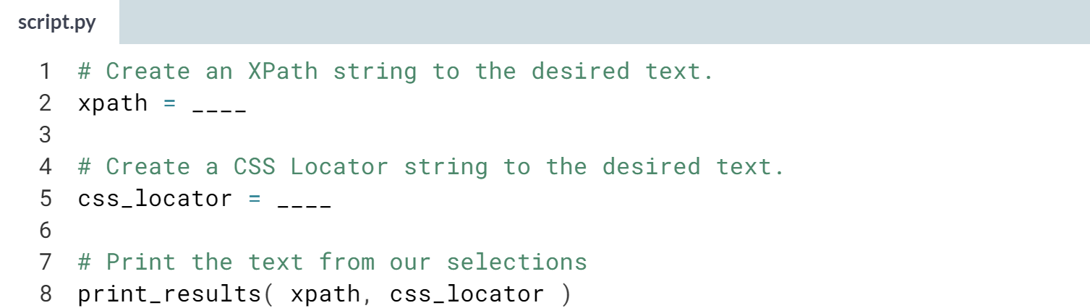

Hint:

1) Remember that in CSS Locator notation, the pound sign ***#*** is used in helping identify an element by its id.

2) Don't forget that for an XPath string, you need to have parentheses following the word text (i.e., ***text()*** should be part of the string).

3) Don't forget that for a CSS Locator string, you need to connect the word text with a double colon **::**.

(Solution on the next page)

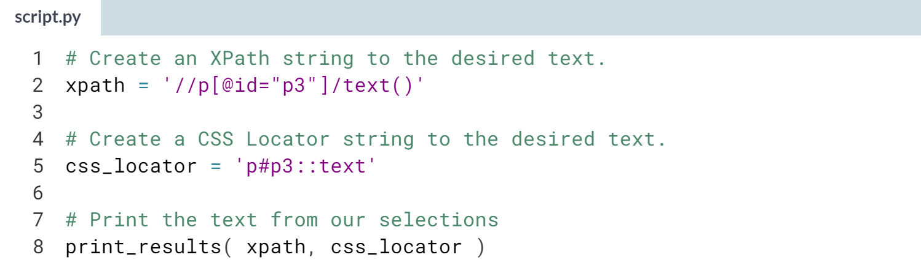

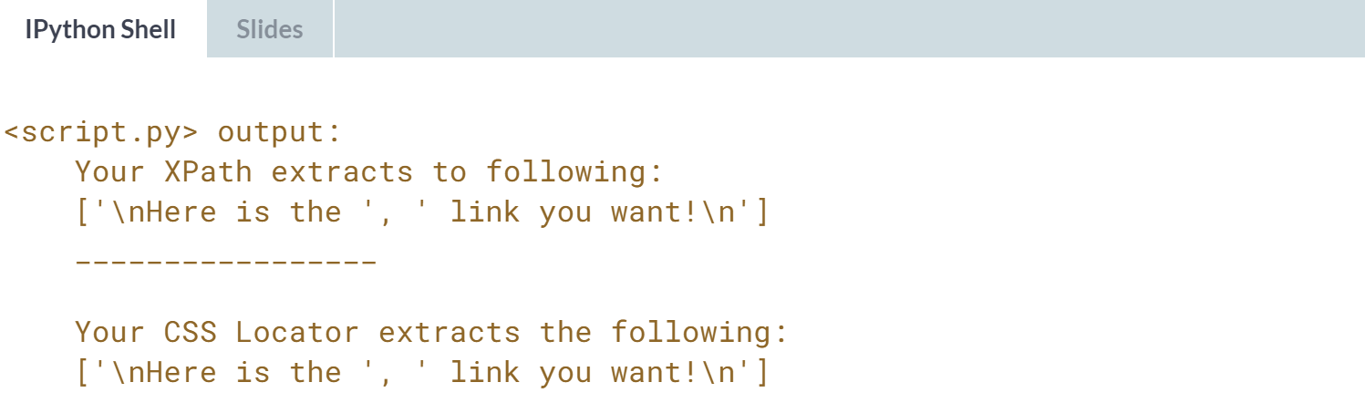

Great Job! You were able to direct to text with both XPath and CSS Locator strings!

# All Level Text

This exercise is similar to the previous but differs in that you will be selecting text from multiple generations of a given element.

You will write an XPath and CSS Locator strings to direct to the text of a specific paragraph p element. The p element in the HTML is uniquely defined by its id attribute, which is "p3".

With this small piece of information, you should be able to create the desired strings; however, we have preloaded the variable html with a string containing the HTML in which this link belongs, if you want to peruse it.

In this exercise, you will only be selecting the text within the element which **includes** all text within the future generations.

We have created a function print_results for you to compare which elements your strings direct to.

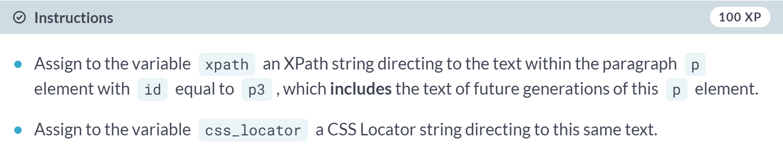

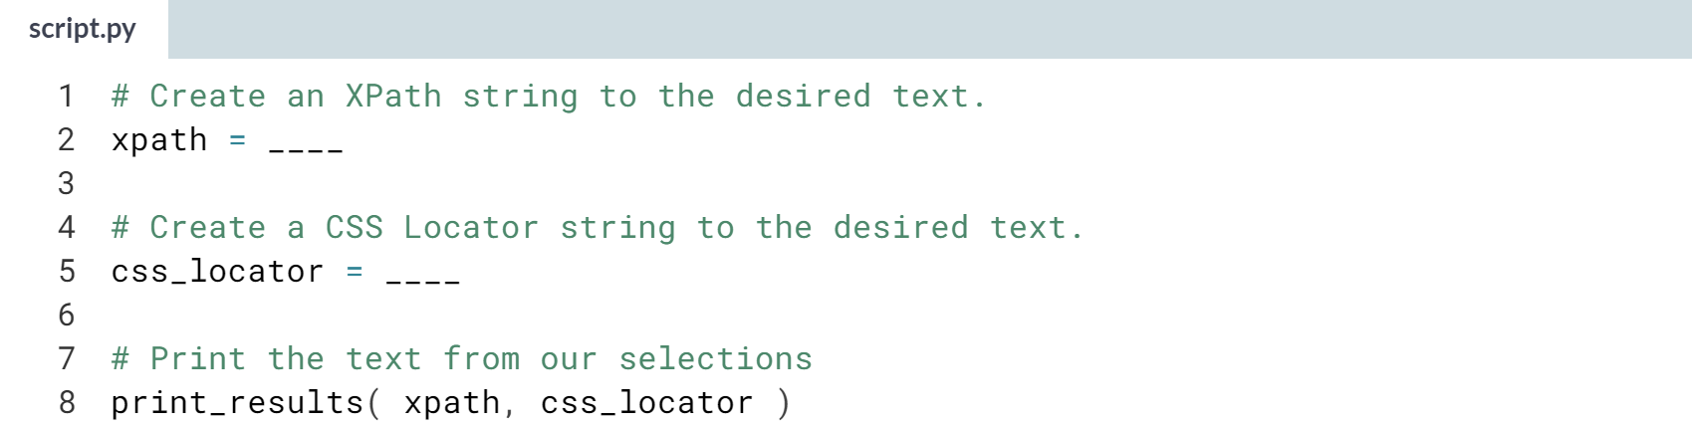

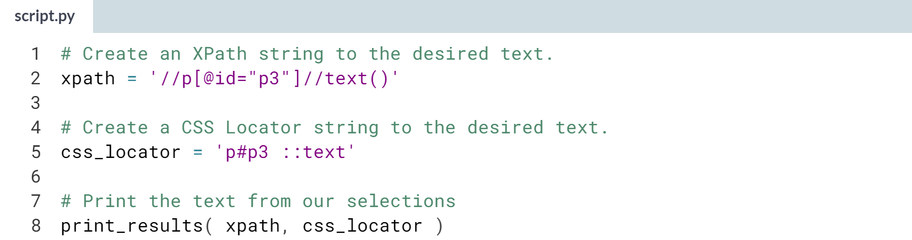

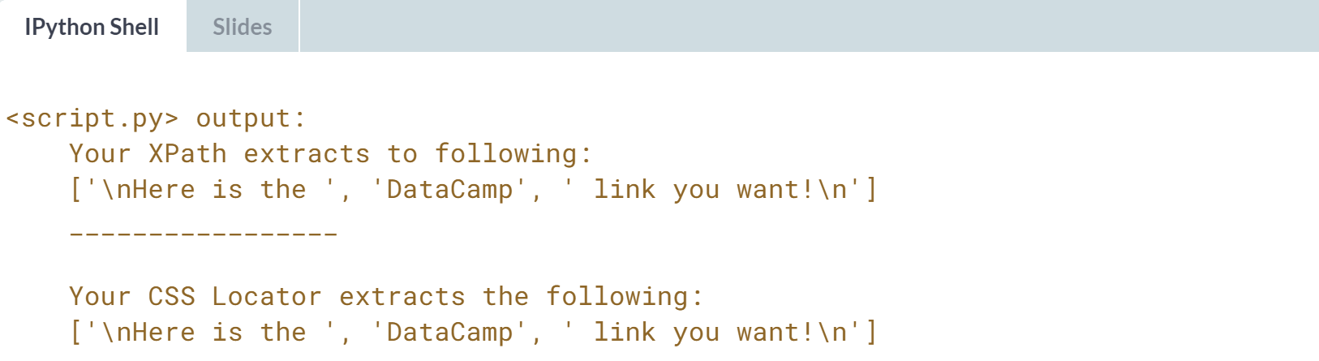  
Great Job! You were able to direct to text with both XPath and CSS Locator strings!



In this lesson, we will introduce Response objects in scrapy, which behaves like Selectors but gives us extra tools to mobilize our scaping efforts across multiple websites.

You see, we are moving towards creating spiders, programs that crawl the web and scrape data in a way we specify, and although we will need to wait to the next chapter to build a spider, moving from Selector objects to Response objects gives us these extra pieces we need to crawl between sites instead of simply parsing one site.

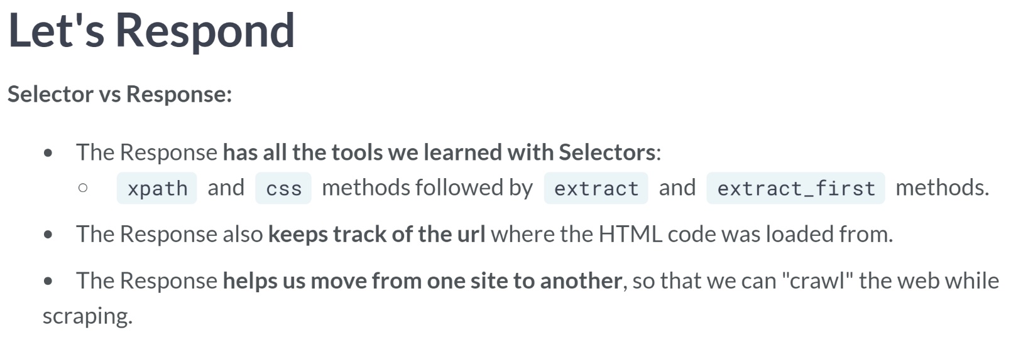  
In the next chapter, we will learn exactly how to scrape a site and load its HTML code into a scrapy variable without having to do all the work we have previously done: loading the HTML code into a string and then passing that string as a variable to a Selector object.

But for now, we will focus on Response objects, which already have HTML pre-loaded. You may ask, "Why are you making us learn a new Response object when you just taught us about Selectors?".

It is because you can use everything we've learned for selectors with Responses. The Selector object was our introduction to a Response object.

What makes us want to use a Response object rather than a Selector is that, on the top of all the Selector functionality, the Response object keeps track of which URL the HTML code is from and hence gives us a tool to not only scrape one single site, but crawl between links on sites and scrape multiple sites automatically.

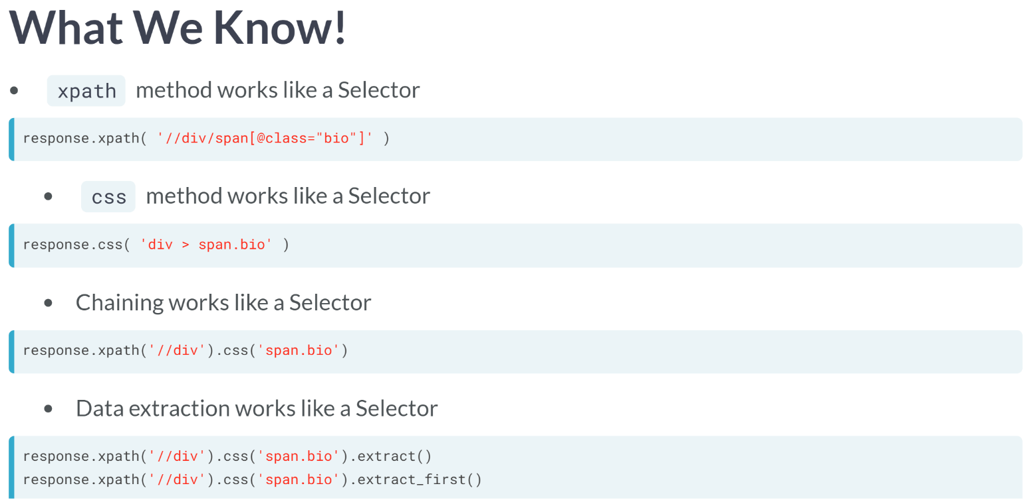  
As an illustration of what we already know for Response variables from our Selector expertise, suppose we have preloaded a Response variable with the HTML from some website, and we are interested in the span elements which are children of some div element and whose class attribute is "bio". We can still use the ***xpath()*** method as we have before.

We can still use the css method as we've learned about in this chapter. We can chain together these methods. And we can extract the selected data using the extract or ***extract_first()*** methods we already know about.

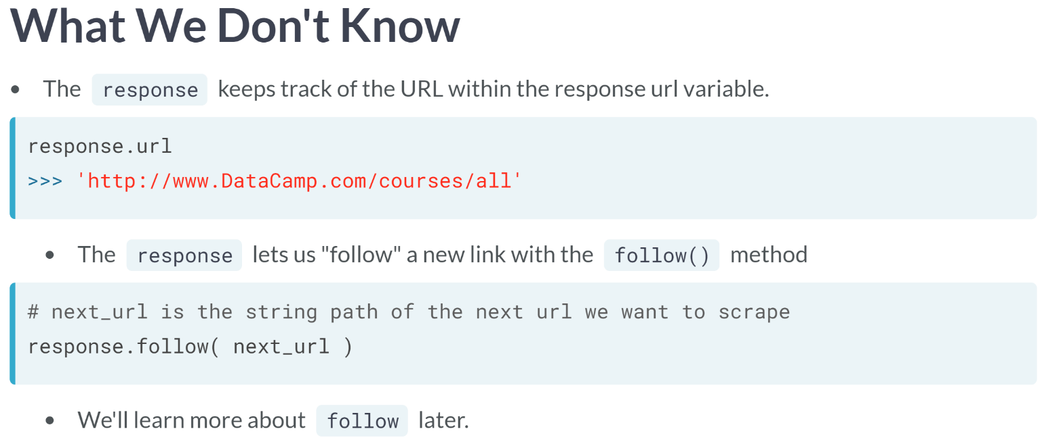  
What we gain by using a Response object is the functionality to keep the track of the URL where the HTML was scraped from, which it stores as a string in its URL variable, and the ability to follow a new link using the ***follow()*** method, which allows us to crawl through multiple pages for scraping.

We will learn more about the ***follow()*** method in the next chapter, but for now, just realize that this ability to "follow" links automatically makes using Response the correct choice when we want to crawl between websites for scraping.

In this lesson to summarize, we introduced the scrapy Response object, showing how it can be used like a Selector, but adds crawling capability.

Although we still have some gaps to fill in with regards to our understanding of creating a Response and utilizing the follow method for crawling, those gaps will be the focus of our next chapter, and the culmination of our work so far.

# Reveal By Response

We have pre-loaded a Response object, named response, with the content from a secret website. Your job is to figure out the URL and the title of the website using the response variable. You learned how to find the URL in the last lesson. To find the website title, what you need to know is:

* The title is the **text** from the title element
* The title element is a child of the head element, which is a child of the html root element.

To note: the html root element only has one child head element, and the head element only has one child title element.

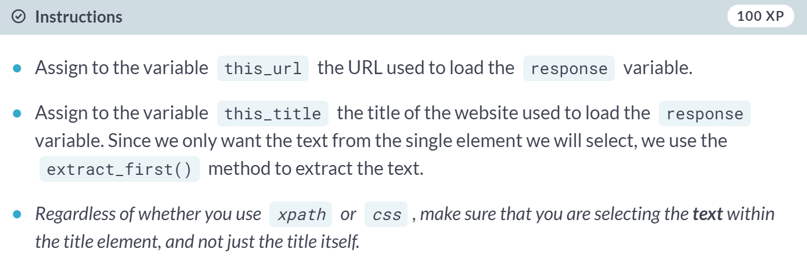

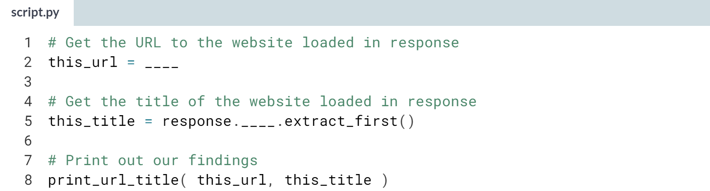

Hint:

1) You can access the URL of the *response* via its *.url* attribute.

2) You can use your choice of either the *xpath* or *css* method within *response* to get to the title.

3) If you are using *xpath*, don't forget that you will need to include */text()* within your XPath string to point to the text of the title.

4) If you are using *css*, don't forget that you will need to include *::text* within your CSS Locator string.

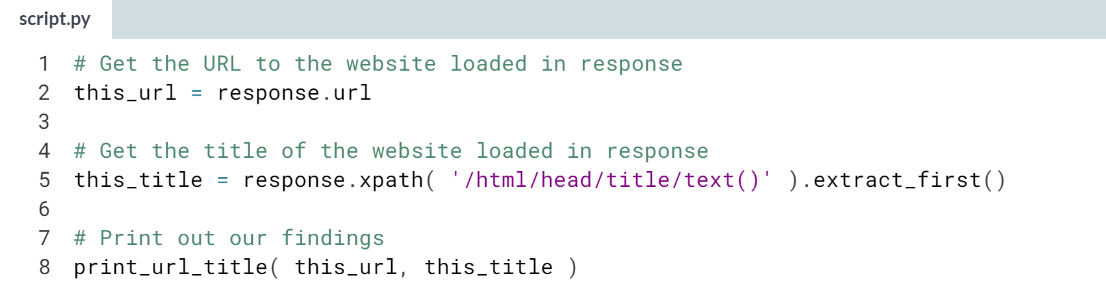

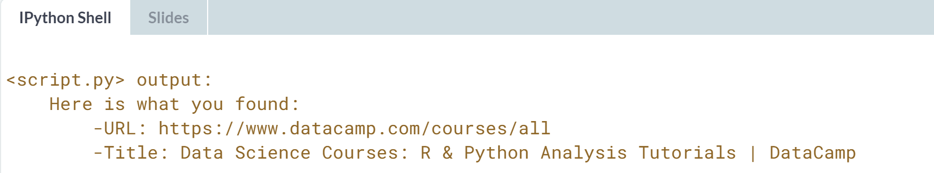

Wow! Without first knowing the website, you were able to figure out its URL and Title -- Congrats!

# Responding with Selectors

Something that we should emphasize at this point about the relationship between a Selector and Response objects is that both objects return a SelectorList when using the xpath or css methods to direct to elements.

In this exercise, we'll prove it to you, by having you find all hyperlink elements belonging to the class course-Blacklick (notice the double underscore!) and looking at the object that is produced when doing so.

Recall that to find an element by class, you can use a period (.). For example, div.class-2 selects all div elements belonging to class-2.

We have pre-loaded both a Response object named response and a Selector object named sel with the content from the same "secret" website. Once you complete the task of creating a CSS Locator, you will compare both the output from response.css and selector.css to see that they are effectively the same!

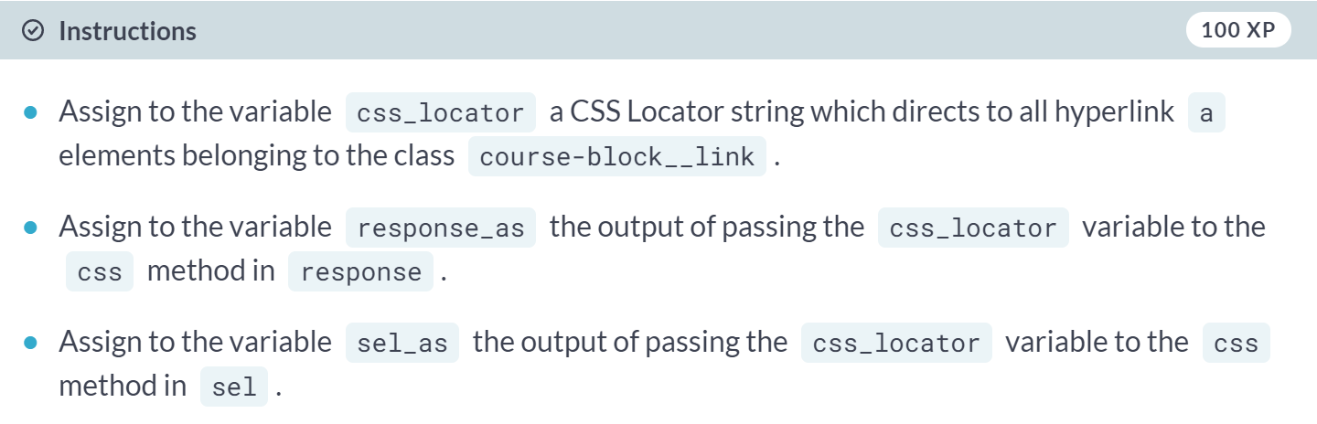

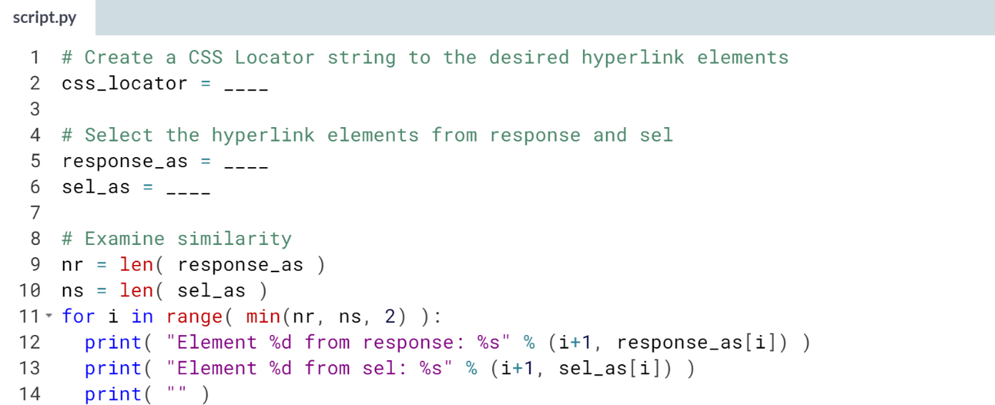  
Hint: Your CSS Locator string should take the form **a.____**, where the blank represents the class that you want to find. Also, don't forget the double underscore! (Solution on the next page)

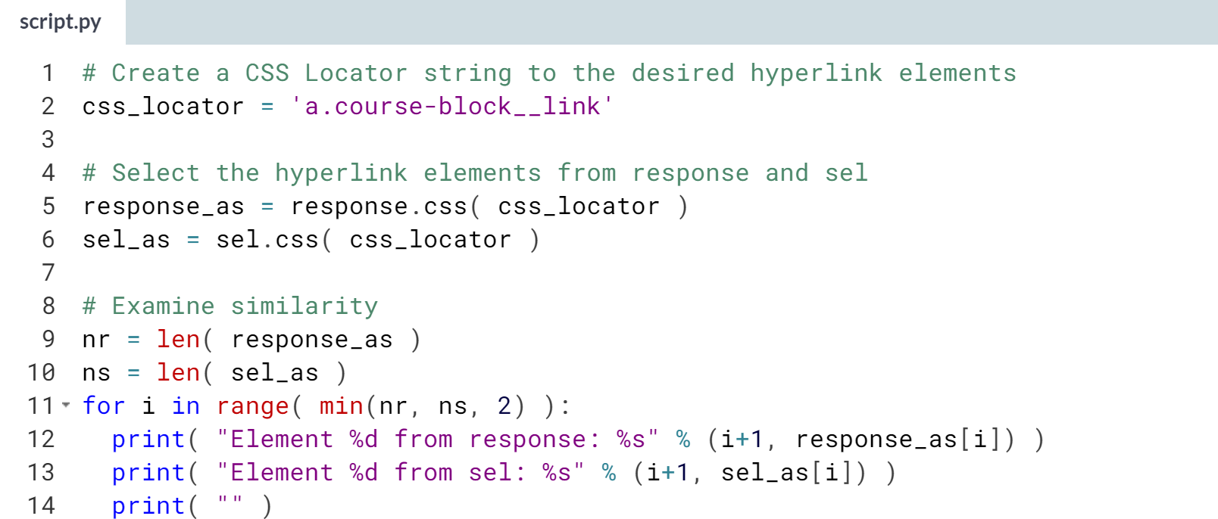

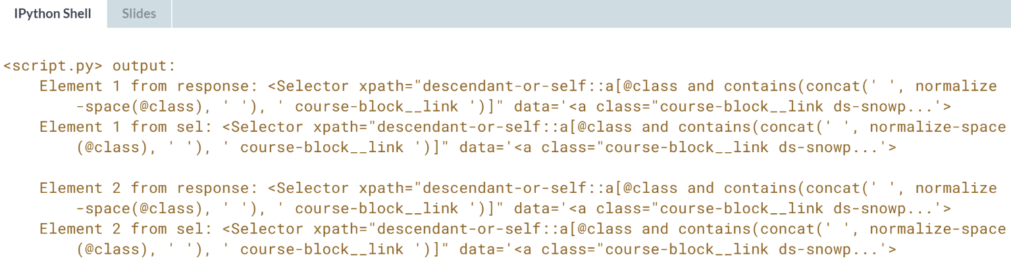

Nicely done! Surely you see now that if we use a response variable to select elements, we are back in the realm of Selectors and SelectorLists.

# Selecting from a Selection

In this exercise, you will find the text from an h4 element within a particular div element. It will occur in steps where the first step is selecting a family of div elements, and the second step is narrowing in on the first one, from which we will grab the h4 element text.

This process of progressively narrowing in on elements (e.g., first to the div elements, then to the h4 element) is another example of "chaining", even if it doesn't look exactly the same as we've seen it before.

Along the way in this exercise, there is a variable first_div set up for you to use. Think carefully about what type of object first_div is!

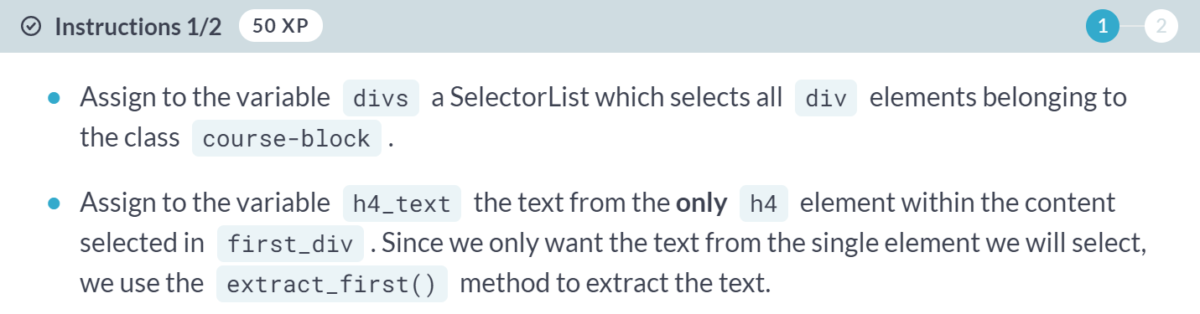

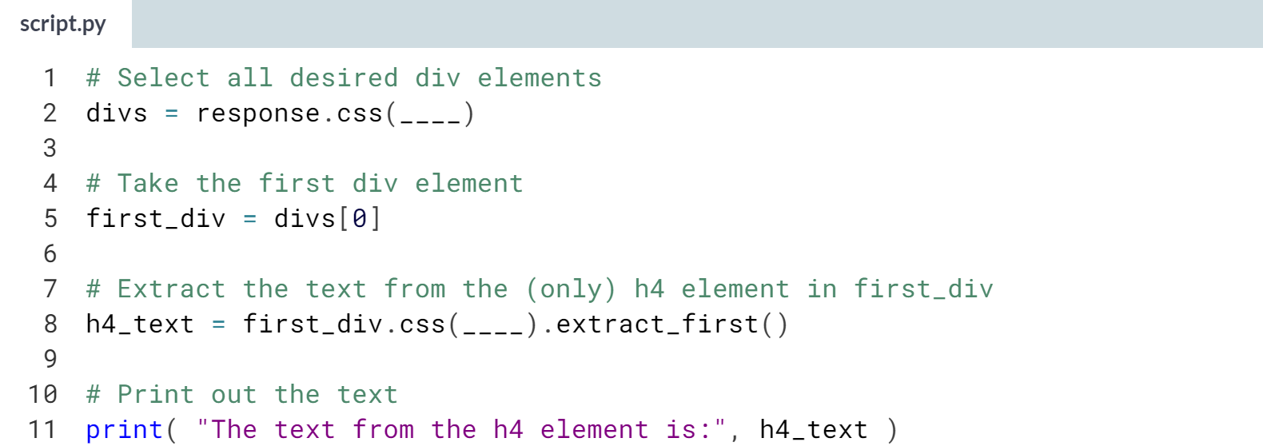

Hint: Remember that to point to the text within the *h4* element, you need to include *::text* within your CSS Locator string for *h4_text*. Also, remember that the *h4* element is the only *h4* element in the content selected within *first_div*.

(Solution on the next page)

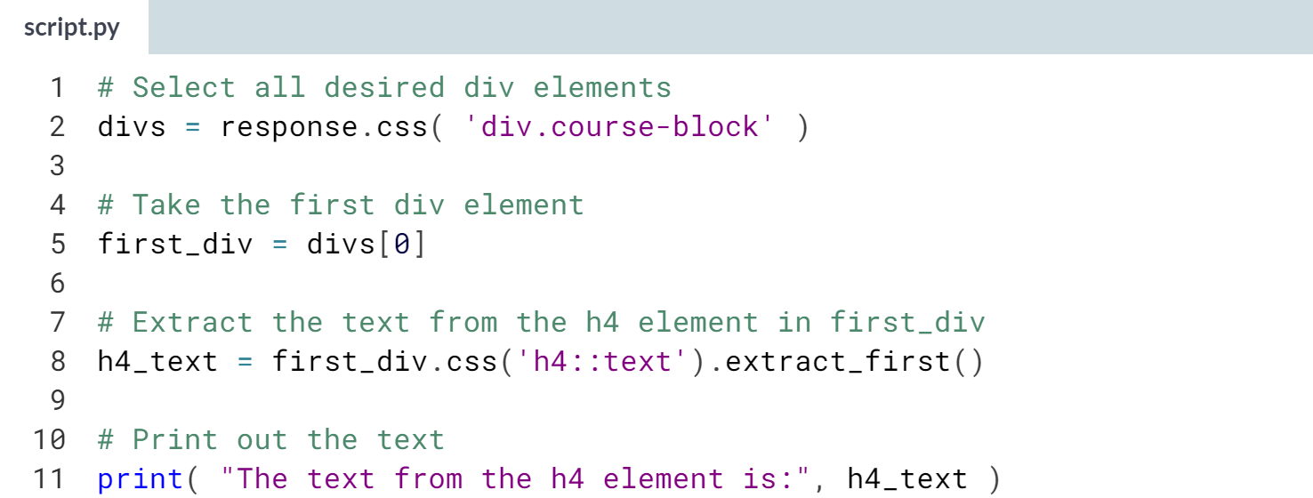

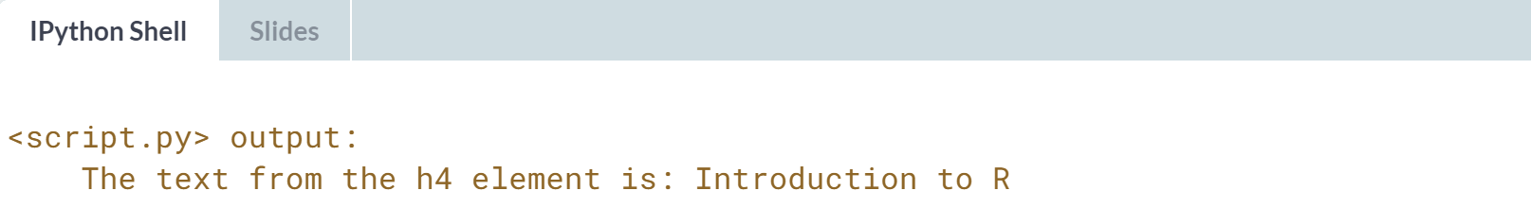

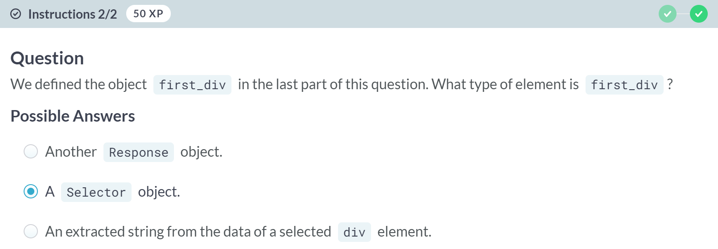

Awesome! That's right -- the variable *divs* was a *SelectorList*, so the first element in this list is a Selector object.

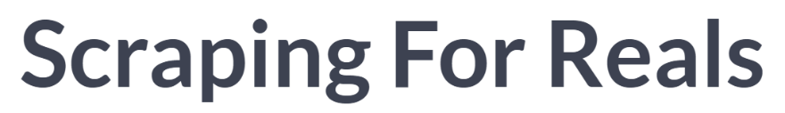

At this point, you have a grasp of the structure of HTML; you can translate that knowledge into XPath and CSS Locator phrases to direct us computationally to specific elements of interest; from there, you can extract attributes such as hyperlinks; you can extract text; and you can do all this within the scrapy Selector and Response framework. In this lesson, we will scrape an actual site using only the techniques that we've built up throughout these lessons.

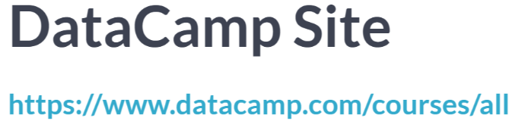  
We are going to scrape the course directory on DataCamp and create a list of links to the course pages. That is, we will end up with a list of strings, where each string is the link to one of the course pages.

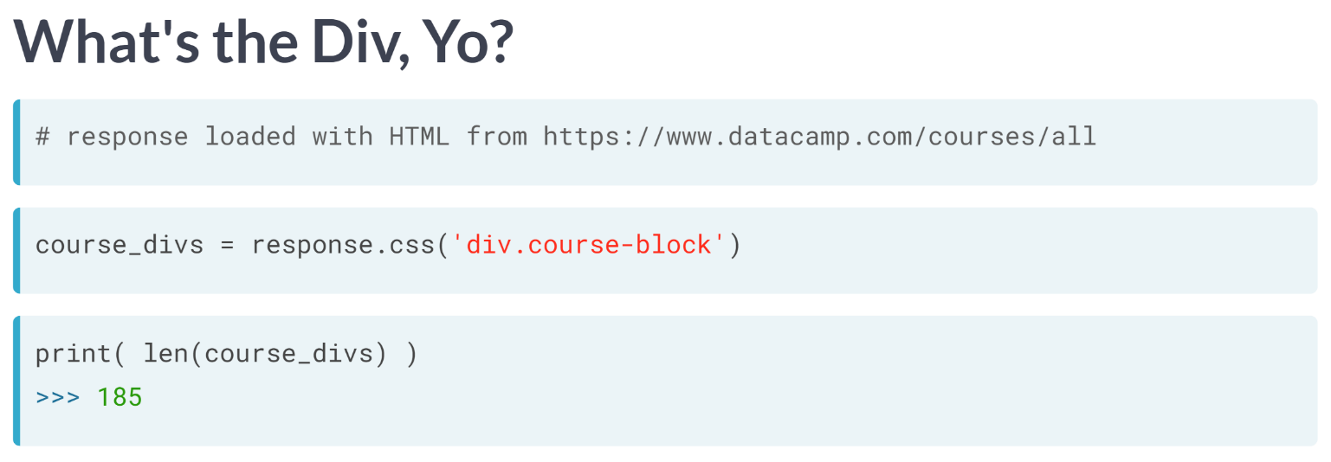  
We have taken the HTML for the DataCamp course directory and loaded it into a scrapy Response variable.

After manually inspecting the HTML code, I noticed that each of the courses displayed on the DataCamp site belong to a div element within the class "course-block".

So, let's go ahead and move those elements using a CSS Locator. We will store this output in the variable *course_divs*.

By the way, at the time we scraped this site, DataCamp had 185 courses listed in this directory, and it seems we've got them all in these selected div elements.

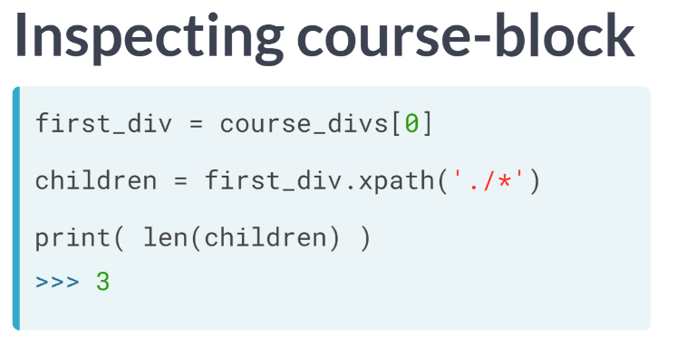  
Examining the first of the div elements in the course-block class, we notice that there are three children.

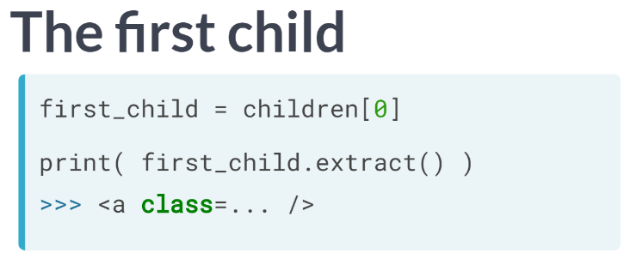  
The first child is a hyperlink element to the course website. It also contains several other elements as children which comprise the upper portion of the course block, highlighted here.

Let's note that we took the first element from the SelectorList as the variable first_child, meaning the first_child is a Selector object. So, to get to the data in the first_child element, we can easily apply the ***extract()*** function.

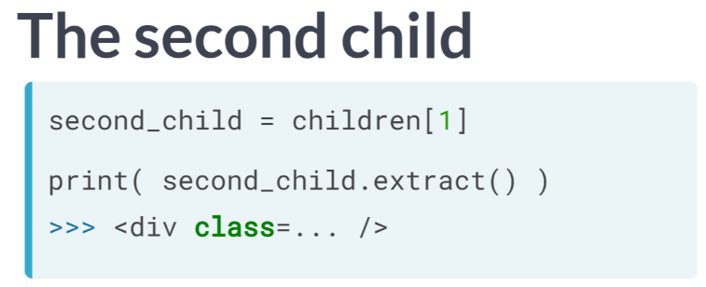  
The second child is another div element, which also contains several other elements, which comprise the footer of the course block; the selection of the course block highlighted here.

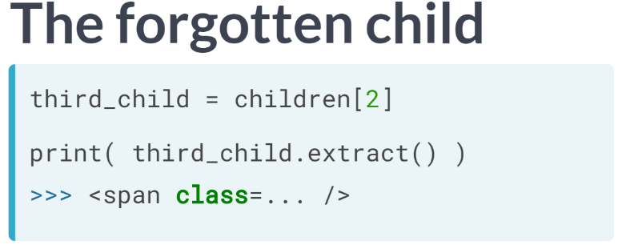  
The third child is a span element, which acts as an invisible container for some specific information but really isn't visible in the course block itself.

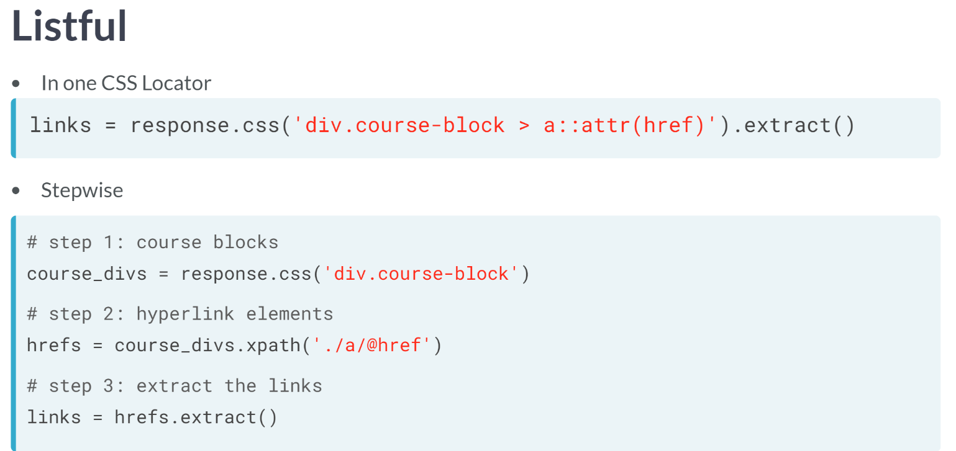

After this inspection, we are now in the position to easily create the list of course links, our original goal. Here I present two options, though others are certainly possible.

The first and possibly simplest is to use just a single CSS Locator to direct to the course-block div elements, then direct to the href attributes of the hyperlink child (the hyperlink child we found when exploring the children of the course block).

From there, a quick call to extract. The second is to do this stepwise, mixing CSS locator and XPath methods. First, we collect the course divs with a CSS locator; then direct to the href attributes of the hyperlink child using XPath and finally extract these.

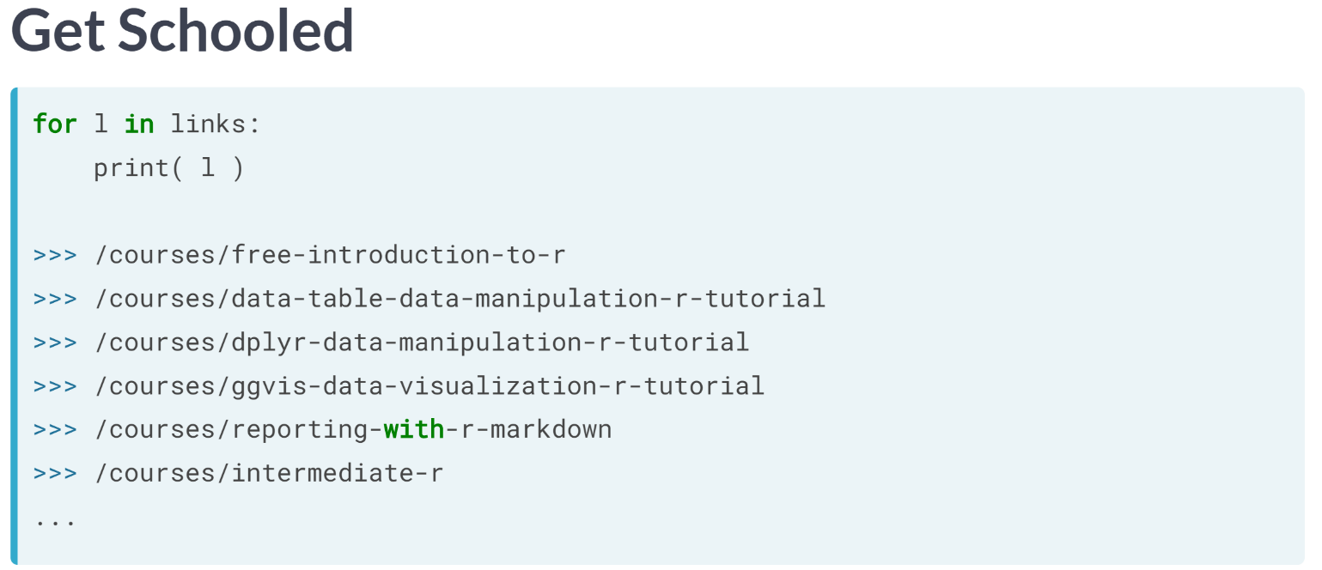  
At this point, we are done! Let's look at the list we created. We have collected all links to the course.

# Titular

Similar to the work given in the previous lesson, we will have you use a pre-loaded Response object, named response to scrape the course titles from the (shortened version of the) DataCamp course directory [**https://www.datacamp.com/courses/all**](https://www.datacamp.com/courses/all). To successfully do so, you only need to know the following

* The course titles **are the text** from all the h4 elements within the HTML document.

We ask you to extract these course titles here.

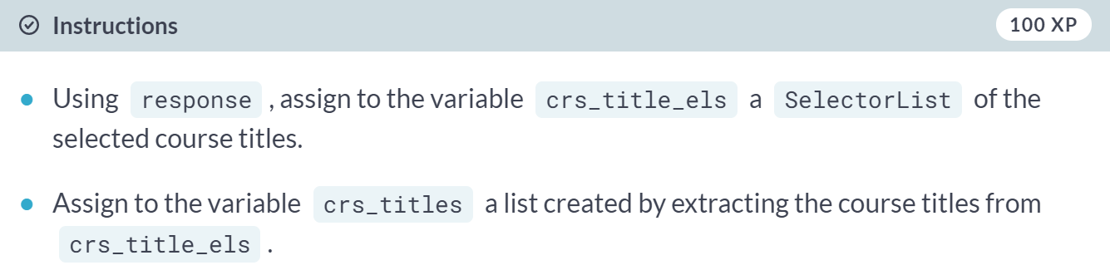

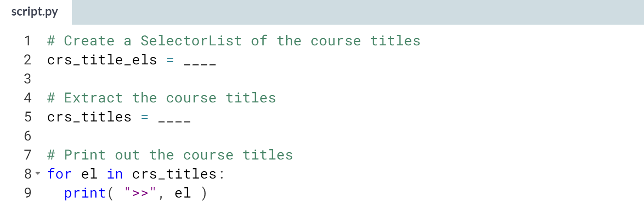

Hint: You can use either the *xpath* or *css* method within response to get to the the course titles. Remember that every *h4* element is used for the course titles (and you need to get the text from these elements).

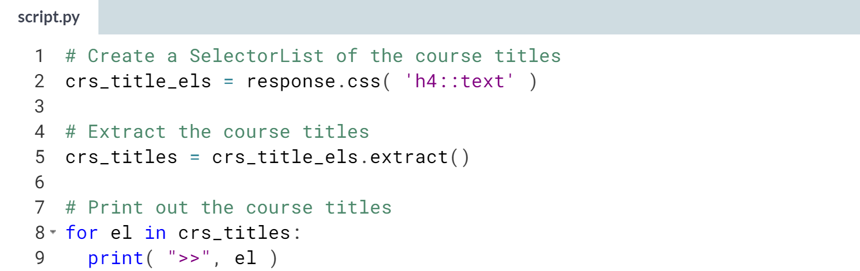

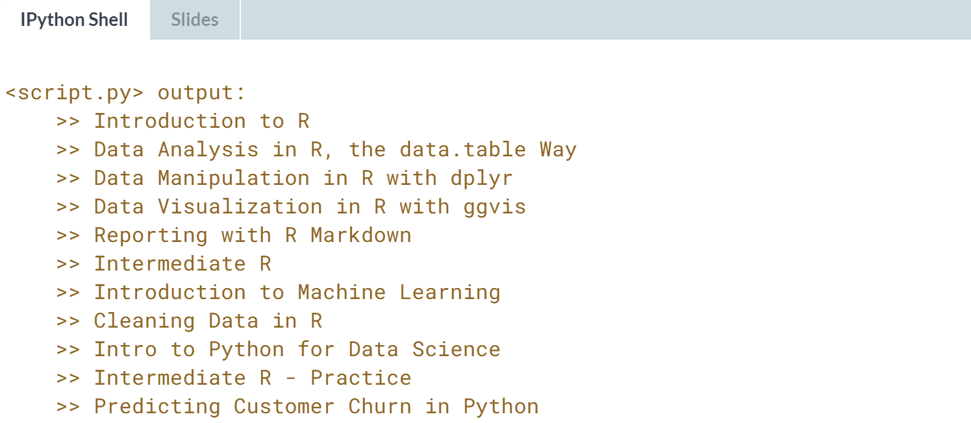

You've done it! With minimal help, you were able to turn a response into something useful!!

# Scraping with Children

We did a cute trick in the lesson to calculate how many children there were of one of the div elements belonging to the class course-block.

Here we ask you to find the number of children of a mystery element (already stored within a Selector object, so you can use the xpath or css method).

To be explicit, we have created the Selector object mystery in the following way:

* We first loaded a Response variable using a secret website as the input.
* Then we used a call to the xpath method to create a SelectorList of elements (but we won't say which ones)
* Finally, we let mystery be the first Selector object of this SelectorList.

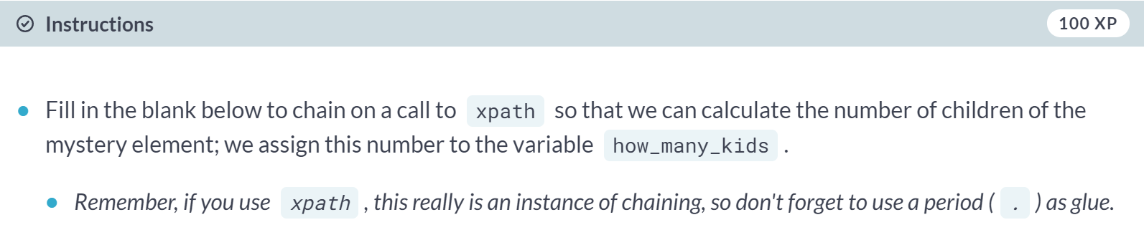

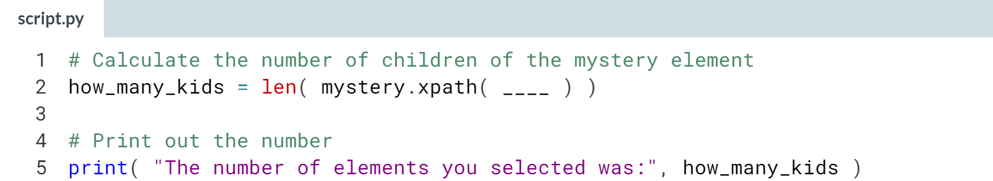Hint: Remember that children are only down one generation, and thus you only need to use a single forward slash (/). You will need to use an asterisks (*) wildcard in your solution.

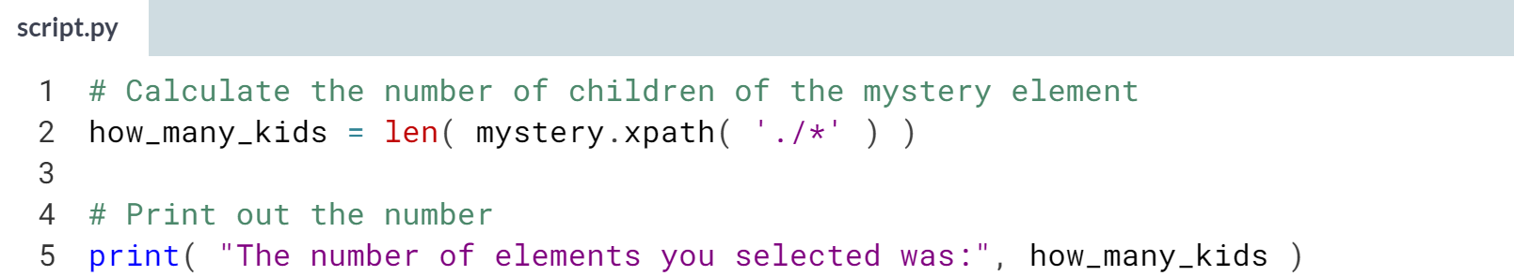

  
Now you know the trick! In xpath, you can use the XPath string './*' to direct to the children of the currently selected element!

**4. Spiders**

Learn to create web crawlers with scrapy. These scrapy spiders will crawl the web through multiple pages, following links to scrape each of those pages automatically according to the procedures we've learned in the previous chapters.



It's now time to put everything we've learned to use while creating spiders. Unlike the scrapping on a single website that we've done already, a spider will crawl the web through multiple pages, following links if we choose, and scrape each of those pages automatically according to the procedures we've programmed.

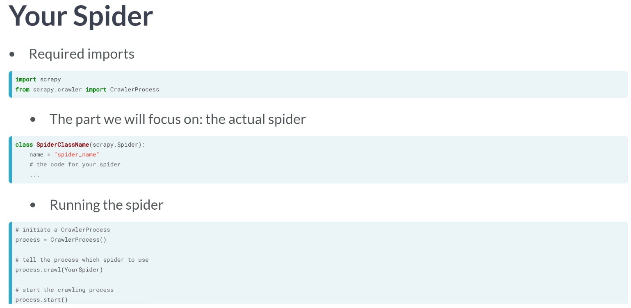

Before narrowing in on our task during this lesson, let's jump into the deep end and look at the general form of the code we will be writing to create our spiders. While this doesn't look super complicated, we will still break it into three parts to ingest.

The first part is simply the necessary importing of scrapy and the CrawlerProcess object.

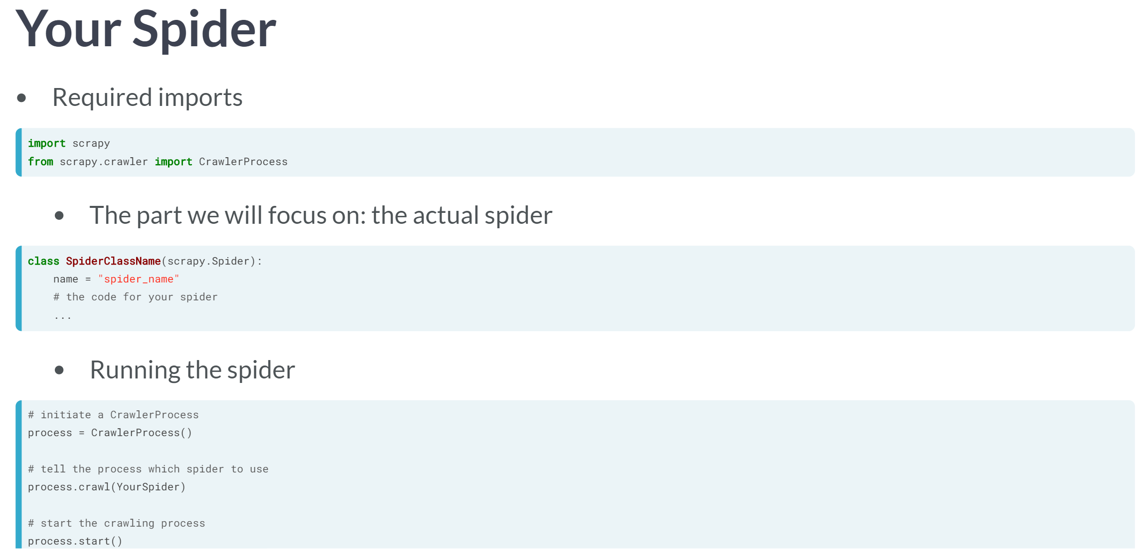

The second part, which happens to be the most important part for us, is the code for the actual spider. This code will tell scrapy what websites to scrape and how to scrape them with all the techniques we've built so far in this course.

The code for the spider comes in the form of a class, a Python object to house together methods and variables that relate to each other. We can name this class whatever we like. Though, the class must take *scrapy.Spider* as an input, which is why we needed to import scrapy above.



The third part runs the spider, using the CrawlerProcess function.

For our purposes in this course, we will only need to make sure that the spider name we pass to crawl method (in this case process.crawl) to the actual name of our spider. From here on, we will focus on the code for the spider.

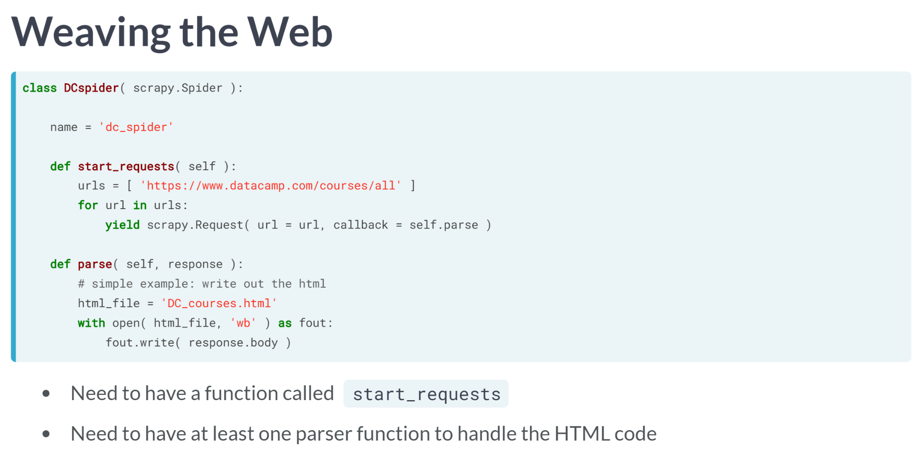  
  
We now narrow in on creating the actual spider. This is the class object, which basically tells what sites we want to scrape and how we want to scrape them.

Again, the code may look a little complicated, but we will walk through it and see that we've built up techniques to cover most of the work.

Here we have the code to scrape the DataCamp course directory. It includes all the basic pieces we need. We can name the class anything we want, here we called the class "DCspider" and defined the name variable within that class with a similar name (although we can assign any string to the name variable we want).

This name variable is important for some of the action that happens under the hood of scrapy. We must have a ***start_request()*** method to define which site or sites we want to scrape, and which tells us where to send the information from these sites to be parsed.

Finally, we need to have at least one method to parse to the website we scrape; we can call the parsing method or methods anything we want as long as we correctly identify the method within the ***start_requests()*** function.

All we are doing in this parser is taking the HTML code and writing it to a file.

# Inheriting the Spider

When learning about scrapy spiders, we saw that the main portion of the code for us to adjust is the class for the spider. To help build some familiarity of the class, you will complete a short piece of code to complete a toy-model of the spider class code.

We've omitted the code that would actually run the spider, only including the pieces necessary to create the class.

As mentioned in the lesson, a class is roughly a collection of related variables and functions housed together.

Sometimes one class likes to use methods from another class, and so we will inherit methods from a different class. That's what we do in the spider class.

We wrote the function inspect_class to look at the your class once you're done, if you'd like to test your solution!

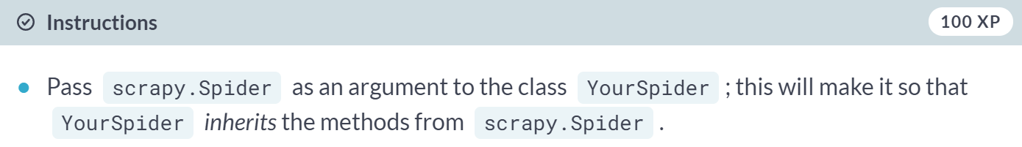

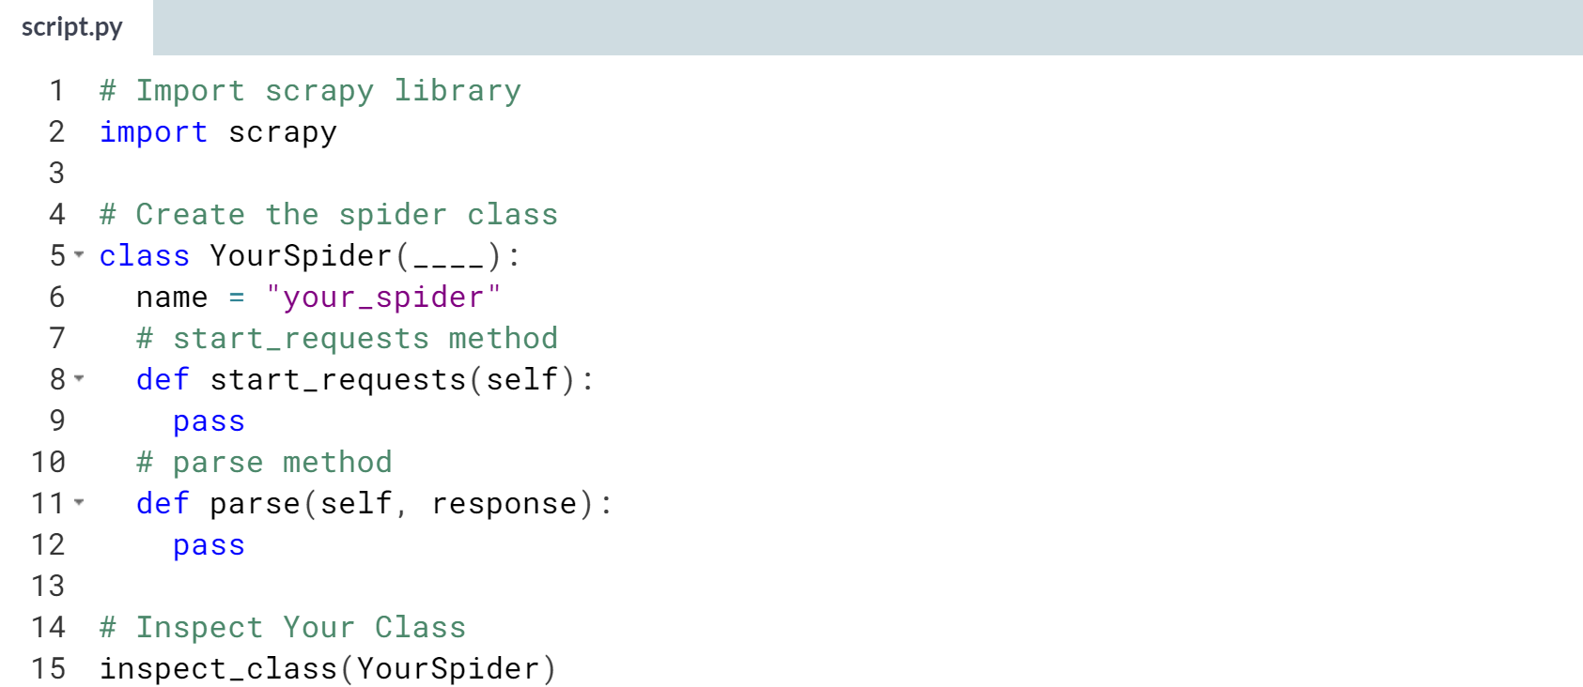

Hint: As stated in the instructions, all you need to do is pass *scrapy.Spider* as an argument into *YourSpider* (Solution on the next page).

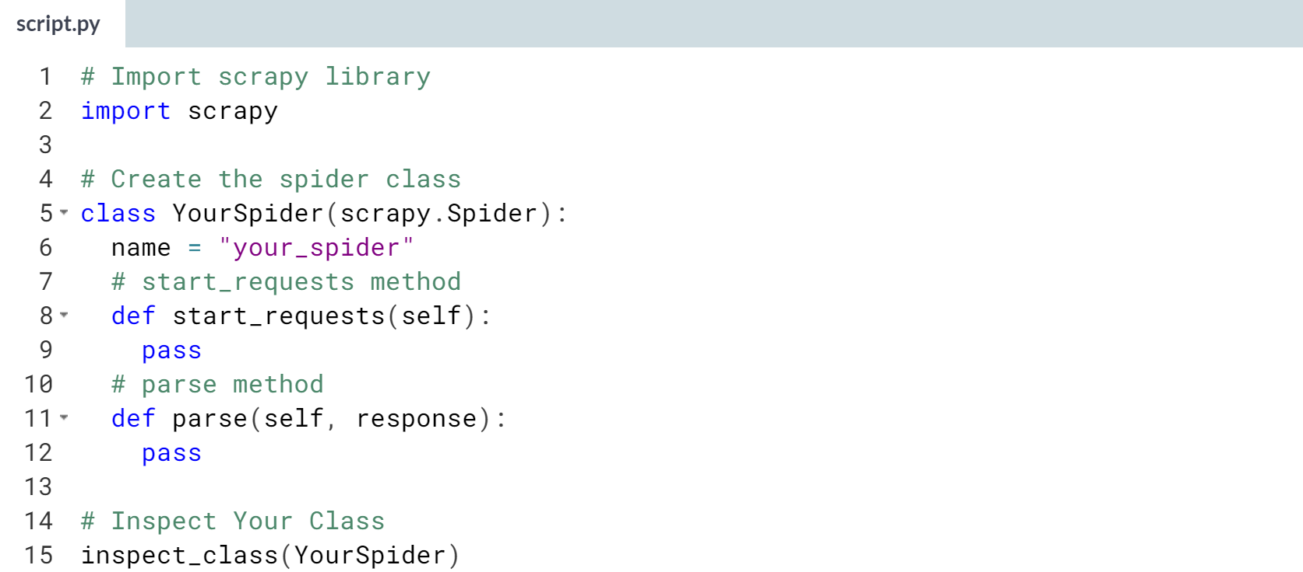

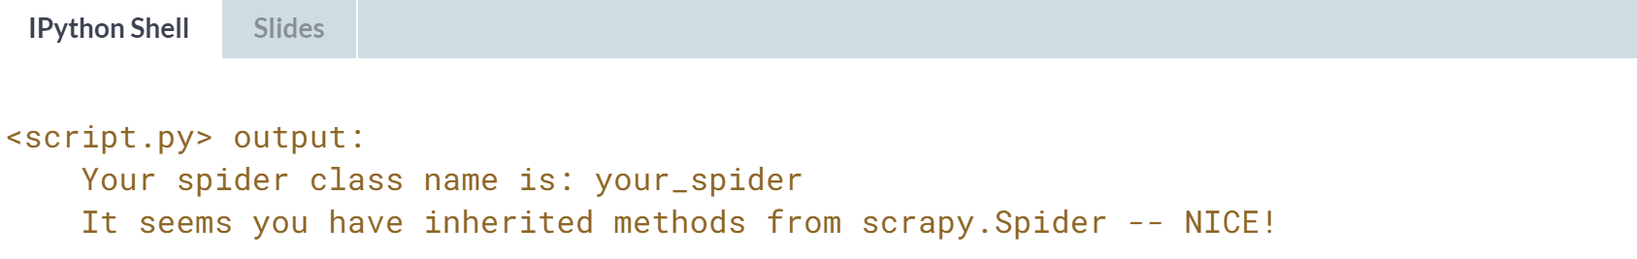

Great job setting up a class so that it inherits the tools from scrapy.Spider!

# Hurl the URLs

In the next lesson we will talk about the start_requests method within the spider class. In this quick exercise, we ask you to change around a variable within the start_requests method which foreshadows some of what we will be learning in the next lesson.

Basically, we want you to start becoming comfortable turning some of the wheels within a spider class; in this case, making a list of urls within the start_requests method.

We've written a function inspect_class which will print out the list of elements you have in the urls variable within the start_requests method.

**Note**: in the next several exercises, you will write code to complete your spider class, but the code does not yet include the pieces to actually **run** the spider; that will come at the end.

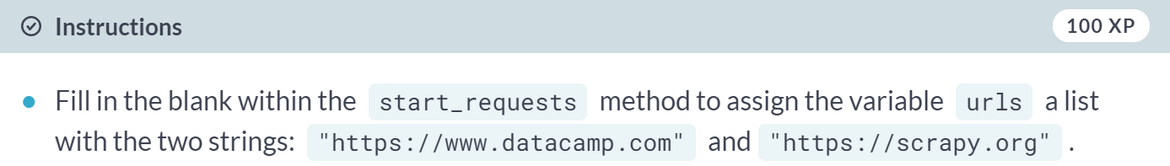

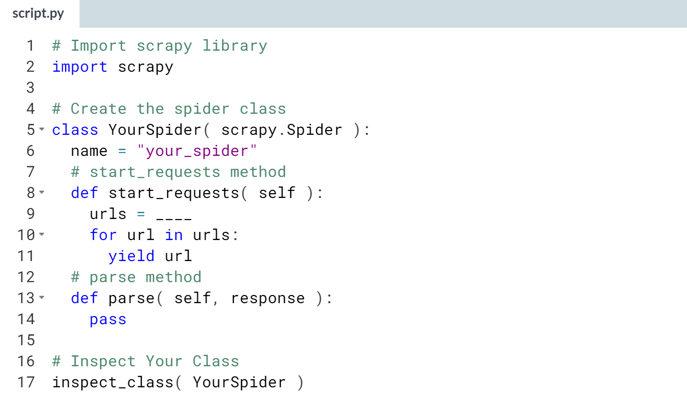  
  
Hint: Set *urls* in *start_requests* equal to a list with the two elements being the two strings in the instructions! (Solution on the next page).

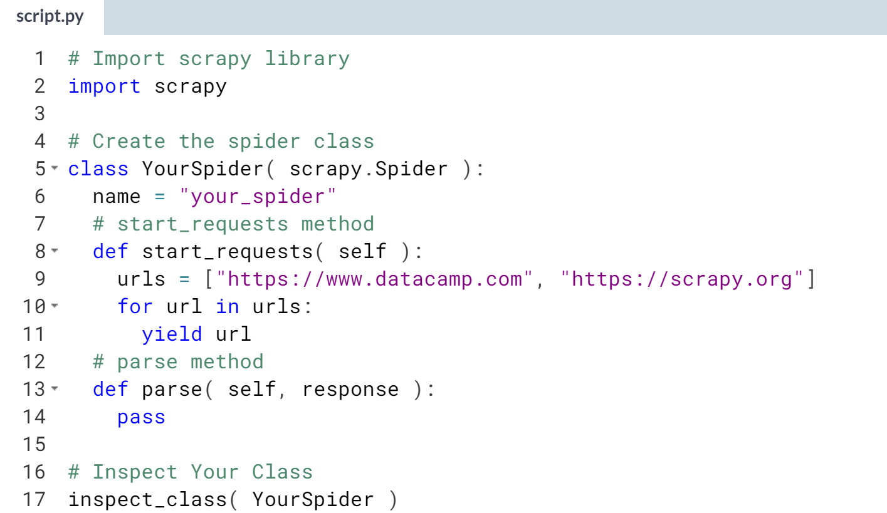

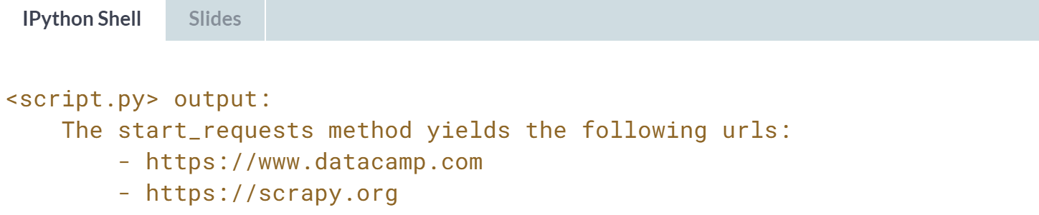

Great! We'll discuss more about the ***start_requests()*** method and how it uses yield in the next lesson.

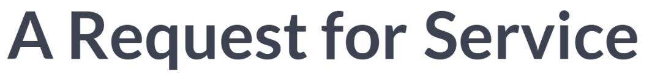

In this lesson, we will look deeper into the start_requests method and its relation to the parsing method or methods within our spider.

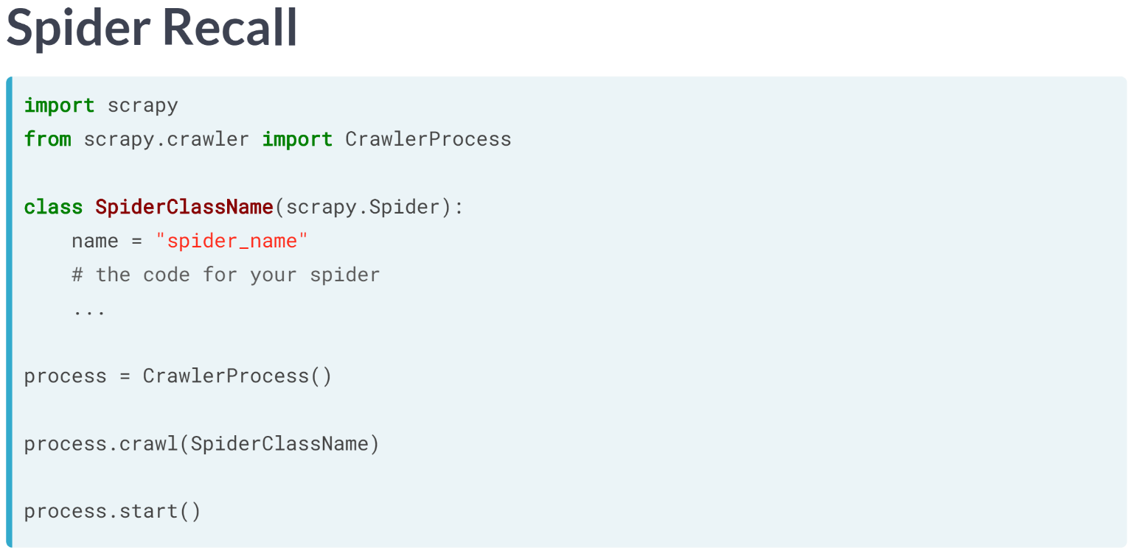  
Remember that the code to setup and run a spider roughly looked like the code above, where most of the work will go into coding the class we define for our spider.

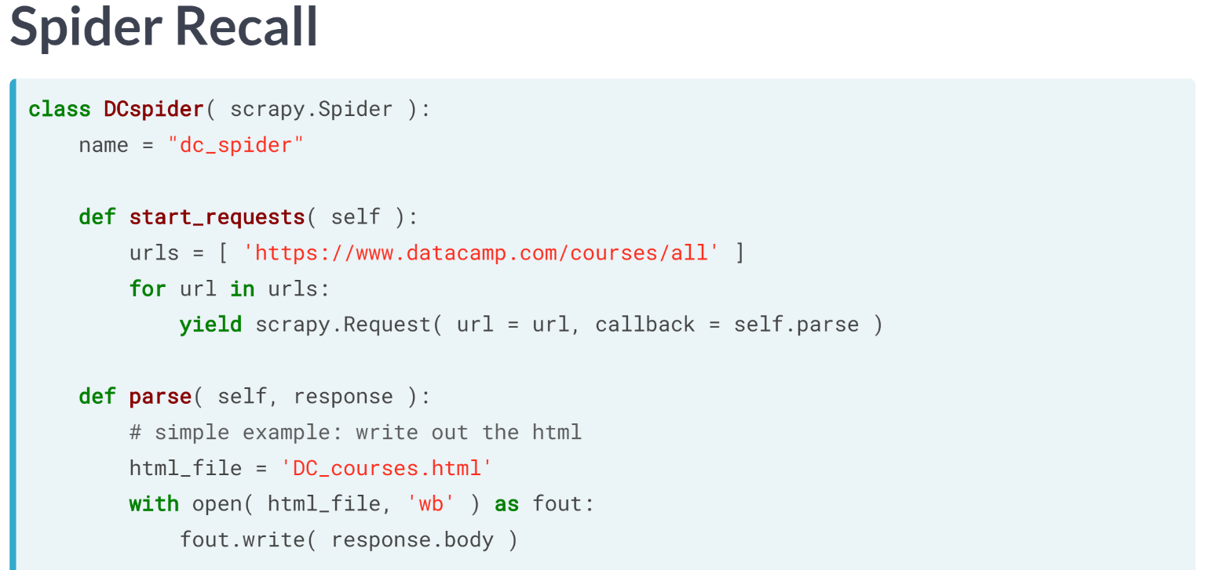  
We've already seen an example of a spider, which effectively would save the HTML code from the DataCamp course directory into a file. So, let's now narrow in on the start_requests method.

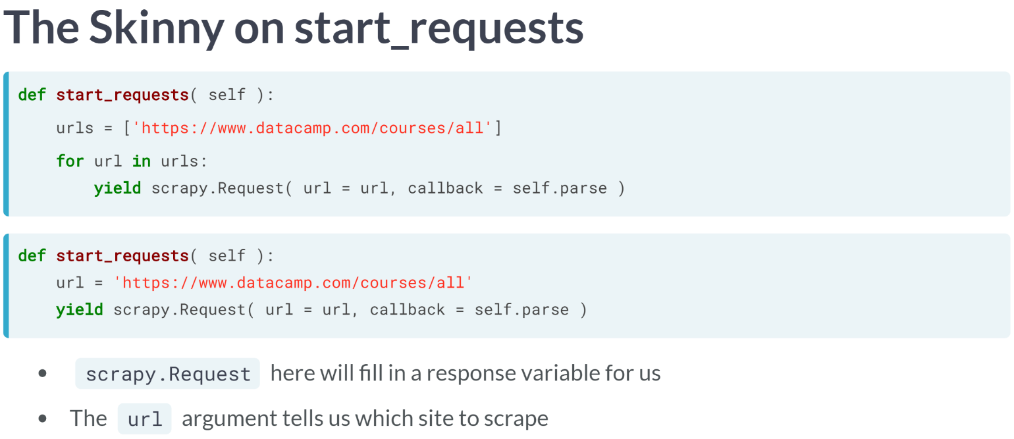  
  
First, within the spider class, we must define a method called ***start_requests()***, which should take self as an input. The reason we don't have flexibility in this method name is because scrapy looks for the start_requests method by name within the class we define for our spider.

We then have a list of the URL or URLs we would like to start scraping (but in this case, only one). It doesn't matter that we named this list URLs, but it seems like a convenient name considering.

Finally, we will take each URL within the URLs list and send it off to be dealt with. Now, this "send-off" is the most complicated part. But even before worrying about the "send-off", let's notice that we really did not need to loop over the URLs list with only one URL.

We could have easily defined it without the for loop, but we wrote it originally with the loop to give you an idea of how you might construct this if you had several URLs you want to initiate the spider with.

Back to the "send-off": the yield command, which you might be familiar with already, acts kind of like a return command in that it returns values when the start_requests is run; yield is a Python call, and is not specific to scrapy.

We won't go into more detail about yield vs return here, but just note that we are using yield in this method. The object we are yielding is a scrapy.Request object.

What yielding the scrapy Request object does is send a responsive variable (the same response variable we are familiar with) pre-loaded with the HTML code from the URL argument of the scrapy.Request call, to the parsing function defined in the callback argument.

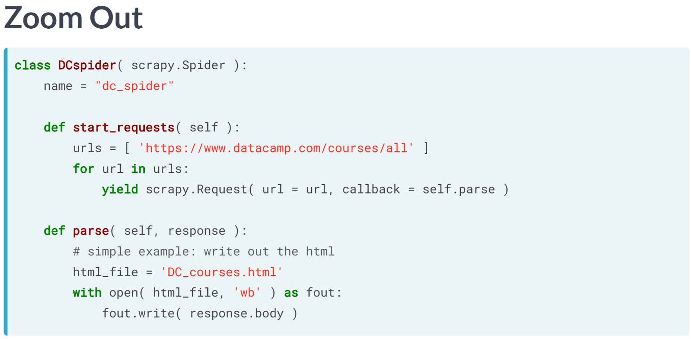

So, if we look at the entire spider class again, what we see is that the ***start_requests()*** call will preload a response variable with the HTML code from the DataCamp course directory, and send it to the method we have named parse.

As a glimpse into the future, notice that the parse method has response as its second input variable, this is the variable passed from the scrapy.Request call.

Also, notice that while there are many wheels turning in the ***start_requests()*** method, most of them are happening under the hood, and the only real adjustment we need to make are to define which URL or URLs we are going to scrape, and what callback method we want to use to parse those scraped sites. So, you've taken a big bite out of scrapy spiders already.

# Self-Referencing is Classy

You probably have noticed that within the spider class, we always input the argument self in the start_requests and parse methods (just look in the sample code in this exercise!). This allows us to reference between methods within the class.

That is, if we want to refer to the method parse within the start_requests method, we would need to write self.parse rather than just parse; what writing self does is tell the code: "Look in the same class as start_requests for a method called parse to use."

In this exercise you will get a chance to play with this "self-referencing".

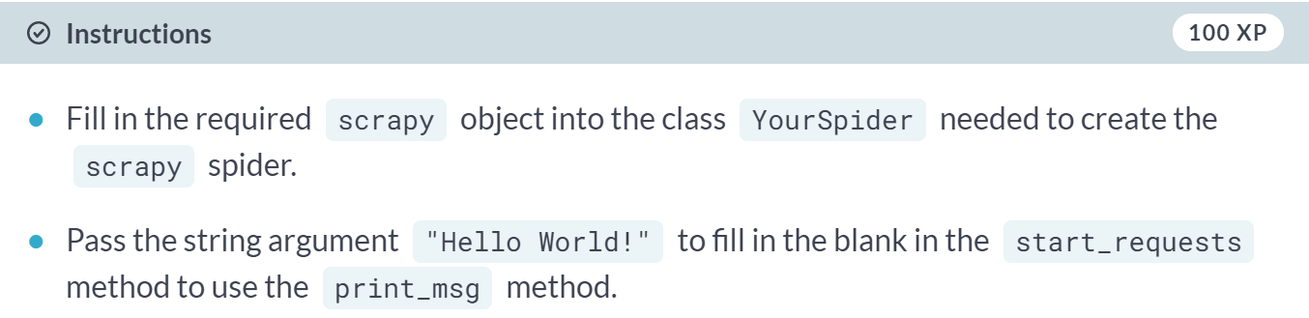

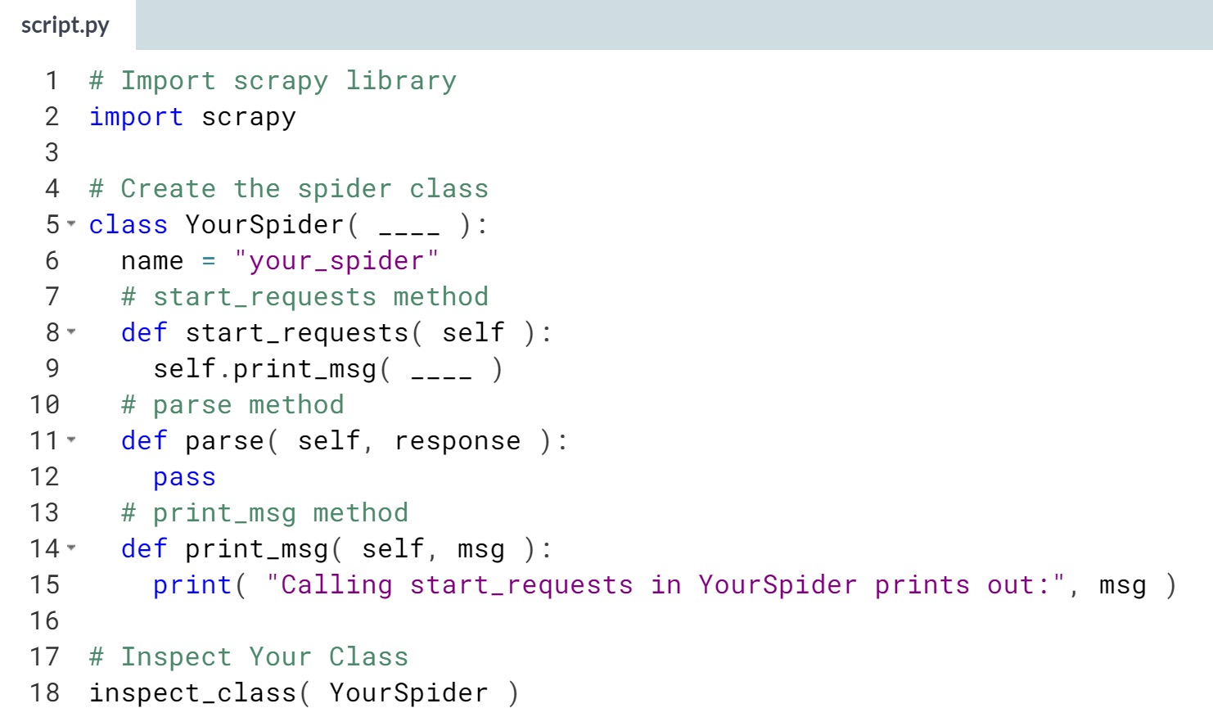  
Hint: Remember that your scrapy spider needs to inherit *scrapy.Spider*. Within *start_requests*, all you need to do is pass the *"Hello World"* string as an argument to the call of *start.print_msg*.

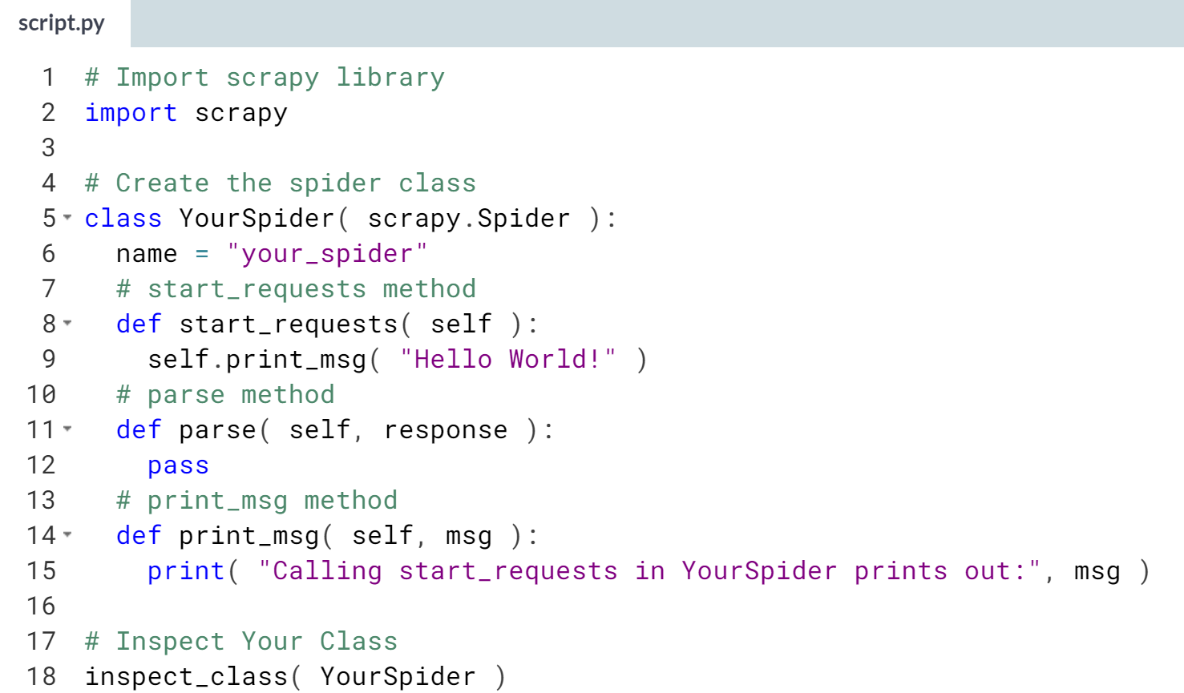

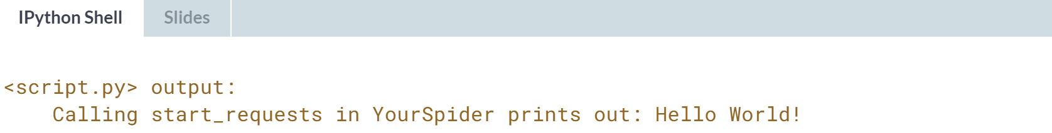

Awesome! Self-referencing in classes can be a bit confusing, but you nailed it!! (And, don't worry, we don't need to worry too much more about this subject for this course)!!

# Starting with Start Requests

In the last lesson we learned about setting up the start_requests method within a scrapy spider.

Here we have another toy-model spider which doesn't actually scrape anything but gives you a chance to play with the start_requests method.

What we want is for you to start becoming familiar with the arguments you pass into the scrapy.Request call within start_requests.

As before, we have created the function inspect_class to examine what you are yielding in start_requests.

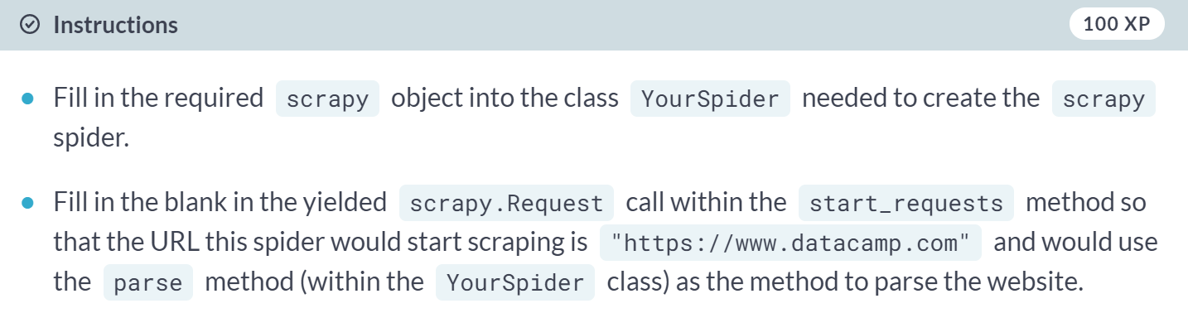

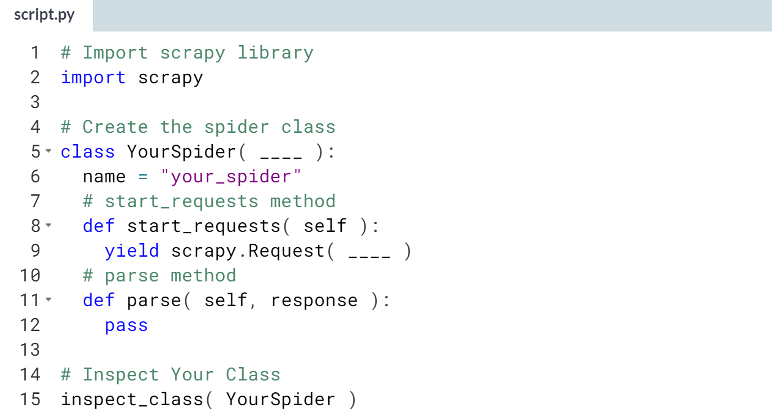  
Hint: Remember that you will use two arguments in *start_requests*, the first is *url* and the second is *callback*. Remember to use *self.parse* to reference the method parse within the *start_requests* method  
(Solution on the next page).

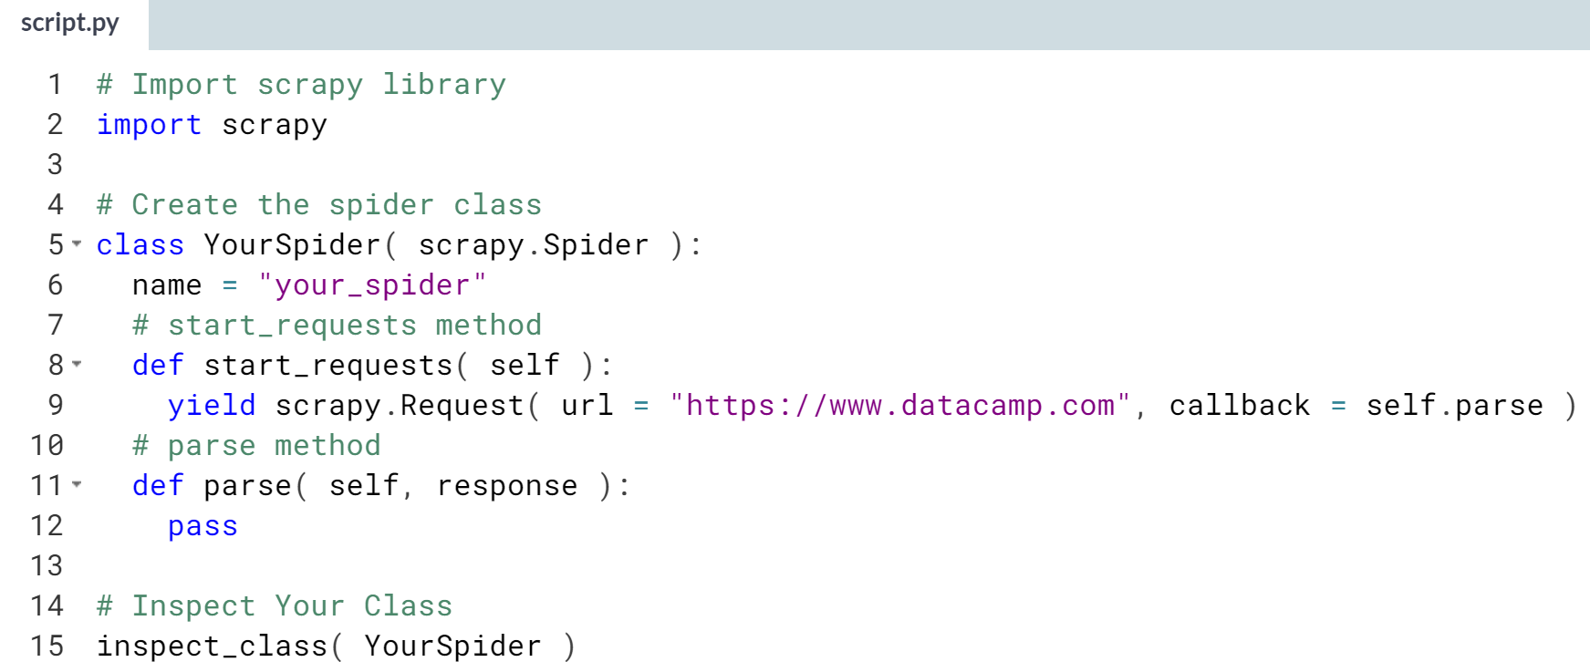

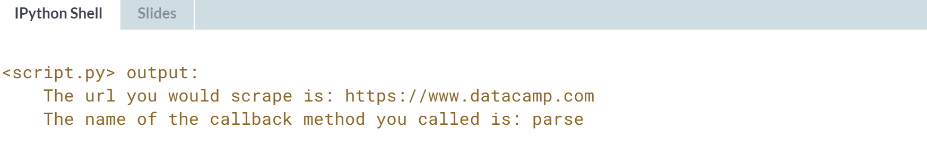  
Well done! You've been able to use the yielded *scrapy.Request* to direct to the correct URL and parsing method!

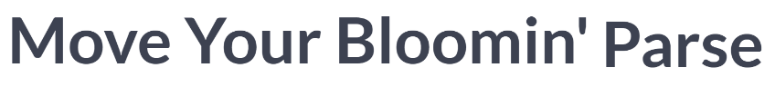

You should have some feeling for how to setup and use the ***start_requests()*** method in your spider, and understand that from the ***start_requests()*** method, the yielded scrapy.Requested call sends a scrapy response object to a parsing function for processing. In this lesson, we will focus on the parsing method.

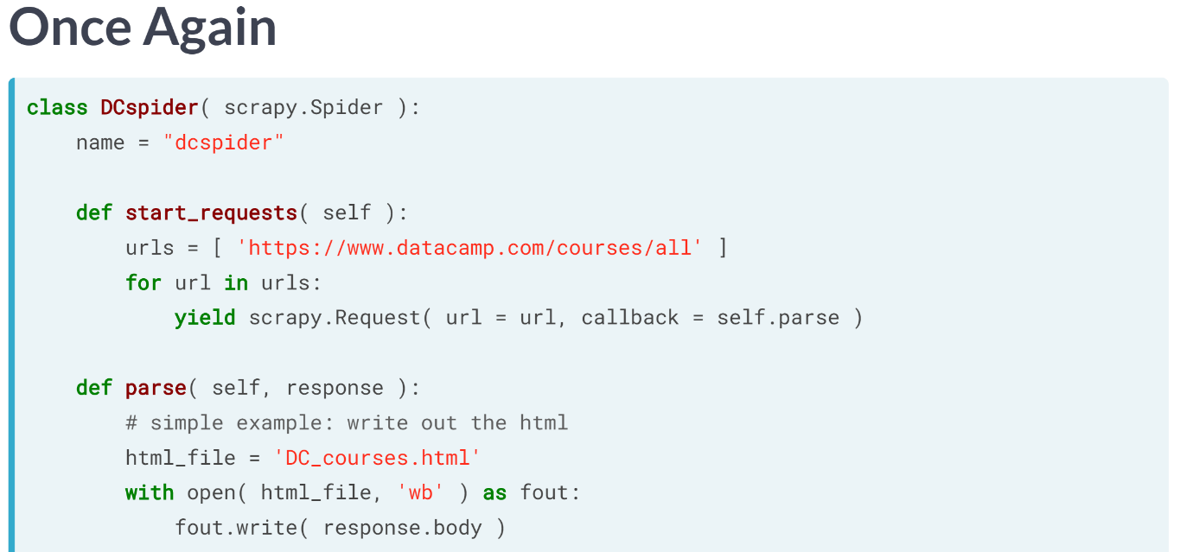  
Let's again quickly remember the simple spider class we've seen before. Our focus will be the parse() method. As a reminder, we don't need to name the parse method ***parse()***, but we could call it whatever we want as long as we correctly use the callback argument in the yielded scrapy.Request call in the ***start_requests()*** function.

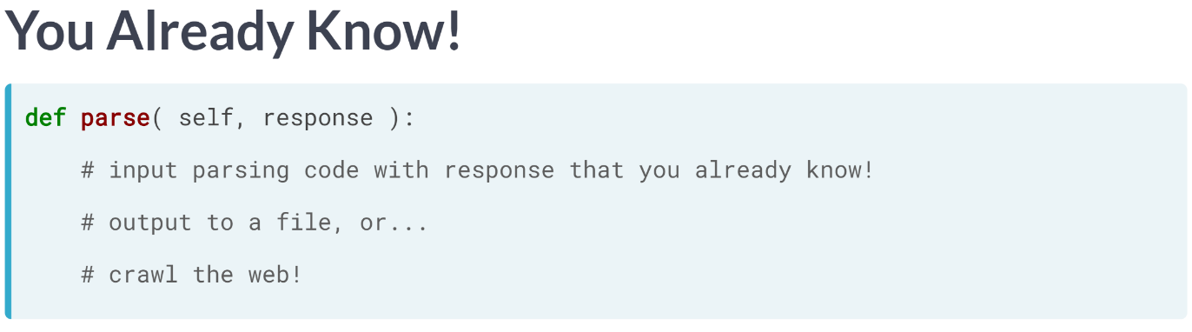  
Most of the scraping actually occurs within the parsing function. This is where we use the materials we've been building up during this entire course. Over the last three chapters in this course, we have built up the techniques to handle a scrapy response variable for data extraction!

So, the only thing we need to focus on here is what to do with the extracted site data once you have your hands on it. In the previous example, we had the parser simply save the HTML code to a local file. In the next couple examples, I'll show you that we can do much more.

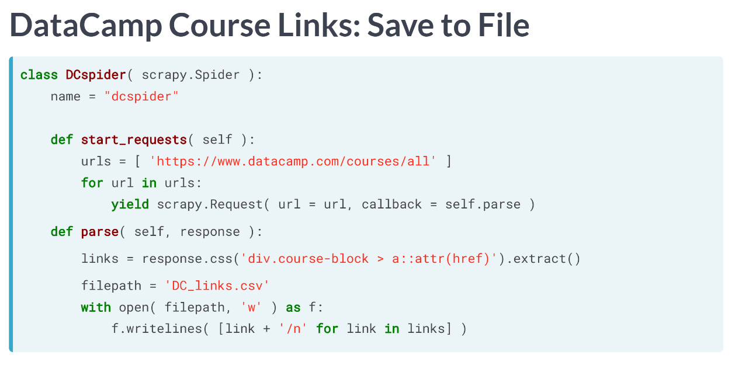  
The first example we will look at extracts the DataCamp course links from the course directory (as we did in previous chapter, then saves these links to a file with one link per line.

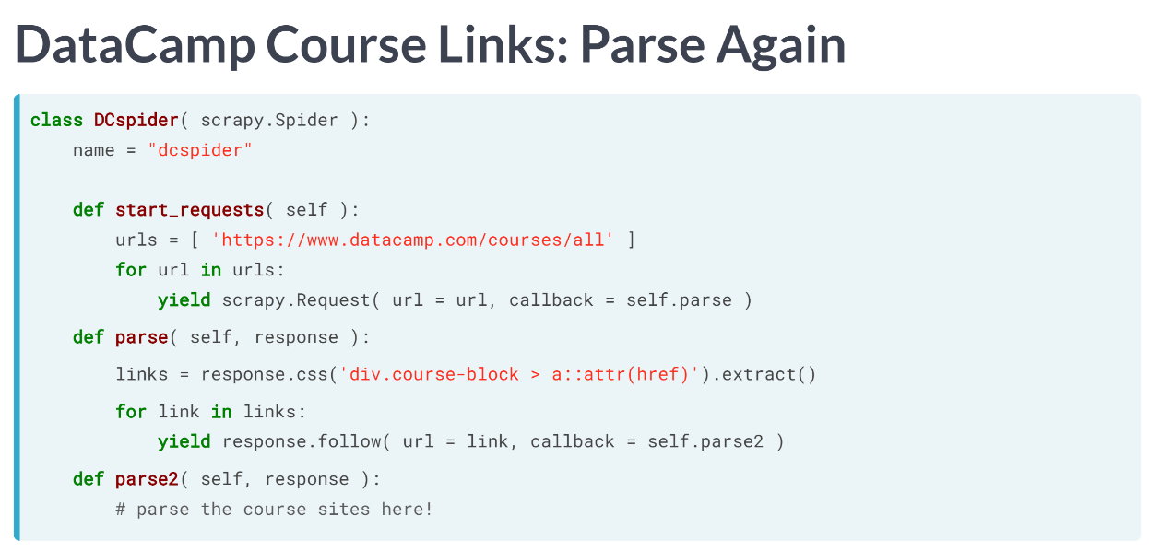  
Another, much more interesting and powerful example is to create a spider, which crawls between different sites. We start by first extracting the course links from the DataCamp course directory (as we did in the last chapter). Then, instead of printing anything to a file here, we will have the spider follow those links and parse those sites in a second parser. You see, finishing the first parse method, we loop over the links we extracted from the course directory, then we send the spider to follow each of those links and scrape those sites with the method parse2.

Notice here that when we send our spider from the first parser to the second, we again use a yield command. But instead of creating a scrapy.Request call like we did in ***start_requests()***, we use the follow method in the response variable itself. The follow method works similarly to the scrapy.Request call, where we need to input the URL we want to use to load a response variable and use the callback argument to point the spider to which parsing method we are going to use next.

Our spider starts at the base site (or sites) indicated in the start_requests method. From there, we can follow links on that site to other sites, and scrape them, or potentially even follow links on those sites to new sites, creating a web for our spider to crawl. Hence the name web-crawlers, and why the programs that crawl the web are often called spiders. You should now understand the ideas behind scraping a single site, creating a spider to scrape for you, and understand the concept of crawling to scrape multiple sites.

# Pen Names

In this exercise, we have set up a spider class which, when finished, will retrieve the author names from a shortened version of the DataCamp course directory. The URL for the shortened version is stored in the variable url_short. Your job will be to create the list of **extracted** author names in the parse method of the spider.

Two things you should know:

* You will be using the response object and the css method here.
* The course author names are defined by the **text** within the paragraph p elements belonging to the class course-block__author-name

You can inspect the spider using the function inspect_spider() that we built for you -- it will print out the author names you find!

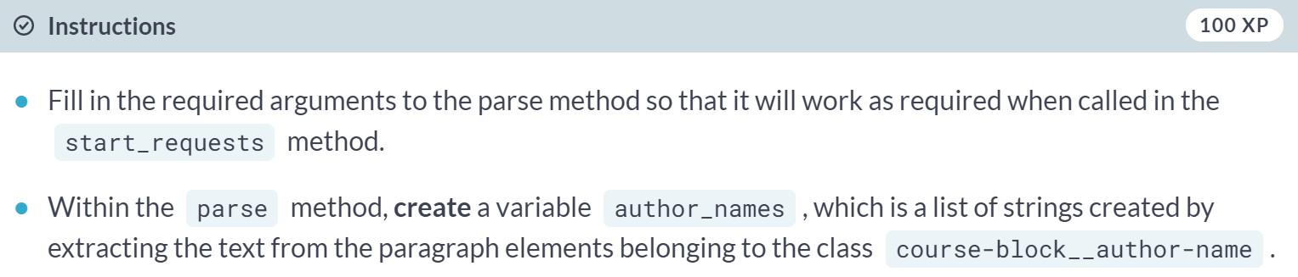  
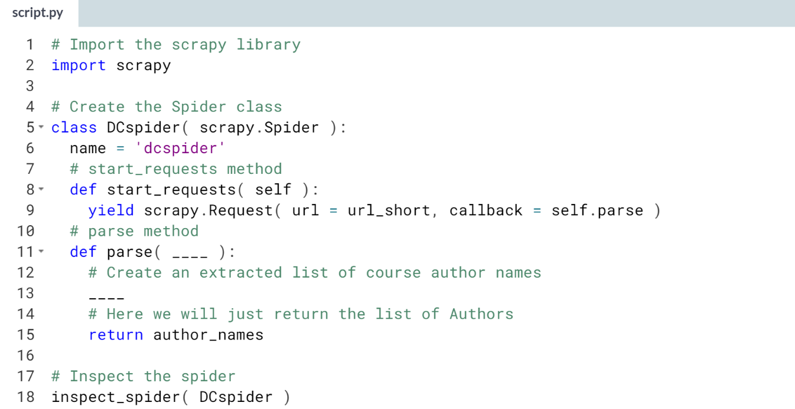  
Hint:   
1) Remember that one of the two arguments parse needs to be passed is self.   
2) When using response.css to get to the author names, make sure to extract the text.   
3) Remember that in CSS Locator notation, use a period . when trying to select an element by class.   
4) Remember that in CSS Locator notation, to select text, you use ::text appropriately in the string.

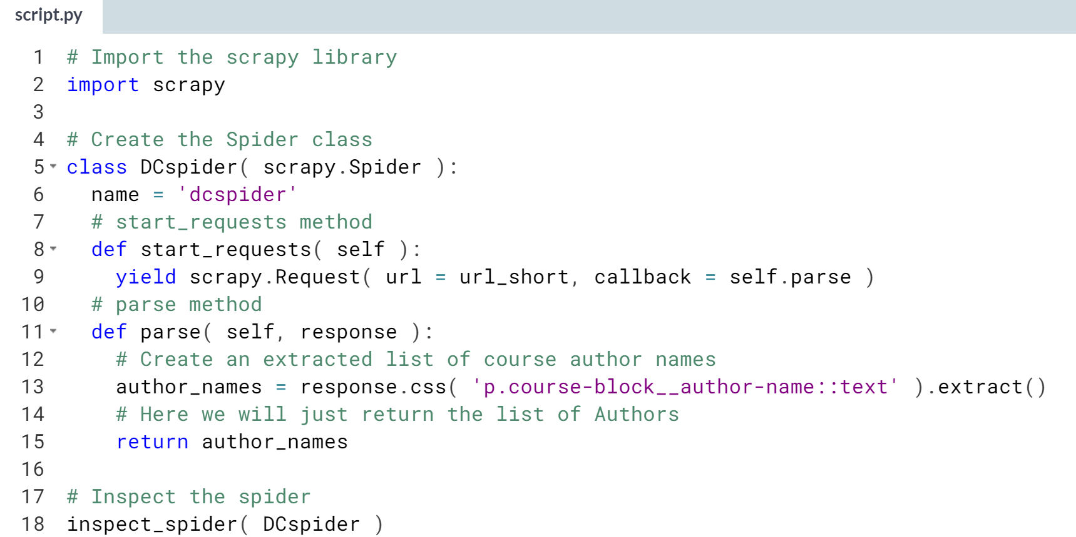

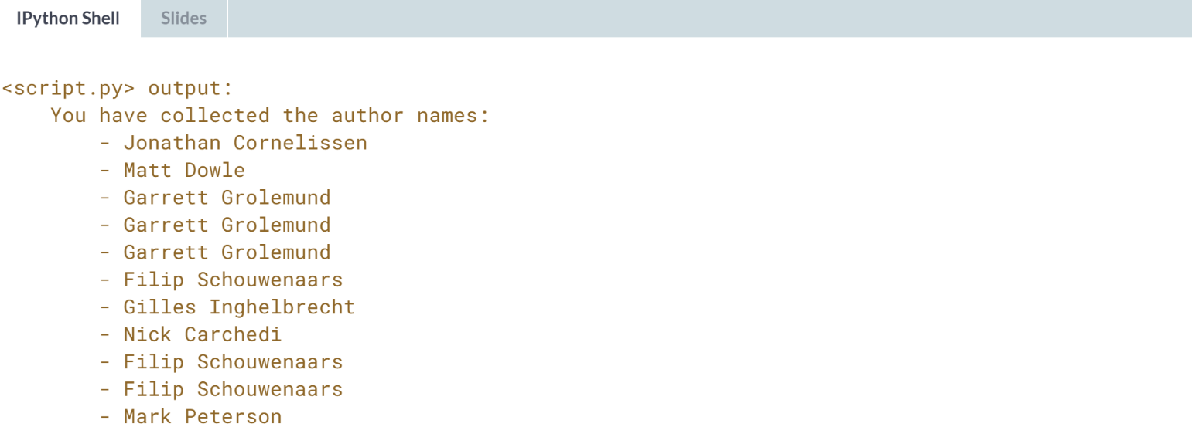  
  
Nicely done! Notice that you could have written the code for this exercise in the previous chapter, the only difference here is that the response variable appeared within your spider.

# Crawler Time

This will be your first chance to play with a spider which will crawl between sites (by first collecting links from one site, and following those links to parse new sites). This spider starts at the shortened DataCamp course directory, then extracts the links of the courses in the parse method.

From there, it will follow those links to extract the course descriptions from each course page in the parse_descr method and put these descriptions into the list course_descrs. Your job is to complete the code so that the spider runs as desired!

We have created a function inspect_spider which will print out one of the course descriptions you scrape (if done correctly)!

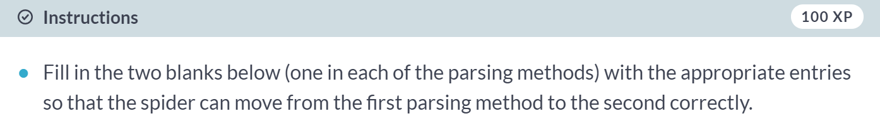  
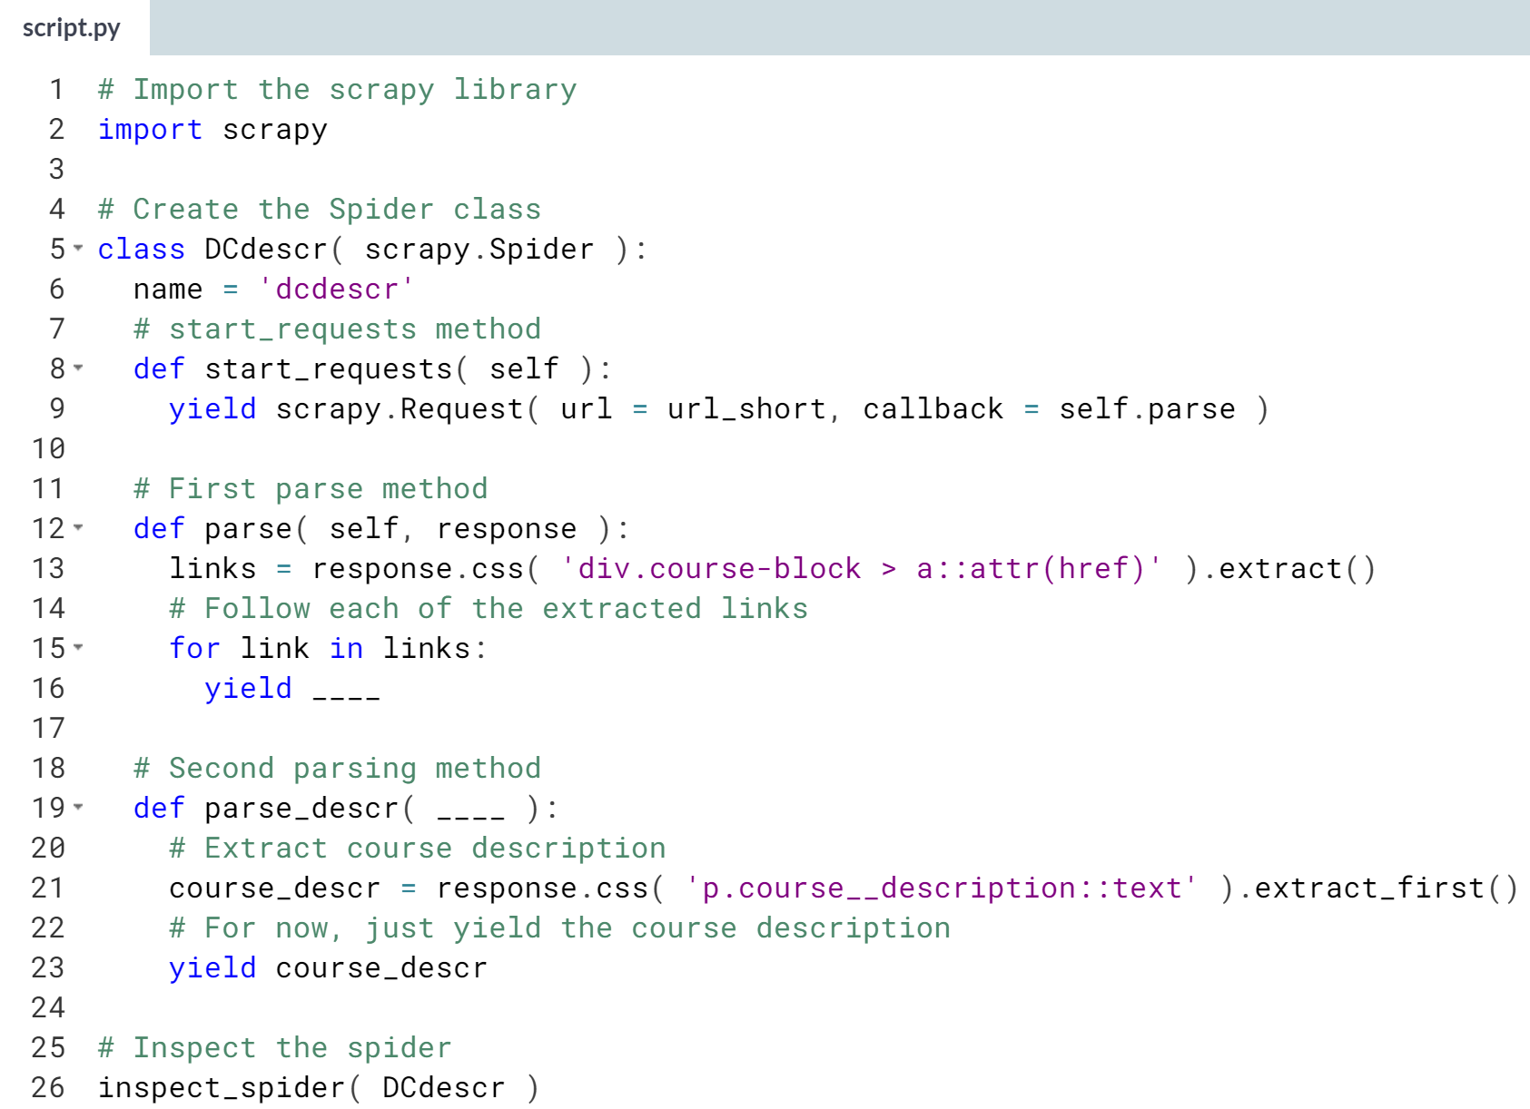

Hint: Remember that *response.follow* works in a similar way to *scrapy.Request*. Also, don't forget that the first of two entries for a parsing method is *self*.

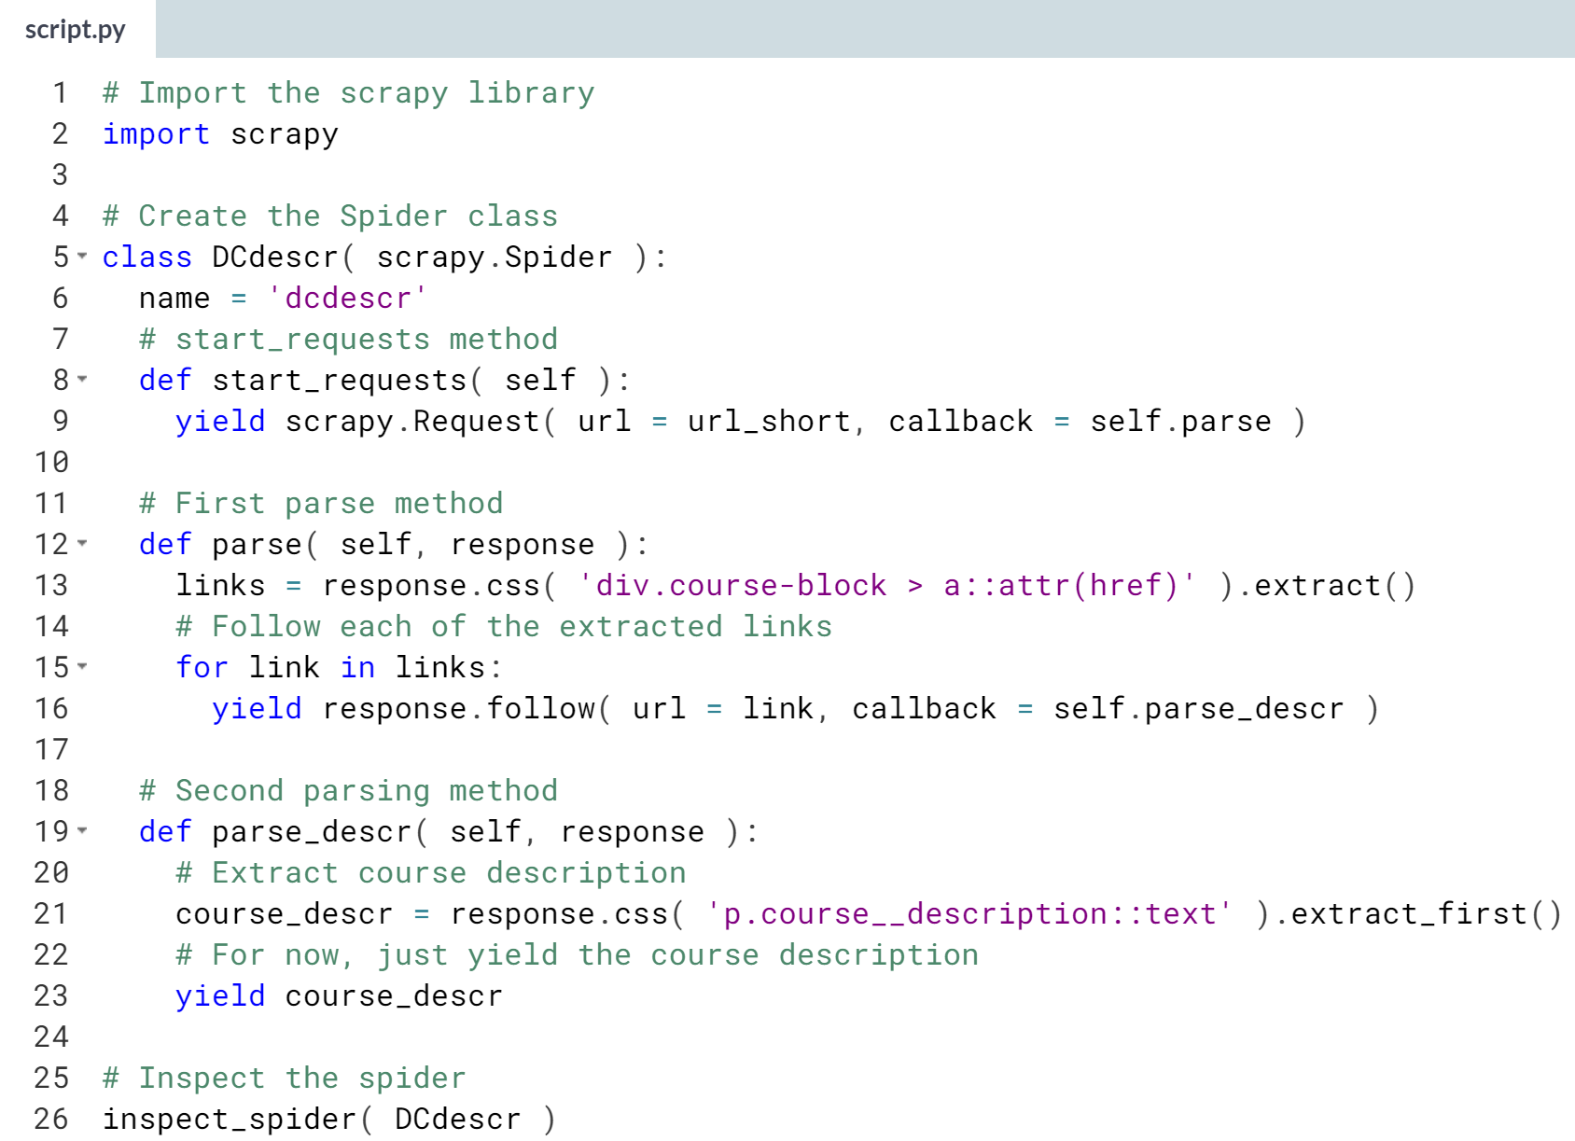

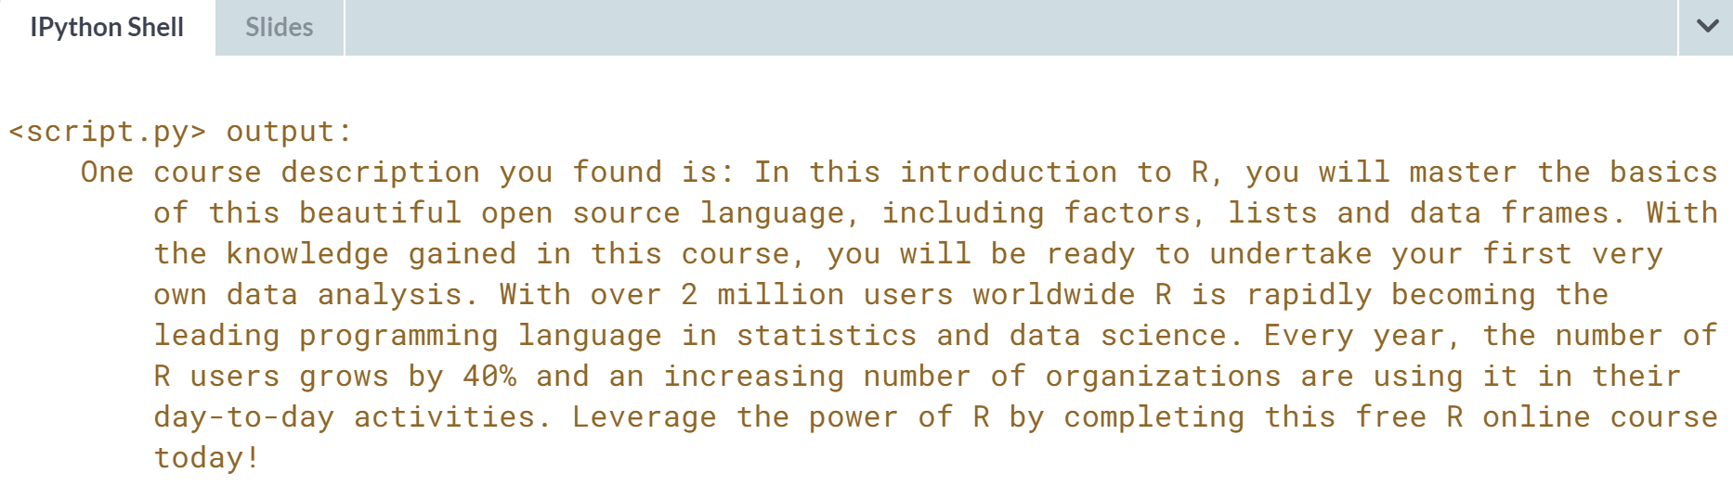  
That was a long bit of code that you had to read through, but you did it! And you got the crawler, well, crawling!!!

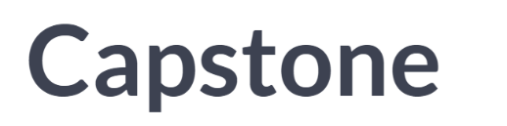

We are finally at the point that we can set up an entire scrapy spider from start to finish. We will create a spider, which collects all the course links from the DataCamp course directory; then, it will follow those links to extract the course title and the titles of all the course chapters; finally, it will store this information in a dictionary for us to use as we want to retrieve later.

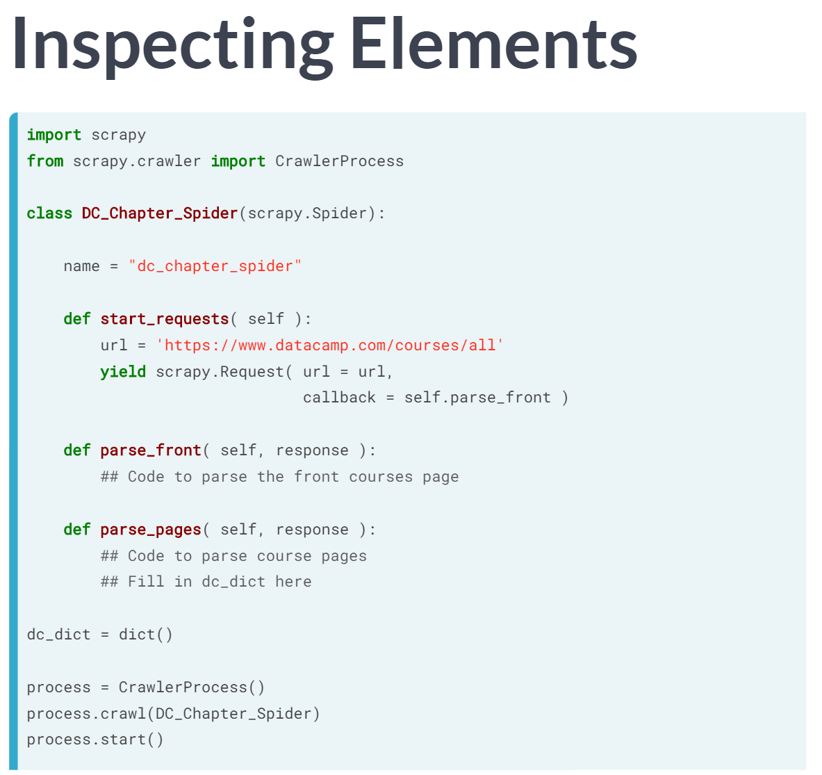  
The structure of our spider will be as you see here. You will notice all the usual suspects set up for us, including the naming variable within the spider class, and a ***start_requests()*** method, which directs us to the DataCamp course directory site. At the bottom, there is an empty dictionary, called dc_dict, which is what we want to fill in with the course titles and course chapter titles during the scrape.

Our first objective of scaping the course directory to extract the course page links will be coded in the parsing method we call ***parse_front()*** within our spider class.

From there, the spider will crawl to each of those course pages and fill in the dc_dict using the course titles as the keys, and a list of the course chapter titles as the items; this second order scraping method we will call parse_pages.

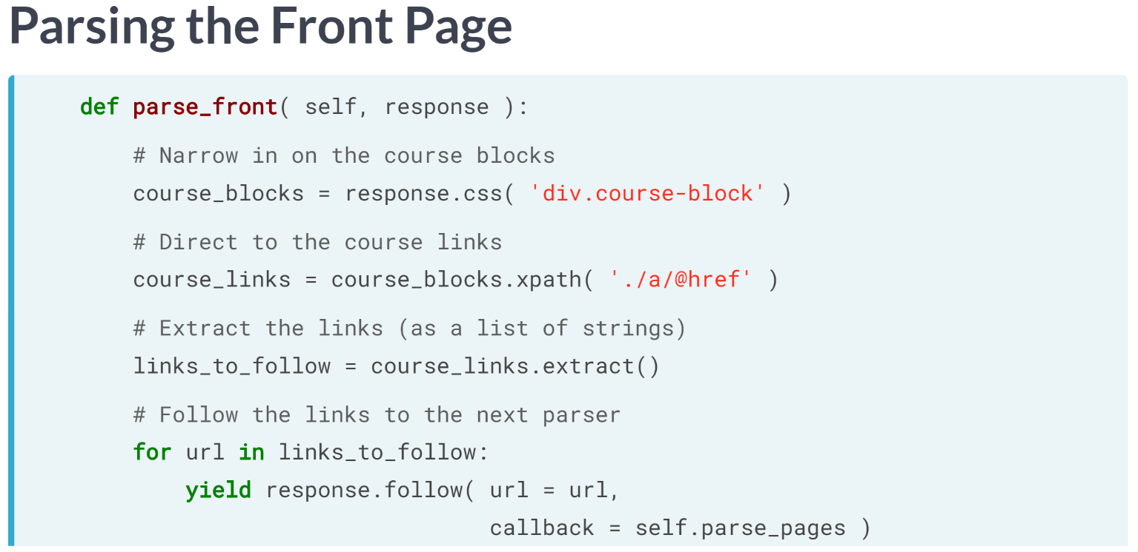  
It remains for us to fill in the parsing code. Starting with parse_front, we will first direct to all the course block div elements (as we have done before).

This course blocks divvy up the course information for each course in the directory. From each course block, we then direct to the course page link, again as we have done before. Using the extract method, we create a list of links (as strings) that we want to follow.

And finally, we will iterate through the links and yield a call to response.follow, directing the spider to crawl to each of these course pages. Note that the follow callback method is directed to ***parse_pages()***, which is the name of the parsing method we want to spider to use at the next step.

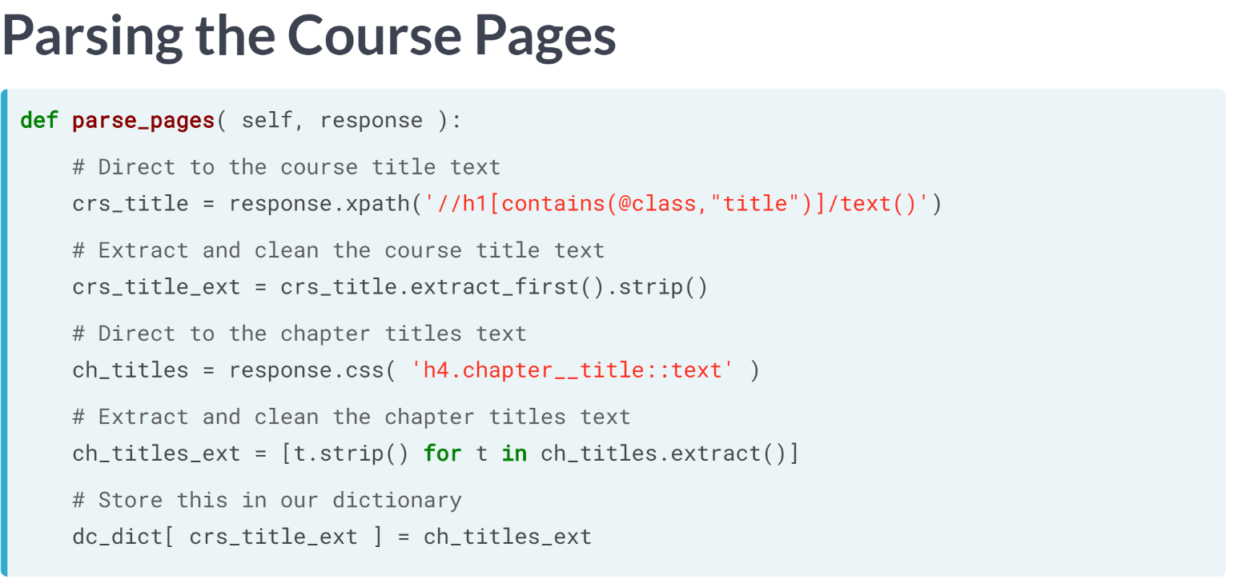Now, to fill in the ***parse_pages()*** method, we remember that we want to extract the course title and the titles of the course chapter. After inspecting the HTML on one of the course pages, we discover that the course title is defined by the text within an h1 element whose class contains the word title. So, we start by directing to this text.

To extract the course title, we will call ***extract_first()*** rather than extract since we want to be left with the title as string, rather than ta list containing the title, as extract would leave us with.

Although it is not necessary, when we do this, we can clean the text a little, removing strange character returns that often crop up in HTML. Fortunately, strings in Python already include a ***strip()*** method to do this cleaning for us.

Next, we want to get to the chapter titles. On inspection, we discover that these are defined as the text within h4 elements whose class is ***chapter_title()***. So, we direct the spider to these pieces of text, extract the text and clean it as before.

This time, we use extract to get a list of the many chapter titles per course. We finally end by filling in our dictionary whose keys are the course titles and corresponding elements are the chapter titles. And now that we have finished this parsing method, we have finished our spider.

# Time to Run

In the last lesson, we went through creating an entire web-crawler to access course information from each course in the DataCamp course directory. However, the lesson seemed to stop without a climax, because we didn't play with the code after finishing the parsing methods.

The point of this exercise is to remedy that! The point of these two exercises is to give you a **very** easy task to complete, with the hope that you will look at and run the code for this spider. That way, even though it is long, you will have a grasp of it!

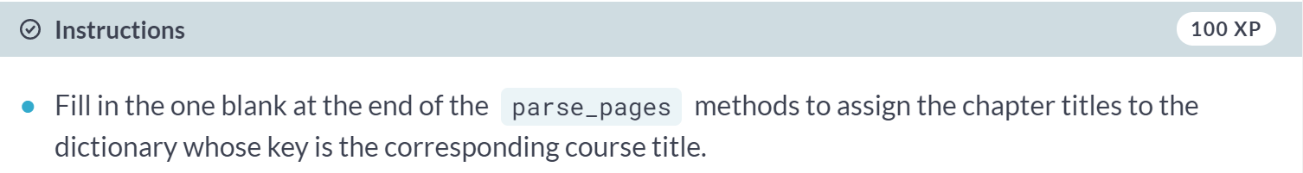  
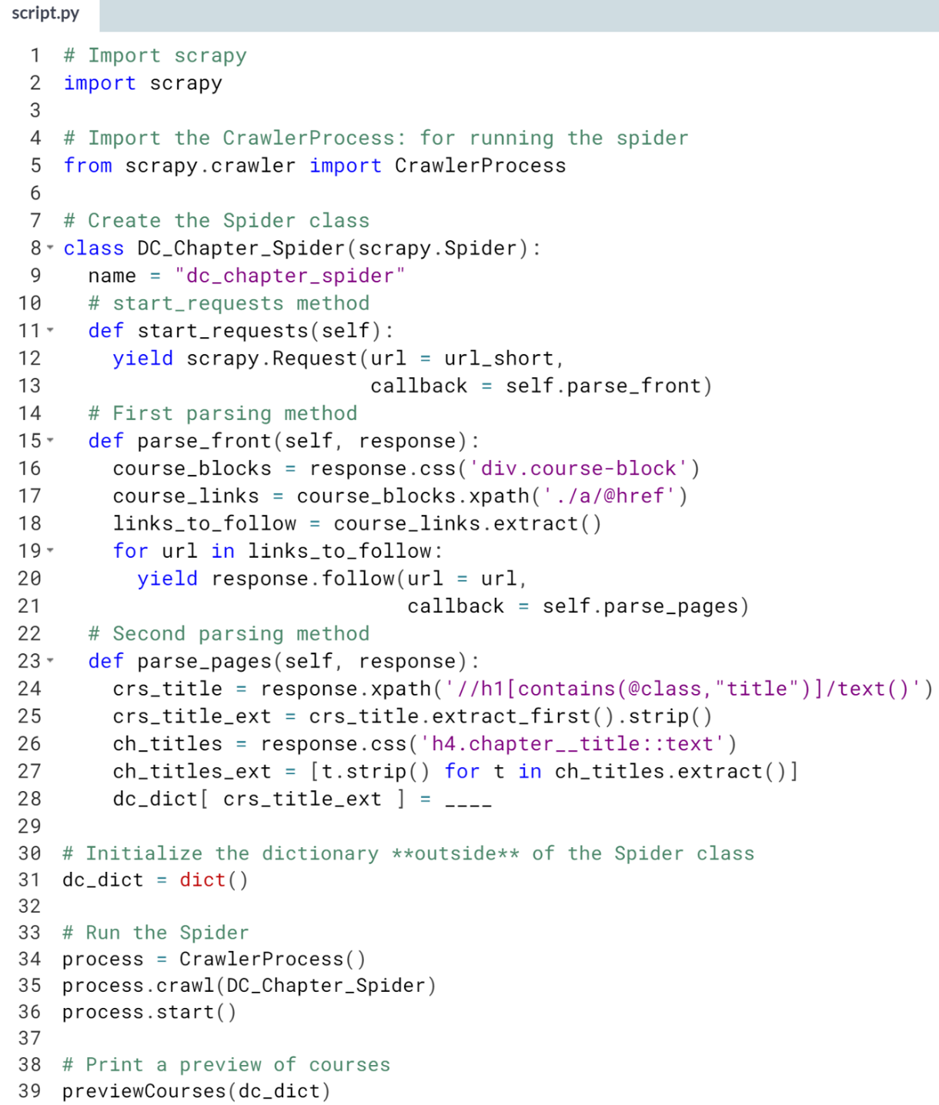

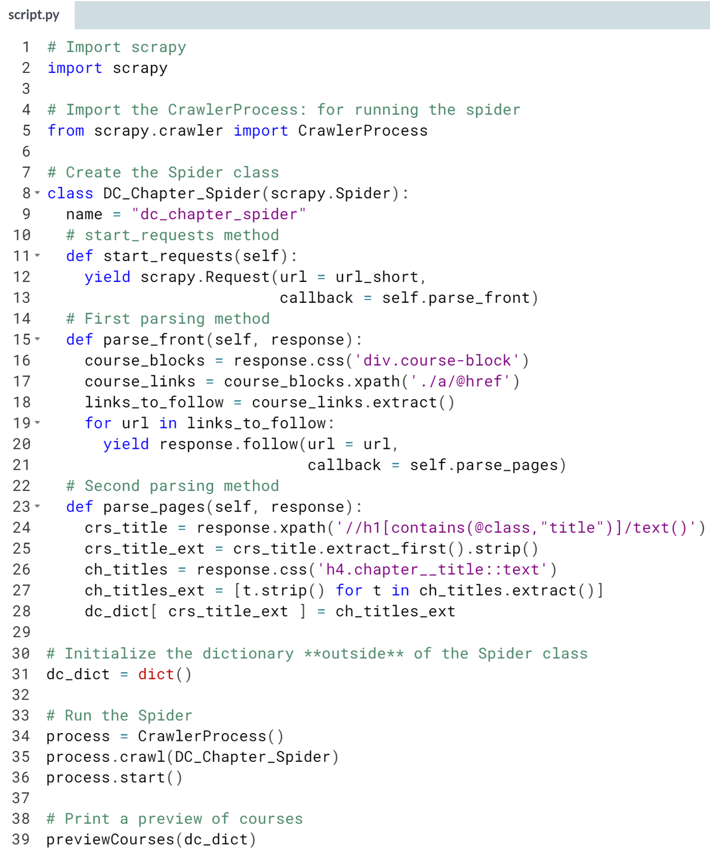

(Result on the next page)

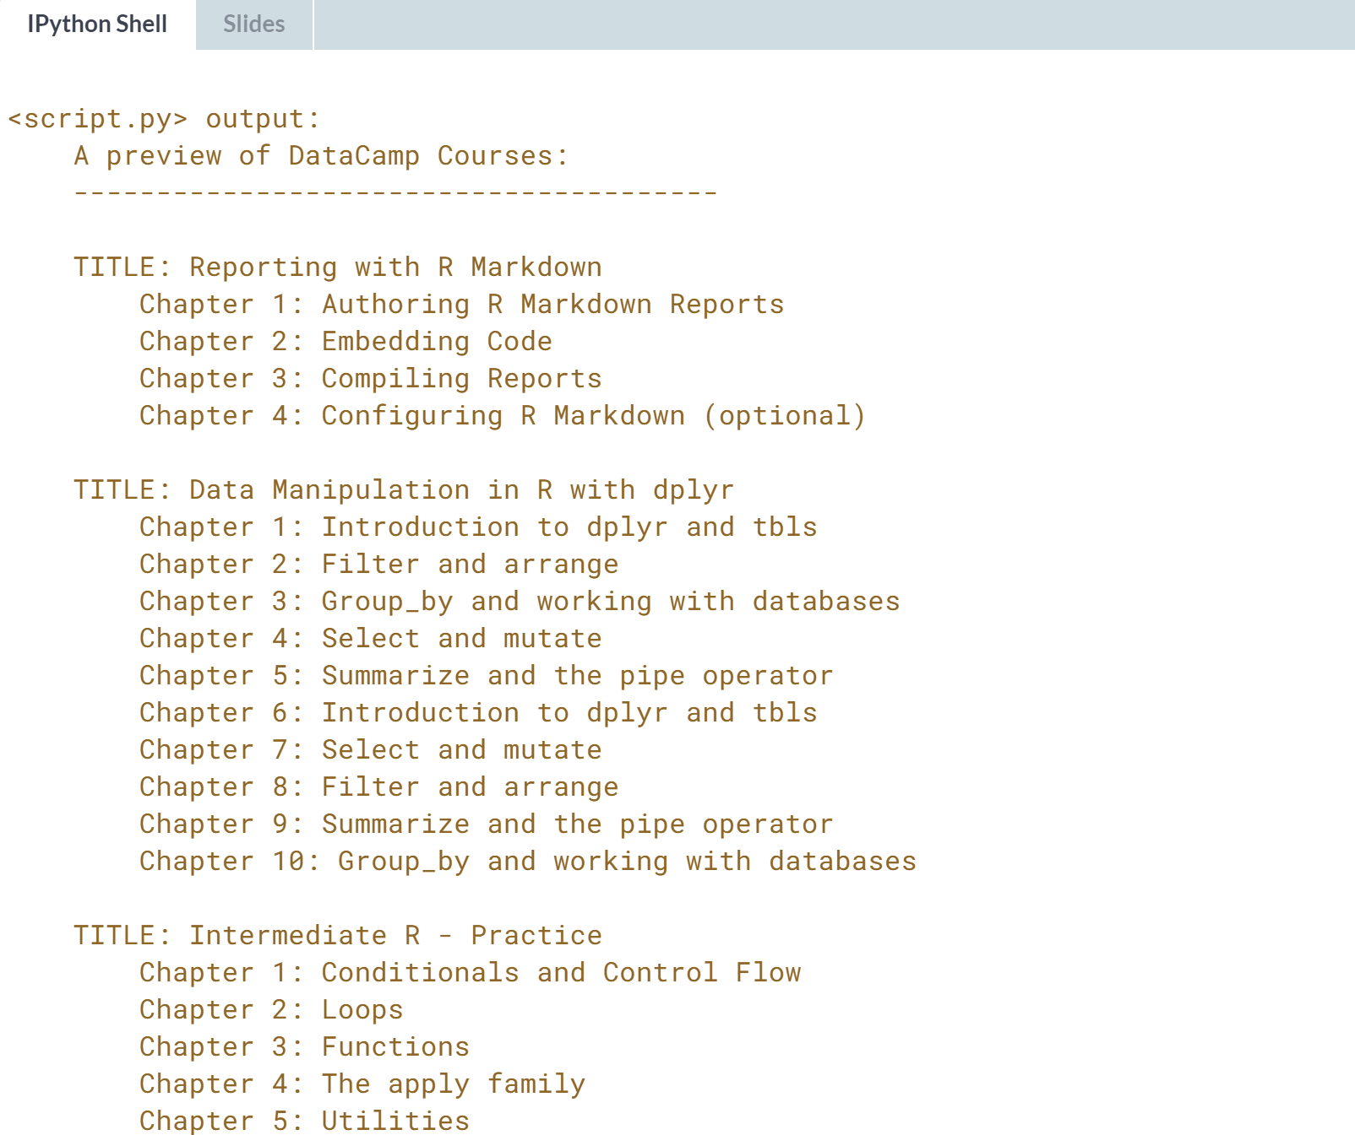

Great job! While there was a lot of code for you to read through, you should be somewhat familiar now with the layout. Your job here was just to help fill in the dictionary items, but really we wanted to give you a chance to look through the actual code (of a fully running spider!!).

# DataCamp Descriptions

Like the previous exercise, the code here is long since you are working with an entire web-crawling spider! But again, don't let the amount of code intimidate you, you have a handle on how spiders work now, and you are perfectly capable to complete the easy task for you here!

As in the previous exercise, we have created a function previewCourses which lets you preview the output of the spider, but you can always just explore the dictionary dc_dict too after you run the code.

In this exercise, you are asked to create a CSS Locator string direct to the text of the course description. All you need to know is that from the course page, the course description text is within a paragraph p element which belongs to the class course__description (two underlines).

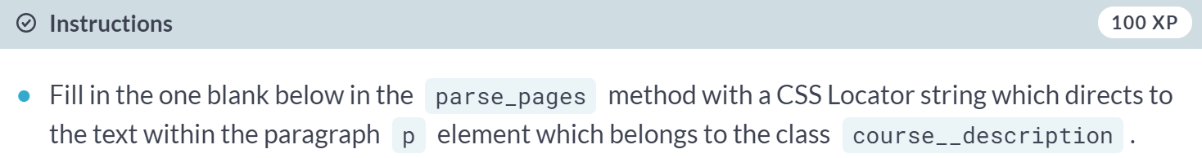

(Exercise continues on the next page)

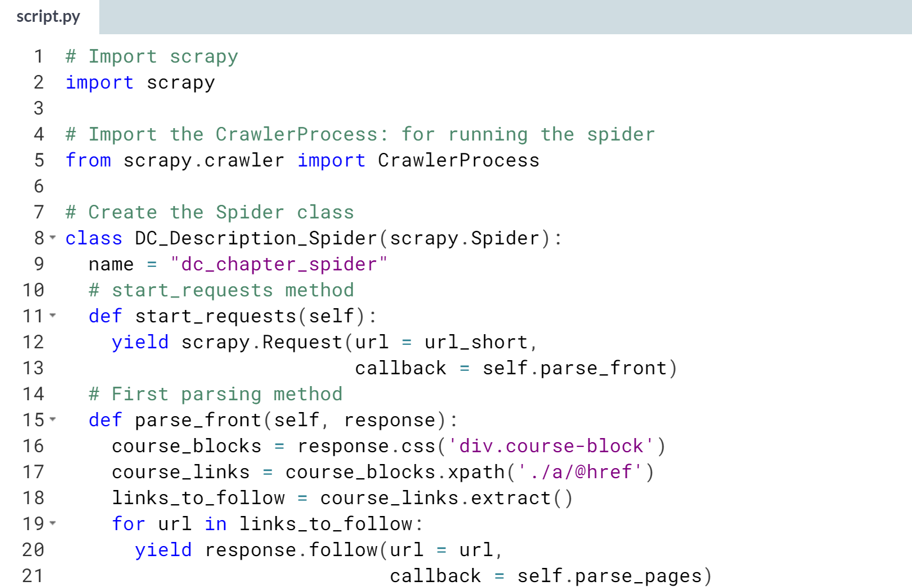  
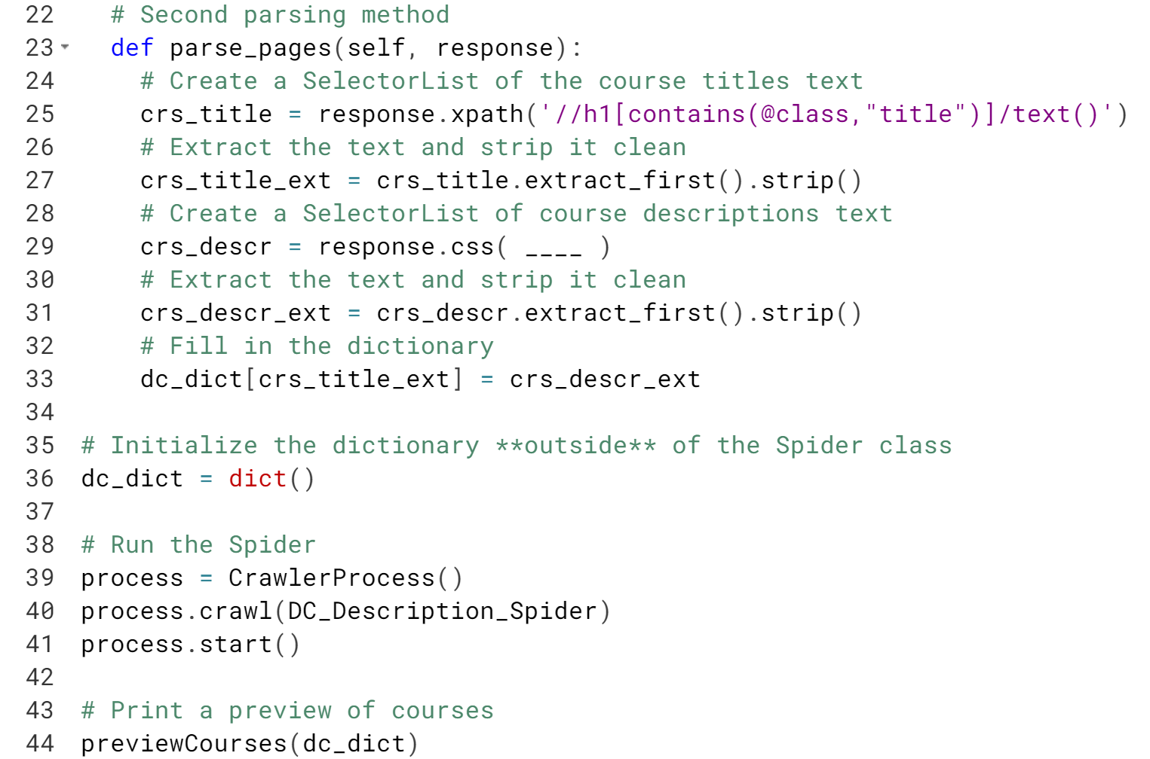  
(Solution on the next page)

Hint: Remember that using a period . in CSS Locator notation tells us to select by class. Also, remember that to select text in CSS Locator notation, you need to use ::text somewhere.

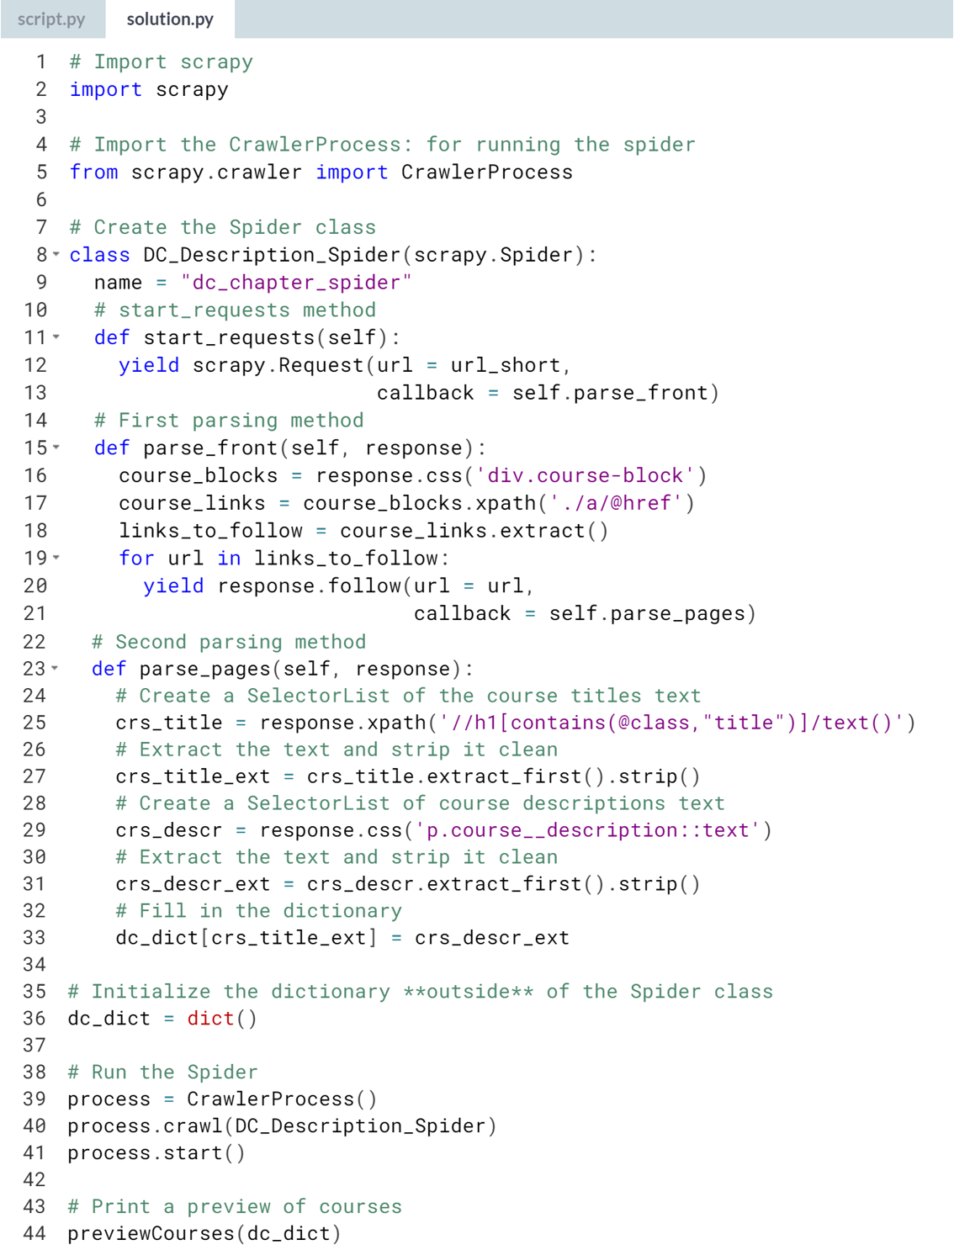

(Result on the next page)

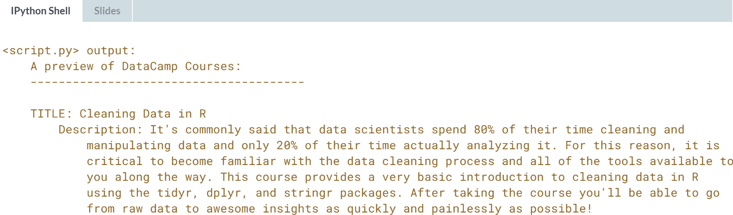

Amazing! As mentioned in the lessons, most of the code you will write for your spider happens in the parsing function(s). Even though you did not have to write much code, please noticed that the code contained in the parsing function(s) is what we've been working to build on throughout this course.

# Capstone Crawler

This exercise gives you a chance to show off what you've learned! In this exercise, you will write the parse function for a spider and then fill in a few blanks to finish off the spider. On the course directory page of DataCamp, each listed course has a title and a short course description. This spider will be used to scrape the course directory to extract the course titles and short course descriptions. You will not need to follow any links this time. Everything you need to know is:

* The course titles are defined by the text within an h4 element whose class contains the string block__title (double underline).
* The short course descriptions are defined by the text within a paragraph p element whose class contains the string block__description (double underline).

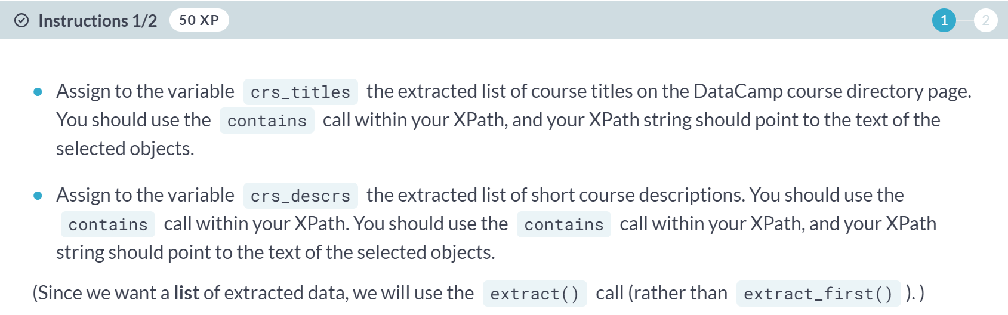

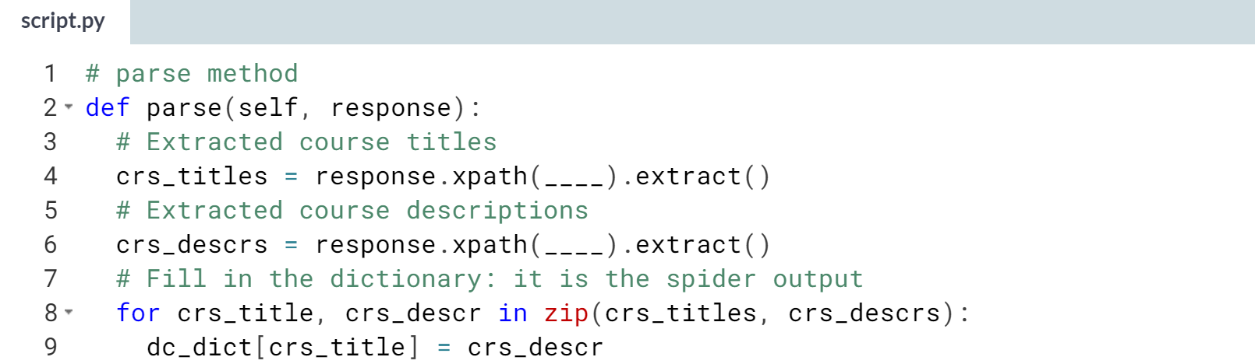

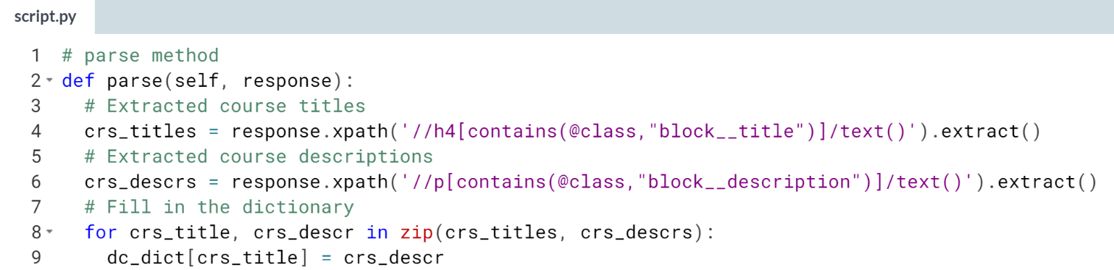

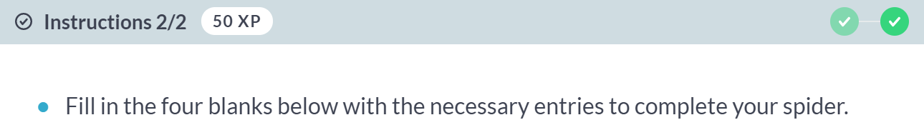

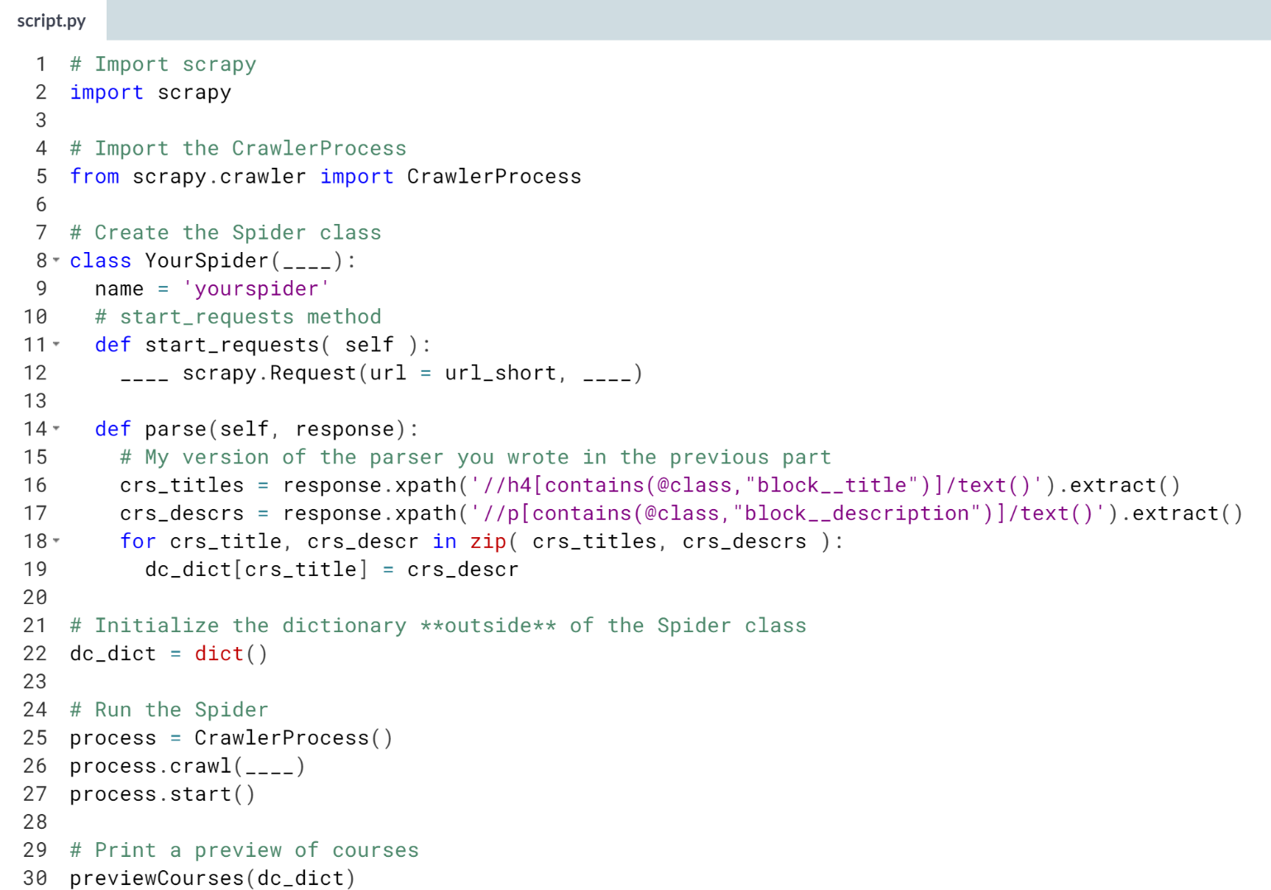

(Solution on the next page)

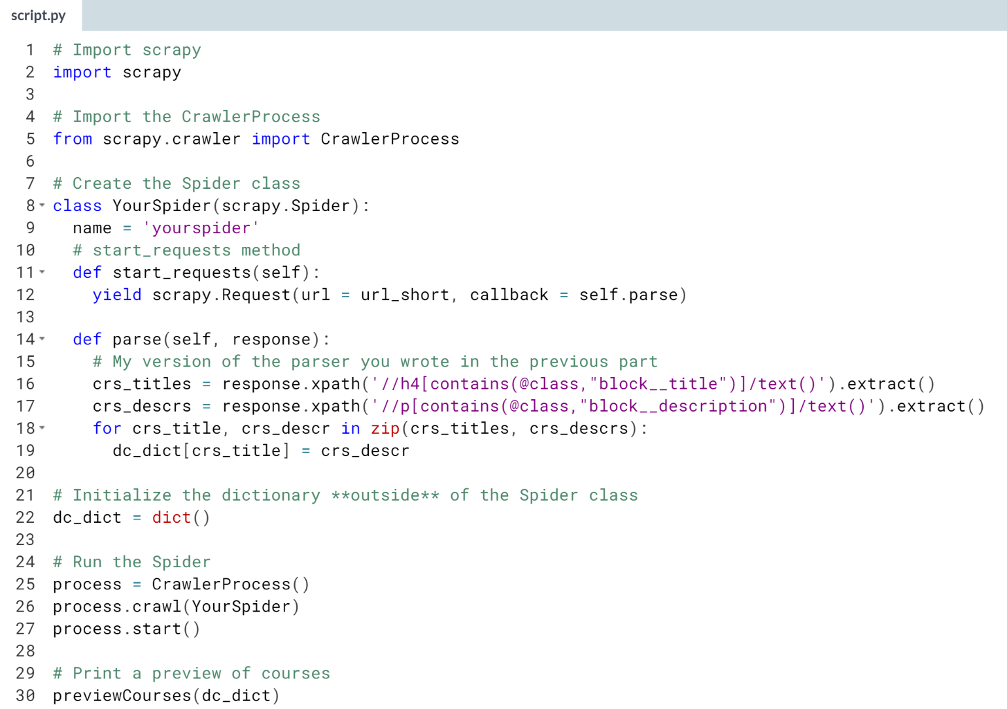

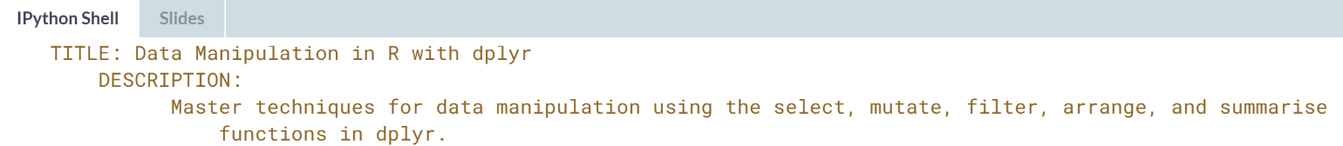

You just finished your Spider! Congratulations! You had already written the parsing code, and here you just filled in the few moving parts surrounding the setup of the spider.



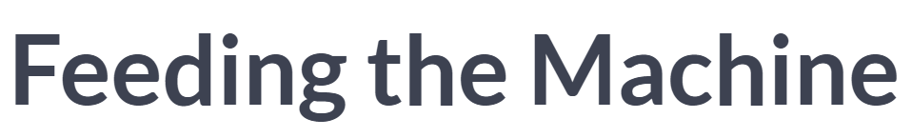  
Many courses in data science deal with how to process data that is already collected. Supervised vs Unsupervised learning, clustering, deep learning, etc. All deal with how to process a collection of data, but these courses or texts rarely deal with how we gather the data itself. Instead, this course has given you one important method of how to acquire these data to start with, from where you can then begin to consider how to analyze and process it. This is an extremely important step in data analysis, getting data to analyze.

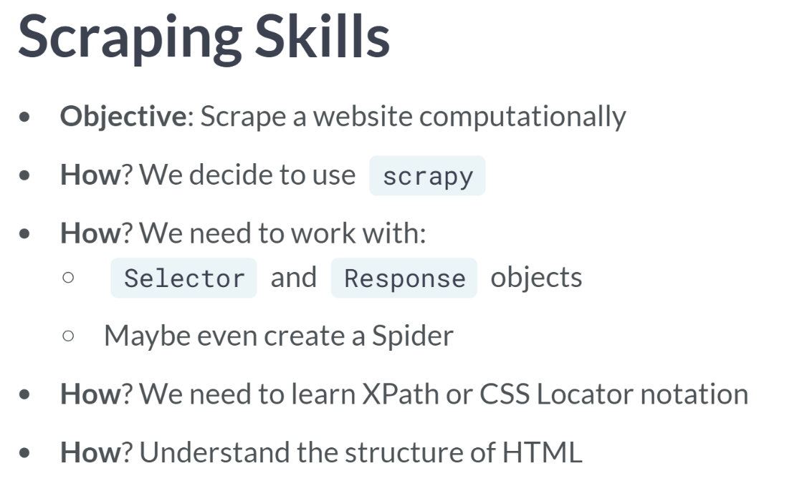

Rather than listing everything we've learned from start to finish, let's consider it in the opposite order, in the context that motivates our desire to learn this material in the first place.

At the top level, we have identified a website or collection of websites with information we want to collect and eventually process. Because of the number of sites, the material on the site, or whatever other reasons, it would be much easier to run through this scraping computationally rather than by hand.

So, we decide that we are going to write some code to scrape for us. In Python, we use scrapy to scrape single sites but also to create spiders which can crawl between multiple sites. Now, since we are going to use scrapy, we learn how to manipulate the Selector and Response object within scrapy, particularly to extract the data we want to collect.

But, we should also learn how to tell scrapy which elements to select. For this, we should learn either XPath or CSS Locator notation, but to make sense out of the XPath or CSS Locator, we really should understand the structure of HTML so we can make heads or tails of it.

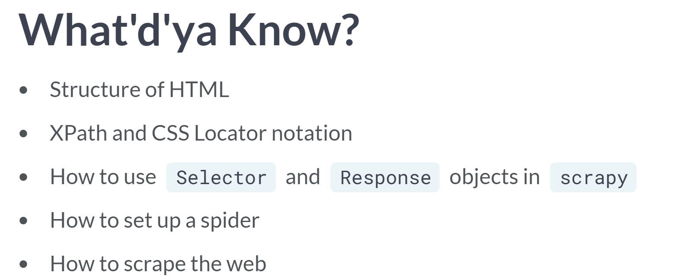  
Notice that you now have learned all these steps in the order you needed so that you can reach the original objective of scraping a site computationally. You have a usable mental model of the structure HTML, which can be translated into a usable XPath or CSS Locator piece of code. You can use 'Selector' and 'Response' objects in scrapy to navigate to and extract the desired information from a website.